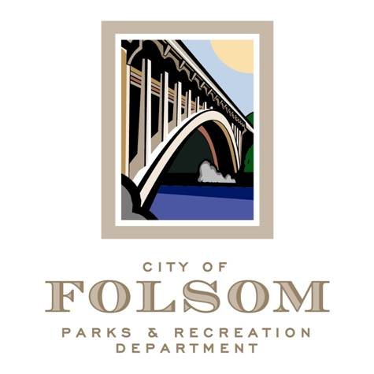
Parks and Recreation Commission
Sports & Recreation Subcommittee

Date: Tuesday, March 28, 2023
Time: 4:00 p.m.- 5:00 p.m.
Location: Parks & Recreation Dept. Conference Room
50 Natoma St.
Folsom, CA 95630

Agenda:
- Select Chair of Subcommittee
- Joint Use Agreement Partnership between City and FCUSD
  - Background, History, and Update
- Recreation & Community Services Special Events
  - Community Events Schedule and Descriptions
- Community Relationships
  - Department collaborations and partnerships with organizations, businesses, and friends’ groups

Future Meeting Topics
- Inclusion Programming
- Inclusion Services Statement
- How and What we Provide
- Park Champion Idea – Commissioner Davis

Attendees:
- Jennifer Tarbox, Commissioner
- Bill Davis, Commissioner
- Marina Leight, Commissioner
- Tom Hellmann, Recreation & Community Services Manager
- Derik Perez, Recreation Supervisor
- Chad Gunter, Recreation Supervisor
- Sarah Trobee, Recreation Supervisor

cc: Lorraine Poggione, Parks & Recreation Director
Brian Wallace, Parks & Recreation Commission Chair

