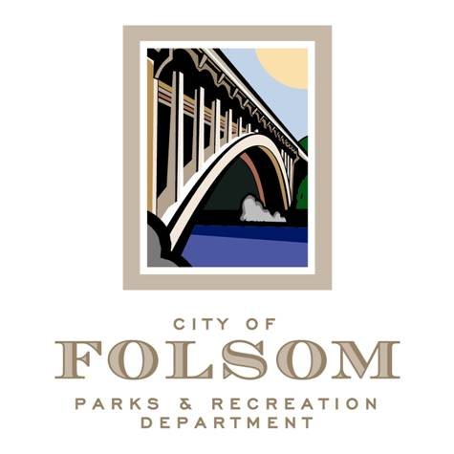

Parks and Recreation Commission – Public Private Partnership
Ad-Hoc Subcommittee
(Meeting #5)

Date: Wednesday, September 7, 2022
Time: 2:00 p.m.
Location: Parks and Recreation Conference Room
50 Natoma Street
Folsom, CA 95630

Agenda:

- Discuss Next Steps and Recommendation to full Commission. Attachments:
  - Summary of June 14, 2022 meeting
  - Discussion Guideline for today’s meeting
  - List of Existing Public-Private Partnership Overview
  - Article on Fund Raising vs. Sponsorships
- Staff to present partnership opportunity for Hinkle Creek Nature Center

Attendees:

- Matt Hedges, Chair
- Samantha Davidson, Commissioner
- Tanya Morales, Commissioner
- Lorraine Poggione, Director of Parks and Recreation
- Tom Hellmann
- Sarah Trobee
- Daniele Taylor
- Derik Perez
- Tim O’Shea

c: Dave Nazworth, Parks & Recreation Commission Chairperson

