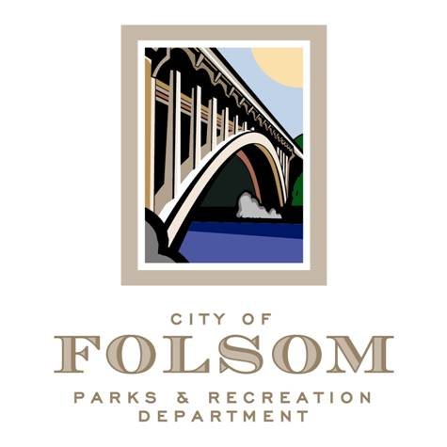

Parks and Recreation Commission – Underutilized City-Owned Properties Ad-Hoc for Zittel Family Amphitheater and Dan Russell Rodeo Arena
(Third Meeting)

Date: Monday, October 10, 2022
Time: 3:00 p.m.
Location: 915 Sutter Street/Office of Folsom Historic District Association

Agenda:

- Discuss Usage of Plaza, Amphitheater, Turntable Areas

Attendees:

- Will Kempton, Chair
- Brian Wallace, Commissioner
- Marina Leight, Commissioner
- Lorraine Poggione, Director
- Daniele Taylor, Senior Management Analyst
- Tom Hellmann, Recreation & Community Services Manager

c: Dave Nazworth, Parks & Recreation Commission Chairperson

