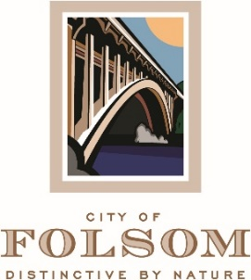

MEETING CANCELLATION NOTICE

THE REGULAR MEETING OF JANUARY 3, 2023 OF THE FOLSOM PARKS and RECREATION COMMISSION HAS BEEN CANCELED.

THE NEXT REGULAR MEETING IS SCHEDULED TO BE HELD ON TUESDAY, JANUARY 17, 2023 AT 6:30 P.M.

DUE TO A SCHEDULING CONFLICT OUR MEETING WILL BE HELD ON THURSDAY, JANUARY 19, 2023

