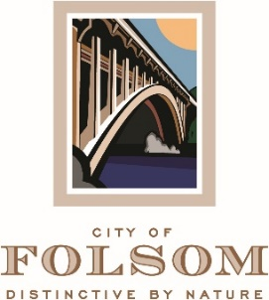

MEETING CANCELLATION NOTICE

THE REGULAR MEETING OF APRIL 4, 2023 OF THE FOLSOM PARKS and RECREATION COMMISSION HAS BEEN CANCELED.

THE NEXT REGULAR MEETING IS SCHEDULED TO BE HELD ON TUESDAY, MAY 02, 2023 AT 6:30 P.M.

