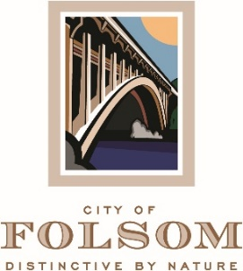

MEETING CANCELLATION NOTICE

THE REGULAR MEETING OF JULY 04, 2023 OF THE FOLSOM PARKS and RECREATION COMMISSION HAS BEEN CANCELED.

THE NEXT REGULAR MEETING IS SCHEDULED TO BE HELD ON TUESDAY, AUGUST 01, 2023 AT 6:30 P.M.

