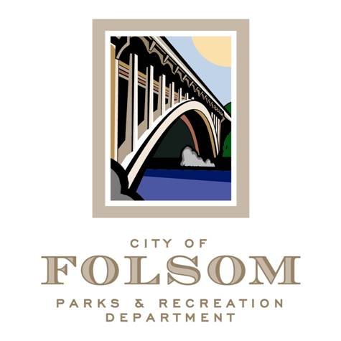
Parks and Recreation Commission
Parks & Recreation Subcommittee

Date: Friday, August 11, 2023
Time: 1:00 p.m.- 2:00 p.m.
Location: Parks & Recreation Dept. Conference Room
50 Natoma St.
Folsom, CA 95630

Agenda:
- Select Chair
- Purpose
- Renovation Master Plan
- Funding Priorities
- Vandalism
6. Park Ambassador Program

Future Meeting Topics

Attendees:
- Brian Wallace, Commissioner
- Samantha Davidson, Commissioner
- Jennifer Tarbox, Commissioner
- Kelly Gonzalez, Parks & Recreation Director
- Elizabeth Vaage, Senior Management Analyst
- Brad Nelson, Park Planning & Trails Manager
- Chris O’Keefe, Parks 7 Facilities Manager

