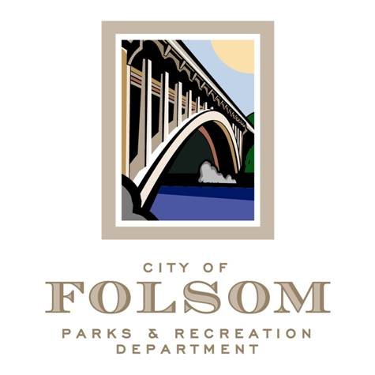

Parks and Recreation Commission
Park Renovation Plan Subcommittee

Date: Tuesday, October 17, 2023
Time: 9:00 a.m.- 10:00 a.m.
Location: 50 Natoma Street – Public Works Large Conference Room

Agenda:
- Folsom CA Community Build Playground Presentation – Kid's Play Park
- Presentation by Leather’s Playground via Zoom to the subcommittee

Future Meeting Topics

Attendees:
- Brian Wallace, Commissioner
- Samantha Davidson, Commissioner
- Jennifer Tarbox, Commissioner
- Kelly Gonzalez, Parks & Recreation Director
- Elizabeth Vaage, Senior Management Analyst
- Brad Nelson, Park Planning Manager
- Chris O’Keefe, Parks & Facilities Manager

