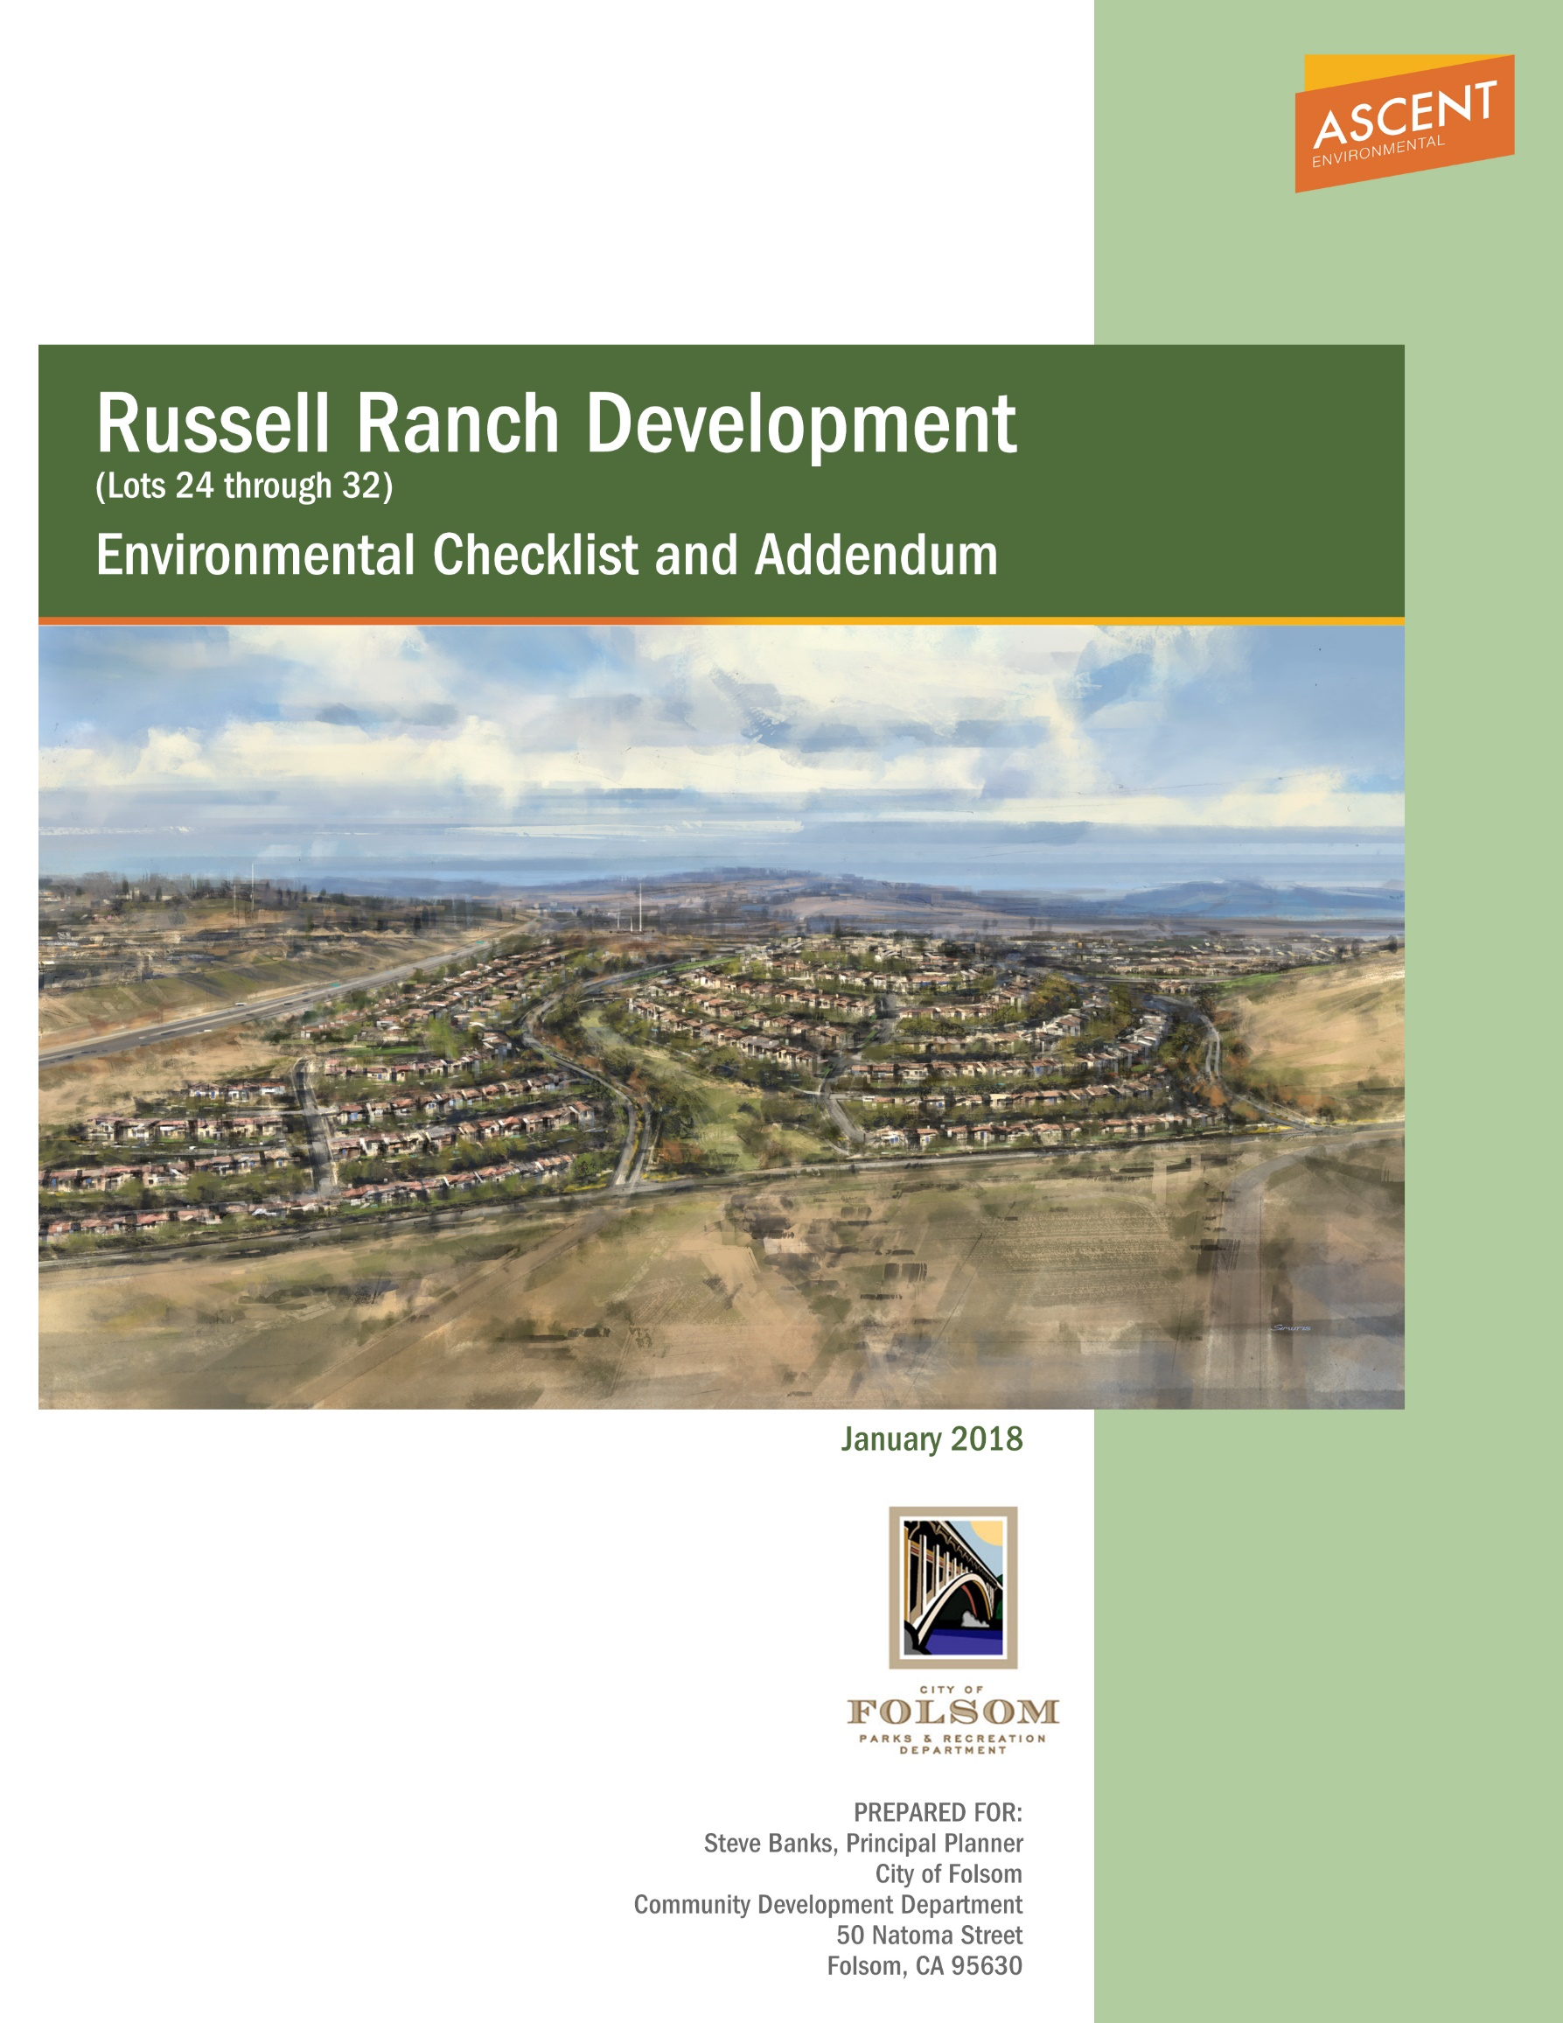

Russell Ranch Development
(Lots 24 through 32)
Environmental Checklist and Addendum

Prepared for:
City of Folsom
50 Natoma Street
Folsom, CA 95630
Contact:
Steve Banks, Principal Planner
(916) 355-7274

PREPARED BY:
Ascent Environmental, Inc.
455 Capitol Mall, Suite 300
Sacramento, CA 95814

Contact:
Amanda Olekszulin
916.444.7301

January 2018

Addendum to the
Russell Ranch Project
Final Environmental Impact Report
for Russell Ranch Lots 24 through 32 Area
January 23, 2018
State Clearinghouse No. 2008092051
BACKGROUND AND ACTION TRIGGERING THE ADDENDUM
This addendum to the Final Environmental Impact Report (Final EIR) for the Lots 24 through 32 Area analyzes the tentative map development in comparison to how this area was analyzed within the Russell Ranch EIR and within the Folsom South of U.S. 50 Specific Plan Project (FPASP) EIR/Environmental Impact Statement (EIS). Specifically, this addendum analyzes an updated tentative map for Lots 24 through 32 of the Russell Ranch Project, with corresponding general plan and specific plan amendments.
As the lead agency under the California Environmental Quality Act (CEQA), the City of Folsom has determined that, in accordance with Section 15164 of the State CEQA Guidelines, the proposed tentative map and other changes differ sufficiently from the development scenario described in the Russell Ranch EIR for the adopted Russell Ranch entitlements to warrant preparation of an addendum.
PREVIOUS ENVIRONMENTAL ANALYSES
The environmental process for the Russell Ranch development (phases 1 -4) involved the preparation of the following documents that are relevant to the consideration of the proposed amendment to FPASP for the Russell Ranch Lots 24 through 32 Area.
- Draft EIR/EIS for the Folsom South of U.S. 50 Specific Plan Project, Volumes I-III and Appendices, June 2010, State Clearinghouse No. 2008092051;
- Final EIR for the Folsom South of U.S. Highway 50 Specific Plan Project, May 2011, State Clearinghouse No. 2008092051;
- CEQA Findings of Fact and Statement of Overriding Considerations for the Folsom South of U.S. Highway 50 Specific Plan Project, May 2011, State Clearinghouse No. 2008092051;
- Initial Study/Mitigated Negative Declaration for the South of Highway 50 Backbone Infrastructure Project (Backbone Infrastructure MND), December 2014, State Clearinghouse No. 2014122018;
- Draft EIR for the Russell Ranch Project, Volumes I-III, December 2014, State Clearinghouse No. 2014062018;
- Final EIR for the Russell Ranch Project, May 2015, State Clearinghouse No. 2014062018; and
- CEQA Findings of Fact and Statement of Overriding Considerations, and a Mitigation Monitoring and Report Program for the Russell Ranch Project, May 2015, State Clearinghouse No. 2014062018.
CALIFORNIA ENVIRONMENTAL QUALITY ACT GUIDELINES REGARDING AN ADDENDUM TO AN ENVIRONMENTAL IMPACT REPORT
Altered conditions, changes, or additions to the description of a project that occur after certification of an EIR may require additional analysis under CEQA. The legal principles that guide decisions regarding whether additional environmental documentation is required are provided in the State CEQA Guidelines, which establish three mechanisms to address these changes: a subsequent environmental impact report (SEIR), a supplement to an EIR, and an addendum to an EIR.
Section 15162 of the State CEQA Guidelines describes the conditions under which a SEIR would be prepared. In summary, when an EIR has been certified for a project, no Subsequent EIR shall be prepared for that project unless the lead agency determines, on the basis of substantial evidence in light of the whole record, one or more of the following:
(1) Substantial changes are proposed in the project which will require major revisions of the previous EIR due to the involvement of new significant environmental effects or a substantial increase in the severity of previously identified effects;
(2) Substantial changes occur with respect to the circumstances under which the project is undertaken which will require major revisions of the previous EIR due to the involvement of new significant environmental effects or a substantial increase in the severity of previously identified significant effects; or
(3) New information of substantial importance, which was not known and could not have been known with the exercise of reasonable diligence at the time the previous EIR was certified as complete, shows any of the following:
(A) The project will have one or more significant effects not discussed in the previous EIR;
(B) Significant effects previously examined will be substantially more severe than shown in the previous EIR;
(C) Mitigation measures or alternatives previously found not to be feasible would in fact be feasible, and would substantially reduce one or more significant effects of the project, but the project proponents decline to adopt the mitigation measures or alternatives; or
(D) Mitigation measures or alternatives which are considerably different from those analyzed in the previous EIR would substantially reduce one or more significant effects on the environment, but the project proponents decline to adopt the mitigation measure or alternative.
Section 15163 of the State CEQA Guidelines states that a lead agency may choose to prepare a supplement to an EIR rather than a Subsequent EIR if:
(1) any of the conditions described above for Section 15162 would require the preparation of a SEIR; and
(2) only minor additions or changes would be necessary to make the previous EIR adequately apply to the project in the changed situation.
An addendum is appropriate where a previously certified EIR has been prepared and some changes or revisions to the project are proposed, or the circumstances surrounding the project have changed, but none of the changes or revisions would result in significant new or substantially more severe environmental impacts, consistent with CEQA Section 21166 and State CEQA Guidelines Sections 15162, 15163, 15164, and 15168.
This addendum is intended to evaluate and confirm CEQA compliance for proposed amendment to the FPASP, which would be a change relative to what is described and evaluated in the Russell Ranch EIR and FPASP EIR/EIS. This addendum is organized as an environmental checklist, and is intended to evaluate all environmental topic areas for any changes in circumstances or the project description, as compared to the approved Final Russell Ranch EIR and Final FPASP EIR/EIS, and determine whether such changes were or were not adequately covered in the certified environmental documents. This checklist is not the traditional CEQA Environmental Checklist, per Appendix G of the CEQA Guidelines. As explained below, the purpose of this checklist is to evaluate the checklist categories in terms of any “changed condition” (i.e., changed circumstances, project changes, or new information of substantial importance) that may result in a different environmental impact significance conclusion from the Russell Ranch EIR or FPASP EIR/EIS. The column titles of the checklist have been modified from the Appendix G presentation to help answer the questions to be addressed pursuant to CEQA Section 21166 and State CEQA Guidelines Section 15162, 15163, 15164 and 15168.

This page intentionally left blank.

TABLE OF CONTENTS
Section Page
Acronyms and Abbreviations ii
1 Introduction and Project History 1-2
1.1 History of the Russell Ranch Entitlements 1-2
1.2 Summary of Prior Environmental Analysis 1-2
2 Project Description 2-2
2.1 Project Overview 2-2
2.2 Project location 2-2
2.3 Existing Setting 2-2
2.4 Project Objectives 2-2
2.5 Summary of Project 2-2
2.6 Required Discretionary Actions 2-2
3 SUPPLEMENTAL ENVIRONMENTAL REVIEW checklist instructions 3-2
3.1 Explanation of Checklist Evaluation Categories 3-2
3.2 Discussion and Mitigation Sections 3-2
4 Environmental Checklist 4-2
4.1 Aesthetics 4-2
4.2 Agriculture and Forest Resources 4-2
4.3 Air Quality 4-2
4.4 Biological Resources 4-2
4.5 Cultural Resources 4-2
4.6 Geology and Soils 4-2
4.7 Greenhouse Gas Emissions 4-2
4.8 Hazards and Hazardous Materials 4-2
4.9 Hydrology and Water Quality 4-2
4.10 Land Use and Planning 4-2
4.11 Mineral Resources 4-2
4.12 Noise 4-2
4.13 Population and Housing 4-2
4.14 Public Services 4-2
4.15 Recreation 4-2
4.16 Transportation/Traffic 4-2
4.17 Utilities and Service Systems 4-2
5 List of Preparers and Persons Consulted 5-2
5.1 List of Preparers 5-2
6 References 6-2

Appendices (to be found on a CD on the back cover)
A Traffic Memo
B Biological Resources Memo
C Cultural Resources
D Noise Mitigations Analysis Memo
E Water Demand Chart
F Water Supply/Demand Table
G Preliminary Stormwater/Drainage Analysis Memo

Exhibits
Exhibit 1-1 Regional Location 1-2
Exhibit 1-2 Project Vicinity 1-2
Exhibit 1-3 Approved Small Lot Vesting Subdivision Map (May 2016) 1-2
Exhibit 2-1 Small Lot Vesting Tentative Subdivision Map 2-2
Exhibit 2-2 General Plan Amendment Land Use Comparison 2-2
Exhibit 2-3 Specific Plan Amendment Land Use Comparison 2-2
Exhibit 2-4 Large Lot Vesting Tentative Subdivision Map 2-2
Exhibit 2-5 Village 5 Small Lot Vesting Tentative Subdivision Map 2-2

Tables
Table 2-1 Adopted FPASP Land Use Summary (Russell Ranch Lots 24 through 32 Area, as amended May 2016) 2-2
Table 2-2 Proposed Russell Ranch Lots 24 through 32 2-2
Table 2-3 Summary of Changes Associated with the Project 2-2
Table 2-4 Entitlements, Approvals and Permits 2-2
Table 4.16-1 Trip Generation Comparison 4-2

Acronyms and Abbreviations
°C | degrees Celsius
AB | Assembly Bill
CAAQS | California Ambient Air Quality Standard
CAFE | corporate average fuel economy
CARB | California Air Resources Board
CEQA | California Environmental Quality Act
EIS | EIR/Environmental Impact Statement
EO | Executive Order
FAPA | First Amended Programmatic Agreement
Final EIR | Final Environmental Impact Report
FPASP | Folsom South of U.S. 50 Specific Plan Project
FPASP | Folsom Plan Area Specific Plan
GPA | General Plan Amendment
HAER | Historic American Engineering Record
lb./day | pounds per day
MMT | million metric tons
mpg | miles per gallon
MPOs | Metropolitan Planning Organizations
MTP | Metropolitan Transportation Plan
NAAQS | National Ambient Air Quality Standards
NHSTA | National Highway Traffic Safety Administration
NOA | naturally occurring asbestos
NPDES | National Pollutant Discharge Elimination System
OAQMP | Operational Air Quality Mitigation Plan
SACOG | Sacramento Area Council of Governments
SANDAG | San Diego Association of Governments
SB | Senate Bill
SCS | Sustainable Communities Strategy
SEIR | subsequent environmental impact report
SHPO | State Historic Preservation Officer
SMAQMD | Sacramento Metropolitan Air Quality Management District
SNF | Sub-Notification Form
SPA | Specific Plan Amendment
tpy | tons per year
USACE | U.S. Army Corps of Engineers

Introduction and Project History

History of the Russell Ranch Entitlements
The Folsom City Council approved project-level entitlements for a portion of the Folsom Plan Area Specific Plan (FPASP) known as the Russell Ranch Project in May 2015. The Russell Ranch Project is located south of U.S. Highway 50 (US 50) within the FPASP area (Exhibit 1-1 and Exhibit 1-2).
After certifying the Russell Ranch Environmental Impact Report (Russell Ranch EIR), and adopting Findings of Fact and Statement of Overriding Considerations for the 437.6-acre project, the City Council approved general and specific plan amendments, vesting large lot and small lot tentative subdivision maps with conditions of approval, an affordable housing agreement and affordable housing plan, planned development permit and design guidelines, conditions of approval, and an amended and restated development agreement. The City Council later approved an amended vesting large lot and small lot tentative subdivision map in June 2016, with amended conditions of approval. The approved land use and zoning changes from the May 2015 amendment resulted in a decrease in single family (SF), the addition of new single family high density (SFHD), decrease in multi-family low density (MLD), elimination of multi-family medium density (MMD), elimination of general commercial (GC), and an increase in parks (P), open space (OS), and public/quasi-public (PQP) from the land uses approved in the FPASP. The June 2016 amendment sought only minor changes to the land use plan and included a transfer of 24 units from the Carr Trust property that was acquired by The New Home Company (applicant) for Russell Ranch. The approved lot configurations and phases for the 2015 and 2016 approved entitlements (approved entitlements) are depicted on Exhibit 1-3.
As noted on Exhibit 1-3, the approved entitlements defined the Russell Ranch Project in four phases. Phases 1 and 2 of the approved entitlements would not be changed by the current application. This application is limited to those lots included within what is identified as Phases 3 and 4 on Exhibit 1-3 (Lots 24 through 32). Although the Russell Ranch EIR evaluated the impacts of lots allocated to Phase 4, the City Council deferred approval of a small-lot tentative subdivision map for this phase pending resolution of right-of-way issues with the Capital SouthEast Connector Joint Powers Authority regarding the alignment of the Capital SouthEast Connector along the southern boundary of Russell Ranch at White Rock Road.
The right-of-way issues have been resolved, and this application includes the anticipated vesting small-lot tentative subdivision map for the lots included within Phase 4. In addition, the applicant has continued to evaluate market conditions and home buyer preferences. Based upon this research, the applicant identified unmet market segments within the Folsom, eastern Sacramento County, and El Dorado Hills markets: (1) future homebuyers that are 55 and older, desiring to live in an age-restricted community (active adult) and (2) first-time and other move-down homebuyers that prefer, or are more likely to qualify for the purchase of single-family homes on higher density lots. To attract the active adult market, move-down, and first-time homebuyer market segment, the applicant seeks to convert SF units within Lots 24 through 32 to smaller lots that are within the SFHD range, and to introduce MLD lots. An updated tentative map for Lots 24 through 32 of the Russell Ranch Project, with corresponding general plan and specific plan amendments, are required to accommodate these changes.

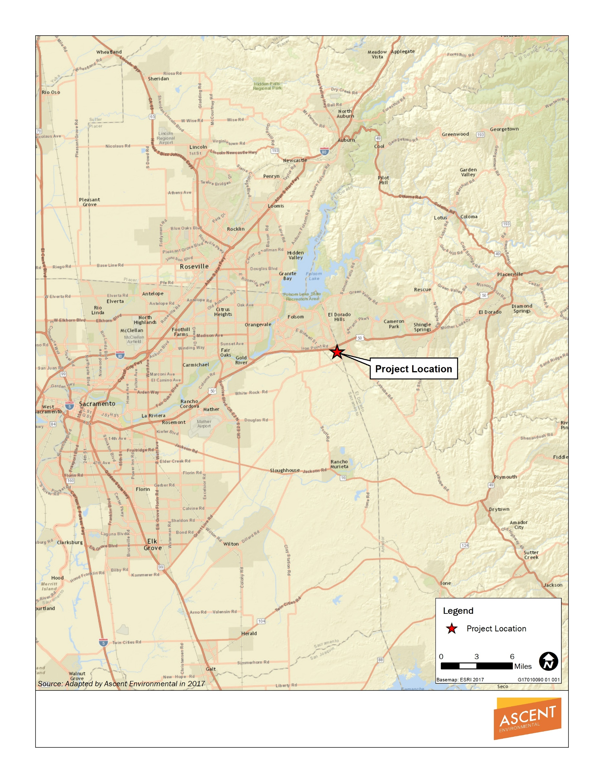

Exhibit 1-1 Regional Location
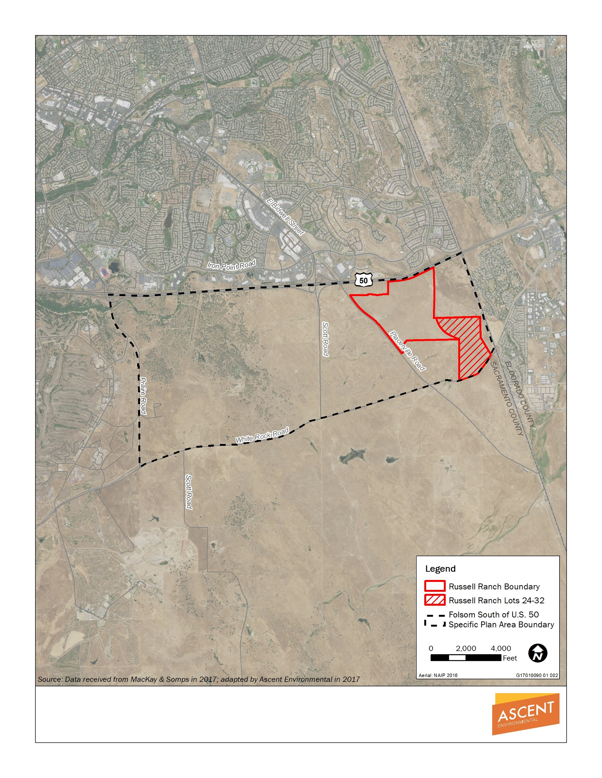

Exhibit 1-2 Project Vicinity

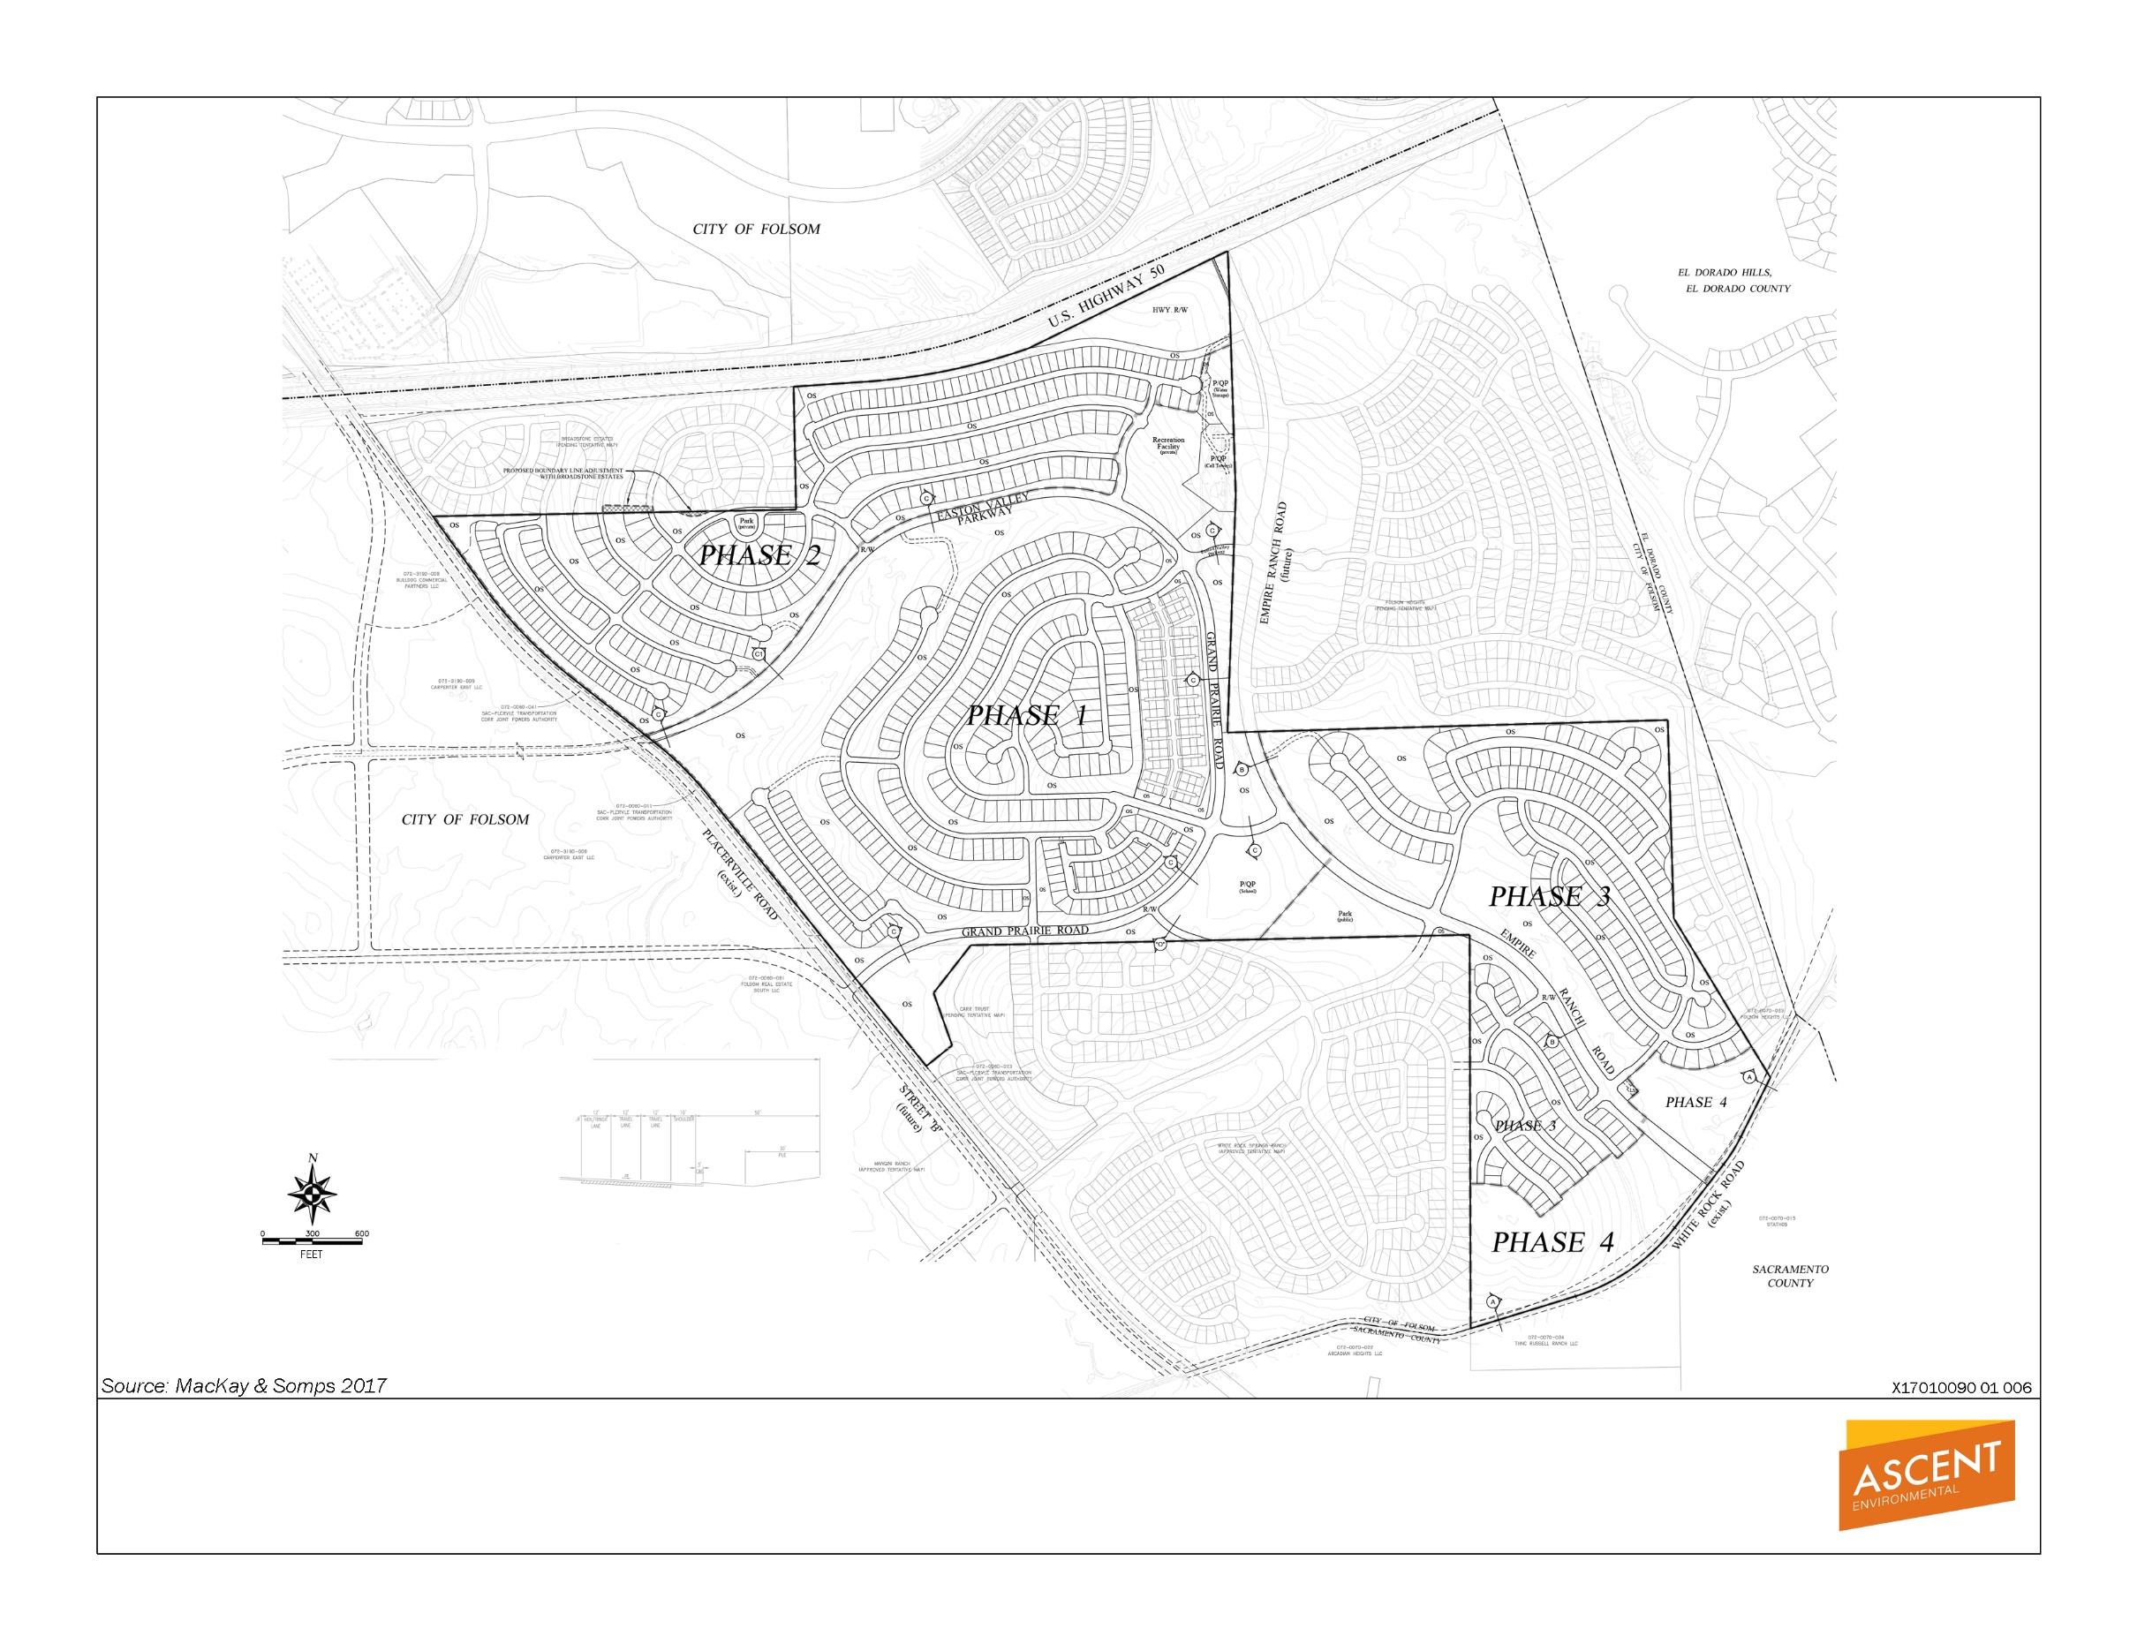

Exhibit 1-3 Approved Small Lot Vesting Subdivision Map (May 2016)

The City is evaluating the project application to determine whether the project would be consistent with the FPASP and approved 2015 and 2016 entitlements and whether and what type of additional environmental review would be required. This analysis considers two previously-certified environmental documents that are applicable to Russell Ranch: (1) the project-level Russell Ranch EIR and (2) program-level Folsom South of U.S. Highway 50 Specific Plan Project EIR/EIS (FPASP EIR/EIS). This environmental checklist has been prepared to evaluate whether: (1) there are substantial changes proposed in the current application that would require major revisions to the previously reviewed and certified Russell Ranch EIR because of the introduction of new significant environmental effects or a substantial increase in the severity of previously identified significant effects; (2) whether circumstances have undergone a substantial change which would require major revisions to the certified Russell Ranch EIR because of the involvement of new significant environmental effects or a substantial increase in the severity of previously identified significant effects, or (3) there is new information of substantial importance (which was not known and could not have been known with the exercise of reasonable diligence at the time the Russell Ranch EIR was certified) showing that new or substantially more severe environmental impacts would occur compared to that evaluated in the Russell Ranch EIR or the FPASP EIR/EIS (CEQA Guidelines Section 15162(a)(1)(3))
The evaluation then considers, under the same standards, whether there are any changes (and related impacts) caused by the project compared to the FPASP EIR/EIS that were not already addressed by the Russell Ranch EIR.
Based on the outcome of this analysis, additional environmental review through the subsequent review provisions of CEQA for changes to previously reviewed and approved projects may be warranted (CEQA Guidelines Sections 15162 through 15164).

Summary of Prior Environmental Analysis
The Russell Ranch Project has received extensive prior environmental review, both through the environmental analysis conducted on the original FPASP and the 2015 project approvals.
The FPASP EIR/EIS (June 2011) included an allocation of 1,119 units to the Russell Ranch Project. The City and the U.S. Army Corps of Engineers (USACE) prepared a joint EIR/EIS for the FPASP that evaluated the environmental impacts associated with development of the entire plan area based on the land use and zoning designations identified in the specific plan. The City was the Lead Agency with respect to preparation of the EIR and USACE was the Lead Agency with respect to preparation of the EIS.
The FPASP EIR/EIS was prepared at the program “first-tier” level of environmental review consistent with the requirements of CEQA Guidelines Sections 15152 and 15168. The program-level analysis considered the broad environmental impacts of the overall specific plan. In addition, the FPASP FEIR/FEIS also included a more detailed analysis of specific topic areas beyond the program level, including: Aesthetics; Cultural Resources; Geology, Soils, Minerals, and Paleontological Resources; Hazards and Hazardous Materials; and Land Use Planning and Agricultural Resources. The FPASP EIR/EIS acknowledged that development of the FPASP area would occur in multiple phases.
In 2015, the City certified the Russell Ranch Project EIR (May 2015). This document included extensive project-level analysis, including aesthetics (emphasizing impacts to the view shed), air quality modeling, biological resources impact assessment, tree survey, cultural resources impact assessment, noise analysis, water usage and availability, and transportation impact analysis. For each topic area, the EIR reviewed the potential impacts associated with the Russell Ranch development and considered whether the existing mitigation that was adopted with the FPASP EIR needed to be updated. In most cases, project-level mitigation was provided but, in some cases, the Russell Ranch EIR incorporated by reference the mitigation from the FPASP EIR. The Russell Ranch EIR (May 2015) evaluated impacts for 879 units, and mitigation measures were included based upon this unit count, which included an allocation of units for what was then identified as Phase 4.
In 2016, the amendments to the vesting large lot and small lot tentative subdivision maps increased the units for the approved entitlements to 903 units. This approval acknowledged the allocation of 51 units to Phase 4.
As noted above, the Approved Entitlements, the impacts of which were evaluated in the Russell Ranch FEIR, included a General Plan Amendment (GPA), Specific Plan Amendment (SPA), Large-Lot and Small-Lot Vesting Tentative Subdivision Maps, planned development permit and design guidelines, conditions of approval, affordable housing plan and amendment to the development agreement.
Table 1-1 shows the number of units approved for Russell Ranch when the FPASP was adopted, and when Russell Ranch was amended in 2015 and 2016. The table also shows the proposed number of units to provide an overview of what was approved previously in comparison to what is requested now.

Table 1-1 Land Use Comparison for Russell Ranch Development (2011 to 2018)
 | Adopted 2011 |  |  | Amended May 2015 |  |  | Amended June 2016 |  |  | Proposed Amendment 2018 |  |  | Change from 2011 to 2018
Land Use | Gross Area (Acres) | Dwelling Units | Projected Population¹ | Gross Area (Acres) | Dwelling Units | Projected Population¹ | Gross Area (Acres) | Dwelling Units | Projected Population¹ | Gross Area (Acres) | Dwelling Units | Projected Population¹ | Gross Area (Acres) | Dwelling Units | Projected Population¹
Residential
Single Family (SF) | 191.5 | 574 | 1,676 | 104.8 | 297 | 867 | 98.5 | 316 | 923 | 64.6 | 224 | 654 | -126.9 | -350 | -1,022
Single Family High Density (SFHD) | 0 | 0 | 0 | 97.5 | 468 | 1367 | 102.4 | 473 | 1381 | 81.7 | 363 | 1060 | 81.7 | 363 | 1,060
Single Family High Density (SFHD) – Private Recreation | 0.0 | 0 | 0 | 0.0 | 0 | 0 | 0 | 0 | 0 | 2.2 | 0 | 0 | 2.2 | 0 | 0
Single Family High Density (SFHD) – Active Adult | 0.0 | 0 | 0 | 0.0 | 0 | 0 | 0 | 0 | 0 | 41.7 | 208 | 416 | 41.7 | 208 | 416
Multi-Family Low Density (MLD) | 17.5 | 163 | 316 | 11.4 | 138 | 268 | 11.4 | 114 | 221 | 23.8 | 232 | 450 | 6.3 | 69 | 134
Multi-Family Medium Density (MMD) | 22.2 | 406 | 788 | 0.0 | 0 | 0 | 0.0 | 0 | 0 | 0.0 | 0 | 0 | -22.2 | -406 | -788
Subtotal Residential | 231.2 | 1,143 | 2,780 | 213.7 | 903 | 2,502 | 212.3 | 903 | 2,525 | 214.0 | 1,027 | 2,580 | -17.2 | 116 | -200
General Commercial (GC) | 59.5 | - | - | 0.0 | - | - | 0.0 | - | - | 0.0 | - | - | -59.5 | - | -
Park (P)- Public | 6.5 | - | - | 5.2 | - | - | 5.2 | - | - | 5.2 | - | - | -1.3 | - | -
Park (P)- Private | 0.0 | - | - | 7.1 | - | - | 7.1 | - | - | 7.1 | - | - | 7.1 | - | -
Open Space (OS)-Slope | 0.0 | - | - | 49.9 | - | - | 57.3 | - | - | 49.9 | - | - | 49.9 | - | -
Open Space (OS)-Measure "W" | 103.2 | - | - | 112.8 | - | - | 106.8 | - | - | 106.8 | - | - | 3.6 | - | -
Public/Quasi-Public (PQP)-Lift Station | 11.8 | - | - | 13.1 | - | - | 13.8 | - | - | 13.8 | - | - | 2.0 | - | -
Major Circulation | 25.4 | - | - | 35.8 | - | - | 35.1 | - | - | 40.8 | - | - | 15.4 | - | -
Total Russell Ranch | 437.6 | 1,143 | 2,780 | 437.6 | 903 | 2,502 | 437.6 | 903 | 2,525 | 437.6 | 1,027 | 2,580 | 0.0 | -116 | -200
Notes: ¹ Population calculated using 2.92 persons per single family unit, 1.94 persons per multi-family unit, and 2.0 persons per age-restricted unit (Abbas Metzker, pers.comm., 2018).
2011 total units includes 1,119 units allocated to Russell Ranch plus 24 allocated Carr Trust units from approved BLA/TDR.
2015 total units includes 828 units mapped Russell Ranch units plus 51 unmapped units Russell Ranch Phase 4 units plus 24 unmapped Carr Trust BLA/TDR units.
2016 total units includes 852 units mapped Russell Ranch units (including 24 Carr Trust BLA/TDR units) plus 51 unmapped units Russell Ranch Phase 4.

This page intentionally left blank.

Project Description

Project Overview
The applicant seeks to (1) obtain approval of a small-lot vesting tentative subdivision map for the prior Phase 4; and (2) an amendment of a portion of the approved small-lot vesting tentative subdivision map for the prior Phase 3. These two phases are now collectively called Lots 24 through 32 on Russell Ranch Large Lot Final Map (PN 16-122), filed on September 21, 2017 in Book 398, Page 1 in the Office of the Sacramento County Recorder (Document No. 201709210431). The currently proposed GPA, SPA, and Large-Lot and Small-Lot Vesting Tentative Subdivision Maps (project) would modify the approved Russell Ranch entitlements approved in 2015 and 2016 by increasing the unit count and density allocations within Lots 24 through 32.

Project location
The Russell Ranch project area is located within the FPASP area within the City of Folsom, south of US 50 and north of White Rock Road, between Prairie City Road and the El Dorado County line (Exhibit 1-1). Lots 24 through 32 of the Russell Ranch project area are located along the southeastern boundary of the FPASP area, south of US 50, immediately west of the Folsom Heights development and east of Placerville Road (Exhibit 1-2).

Existing Setting
The project area is in the process of being developed with backbone infrastructure, including roadways and utilities. It was previously grassland, used for cattle grazing. Developed land north of the project area consists of large residential and commercial developments. The topography of the area consists of gently rolling hills.

Project Objectives
As shown below, project objectives from the Russell Ranch EIR were developed by the applicant and continue to be relevant to Lots 24 through 32, as well as Russell Ranch in general:
- Provide for a mix of private and public land uses, balanced with active and passive recreational and open space that integrates housing with increased public open spaces, enhances the regional recreational trail network, provides for an active public park area as well as a private recreational facility, and provides for an elementary school facility site consistent with the FPASP, and all in an overall design consistent with Folsom design standards and Smart Growth Principles to the extent feasible.
- Create a residential community in an area within the SACOG Blueprint for regional planned growth that provides for a range of lot sizes and home types that will accommodate choices for various age and income demographics within the FPASP area south of US 50.
- Develop a residential hillside community that will allow for lower density development that integrates new homes on the hillside in a manner that blends into the natural surroundings, and preserves and increases natural resource and open space areas.
- Accommodate projected regional growth in a location contemplated by the SACOG Blueprint, and which is adjacent to existing and planned infrastructure, urban services, transportation corridors, and major employment centers within the FPASP south of US 50.
- Place residential uses near existing jobs and services to reduce vehicle miles traveled.
- Create pedestrian-friendly development that promotes and enhances opportunities for non-motorized transportation including bicycling, jogging, and walking via designated bike lanes and/or a pedestrian friendly trail system.
- Design a residential community that promotes social and community connectivity by providing pedestrian linkages within the project site from neighborhood to neighborhood, to active park spaces, through passive open space areas and connection to future planned areas within the FPASP and other areas within the City of Folsom located north of US 50.
The following objectives were added for the current application:
- Obtain approval of a vesting small-lot tentative subdivision map for the prior Phase 4 area, as contemplated by the approved entitlements and provided for in Amendment No. 1 to the First Amended and Restated Development Agreement between the City of Folsom and TNHC Russell Ranch, LLC Relative to the Russell Ranch Project.
- Modify the approved land use plan and densities within the FPASP to allow for active adult and higher density units to meet unmet market demand in the local housing market.

Summary of Project
The project (Lots 24 through 32) is a subset of the overall Russell Ranch development. No changes are proposed to other portions of the Russell Ranch development and those areas will retain the design commitments of single-loaded streets, views, and a range of housing options from court homes to executive style housing.
Lots 24 through 32 are comprised of 135.1 acres. The project would retain the originally-intended residential community character, quality, and design commitments of single-loaded streets on the west side of the future Empire Ranch Road in the SFHD area. The proposed entitlements would also create a new gated active-adult community with an additional private clubhouse on the east side of Empire Ranch Road. The proposed entitlements would be located within the approved development footprint for the Russell Ranch development.

Land Use Summary
As shown in Table 1-1, the 2011 FPASP originally allocated 1,119 units to the Russell Ranch development area, which was the number of units analyzed in the FPASP EIR/EIS. The Russell Ranch Project EIR (May 2015) analyzed impacts for 879 units proposed at that time, a reduction of 240 units. In 2016, changes to the vesting large-lot and small-lot tentative subdivision maps increased the units for Russell Ranch to 903 units (through a density transfer of 24 units from a portion of the Carr Trust property that was acquired by Russell Ranch). The project area comprises 135.1 acres of the 437.6-acre Russell Ranch development area, and is currently planned for 265 units (Table 2-1). The project would increase the unit count by 124 dwelling units within this area; removing 92 SF units and constructing an additional 98 SFHD units and 118 MLD units (Table 2-2).
Table 2-1 Adopted FPASP Land Use Summary of Russell Ranch Lots 24 through 32 Area, as amended May 2016
Land Use | Gross Area (Acres) | % of Site | Density Range (du/ac) | DU | Projected Population¹
Residential
Single Family (SF) | 33.9 | 25.1 | 1 to 4 | 92 | 269
Single Family High Density (SFHD) | 38.2 | 28.3 | 4 to 7 | 173 | 505
Single Family High Density (SFHD) – Private Recreation | 0 | 0 | 4 to 7 | 0 | 0
Single Family High Density (SFHD) – Active Adult | 0 | 0 | 4 to 7 | 0 | 0
Multi-Family Low Density (MLD) | 0.0 | 0 | 7 to 12 | 0 | 0
Subtotal Residential | 72.1 | 53.4 | -- | 265 | 774
Open Space
Open Space-Slope (OS) | 11.3 | 8.4 | -- | -- | --
Open Space-Measure “W” (OS) | 40.9 | 30.3 | -- | -- | --
Circulation and Miscellaneous
Lift Station (PQP) | 0.1 | <0.01 | -- | -- | --
Major Circulation | 10.7 | 7.9 | -- | -- | --
Total Russell Ranch Lots 24 through 32 | 135.1 | 100 | -- | 265 | 774
Notes: ¹ Population calculated using 2.92 persons per single family unit (City of Folsom 2011).
As shown in Table 2-3, the project would result in minor adjustments in acreage between land uses, but would not affect acreages in the project area previously approved for parks, schools, and “Measure W” open space. The proposed entitlements would increase the total unit count by 124 units, for a total of 1,027 units for the overall Russell Ranch development and 389 in the project area. While the unit count is proposed to increase by 124 units, this increase is still below the total original dwelling unit allocation adopted in the FPASP, which allocated 1,143 units to Russell Ranch (including the allocation of 24 units transferred from the Carr property, as explained above). The proposed allocation (1,027 units) is 116 units less than the 1,143 units allocated in 2011 to the Russell Ranch project and the portion of the Carr Trust property added to Russell Ranch by the boundary line adjustment in 2016.
Table 2-2 Proposed Russell Ranch Lots 24 through 32
Land Use | Gross Area (Acres) | % of Site | Density Range (du/ac) | DU | Projected Population¹
Residential
Single Family (SF) | 0.0 | 0.0 | 1 to 4 | 0 | 0
Single Family High Density (SFHD) | 17.5 | 12.8 | 4 to 7 | 63 | 184
Single Family High Density (SFHD)-Private Recreation | 2.2 | 1.6 | -- | -- | --
Single Family High Density (SFHD) – Active Adult | 41.7 | 31.3 | 4 to 7 | 208 | 416
Multi-Family Low Density (MLD) | 12.4 | 8.8 | 7 to 12 | 118 | 229
Subtotal Residential | 73.8 | 54.6 | -- | 389 | 829
Open Space
Open Space-Slope (OS) | 3.9 | 2.9 | -- | -- | --
Open Space-Measure “W” (OS) | 40.9 | 30.3 | -- | -- | --
Circulation and Miscellaneous
Lift Station (PQP) | 0.1 | <0.01 | -- | -- | --
Major Circulation | 16.4 | 12.2 | -- | -- | --
Total Russell Ranch Lots 24 through 32 | 135.1 | 100 | -- | 389 | 829
Notes: ¹ Population calculated using 2.92 persons per single family unit and 1.94 persons per multifamily unit (City of Folsom 2011). Population in age-restricted units was calculated using 2.0 persons (Abbas Metzker, pers.comm., 2018).
Table 2-3 Summary of Changes Associated with Lots 24 through 32
Land Use | Gross Area (Acres) | Dwelling Units | Projected Population (persons)
Single Family (SF) | -33.9 | -92 | -269
Single Family High Density (SFHD) | -20.7 | -110 | -321
Single Family High Density (SFHD)-Private Recreation | 2.2 | 0 | 0
Single Family High Density (SFHD) – Active Adult | 41.7 | 208 | 416
Multi-Family Low Density (MLD) | 12.4 | 118 | 229
Subtotal Residential | 1.7 | 124 | 8
Open Space-Slope (OS) | -7.4 | -- | --
Open Space-Measure “W” (OS) | 0 | -- | --
Lift Station (PQP) | 0 | -- | --
Major Circulation | 5.7 | -- | --
Total Russell Ranch Lots 24 through 32 | 0 | 124 | 55
As shown on Exhibit 2-1, the project site would be developed in five villages. Villages 1, 2, and 4 would be part of an age-restricted active adult community, Village 3 would contain market-rate single-family homes, and Village 5 would contain townhomes. The projected population under the original 2011 FPASP allocation was estimated at 1,067 persons, whereas the population under the approved entitlements was estimated at 774 persons (Table 2-2). The projected population for Russell Ranch if this project is approved would be 829 persons. This is 200 fewer people than under the original 2011 FPASP, and 55 more people than the approved entitlements (Tables 1-1 and 2-3).

Open Space and Recreation
As shown in Table 2-3, and Exhibits 2-2 and 2-3, the proposed entitlements would not result in a change to “Measure W” OS acreage. Consistent with the FPASP, Quimby park dedication requirements are satisfied by parks located throughout the entire FPASP area, with the project contributing its fair share through dedication within the project and an in-lieu fee. Pursuant to the approved entitlements, the applicant would satisfy its total project requirement through dedication of a 5.2-acre park that has been reserved and an in-lieu fee, consistent with FPASP requirements.
As part of the proposed entitlements, the applicant proposes an additional 2.2-acre area (east of Empire Ranch Road) for a private recreation facility that would serve the new active-adult community and a 0.7-acre private park (west of Empire Ranch Road) that would serve the new townhomes within the MLD land use (see Exhibits 2-2 and 2-3). As shown in Table 2-3, the addition of a new private recreation facility and private park results in an increase in private recreation amenities as compared to the Approved Entitlements.

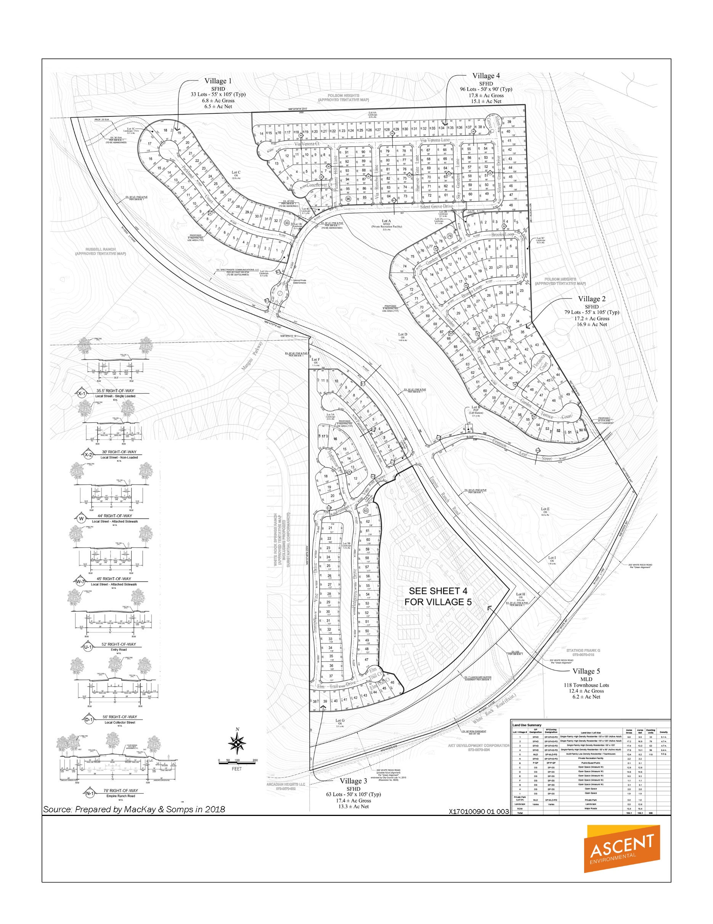

Exhibit 2-1 Small Lot Vesting Tentative Subdivision Map

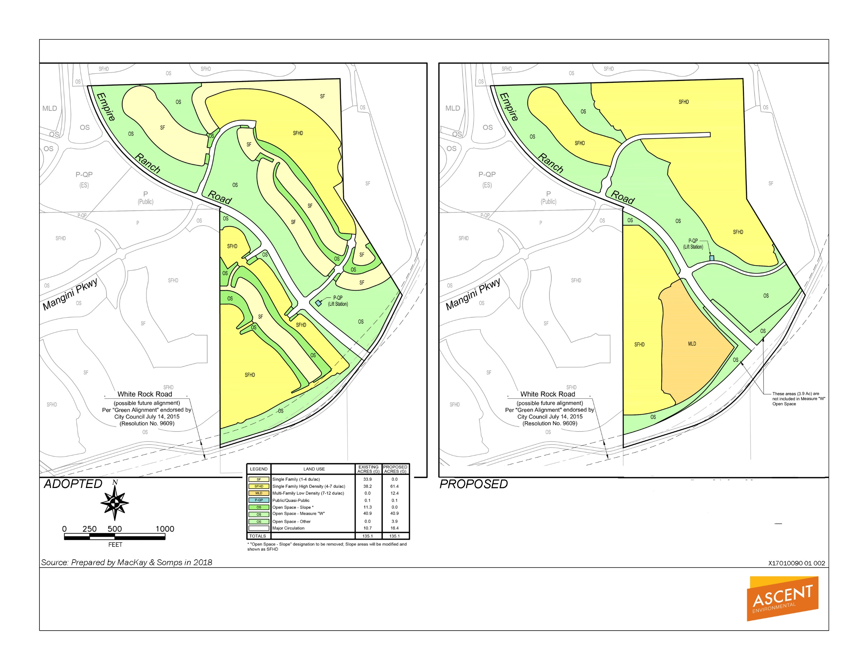

Exhibit 2-2 General Plan Amendment Land Use Comparison
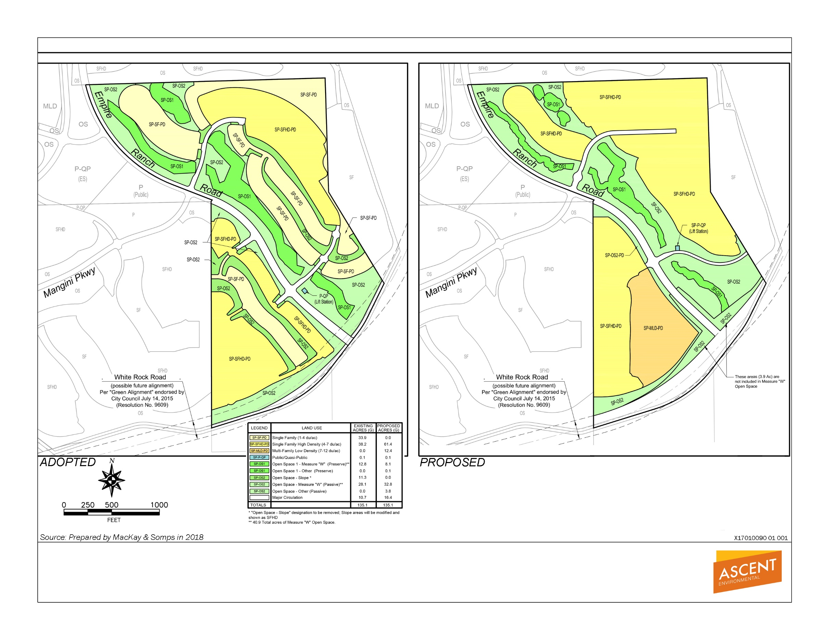

Exhibit 2-3 Specific Plan Amendment Land Use Comparison

Development Agreement
The entire Russell Ranch property is covered by Amendment No. 1 to the First Amended and Restated Development Agreement by and between the City of Folsom and TNHC Russell Ranch LLC Relative to the Russell Ranch Project. The proposed amendment to the Development Agreement related to Lots 24 through 32, only, and would be to incorporate the revised maps and related entitlements within the scope of the Development Agreement, to the extent determined necessary through consultation with the City Attorney and the applicant’s legal counsel.

Required Discretionary Actions
The applicant is requesting entitlements to enable development of an active-adult community east of Empire Ranch Road and accommodate MLD homes west of Empire Ranch Road (Exhibits 2-2 and 2-3). The requested entitlements include:
Large-Lot (Exhibit 2-4) and Small-Lot Vesting Tentative Subdivision Maps (Exhibits 2-1 and 2-5);
General Plan Amendment (Exhibit 2-3);
Specific Plan Amendment (Exhibit 2-4);
Planned Development (PD) Amendment; and
Development Agreement Amendment.

Lead Agency
Table 2-4, below, shows the anticipated entitlements, approvals, and permits needed to develop the project as it moves forward through the entitlement process. It should be noted that if the addendum is approved, no physical development different from that allowed by the approved entitlements would commence until such time the applicant secures all entitlements noted below.
Table 2-4 Entitlements, Approvals and Permits
Entitlement/Approval or Permit Needed | Agency
Large-Lot Vesting Tentative Subdivision Map | Folsom City Council
Small-Lot Vesting Tentative Subdivision Map | Folsom City Council
Development Agreement, Amendment No. 2 | Folsom City Council
Grading Permit | City of Folsom Engineer

Responsible Agencies
In addition to the list of entitlements, approvals, and/or permits identified in Table 2-4 above that must be obtained from the City of Folsom, the following approvals, consultations, and/or permits may be required from other agencies prior to physical development of the site. However, none of the entitlements listed below would be required prior to consideration of this addendum. Where permits have been obtained or progress made, it is noted in specific resources chapters of this document.

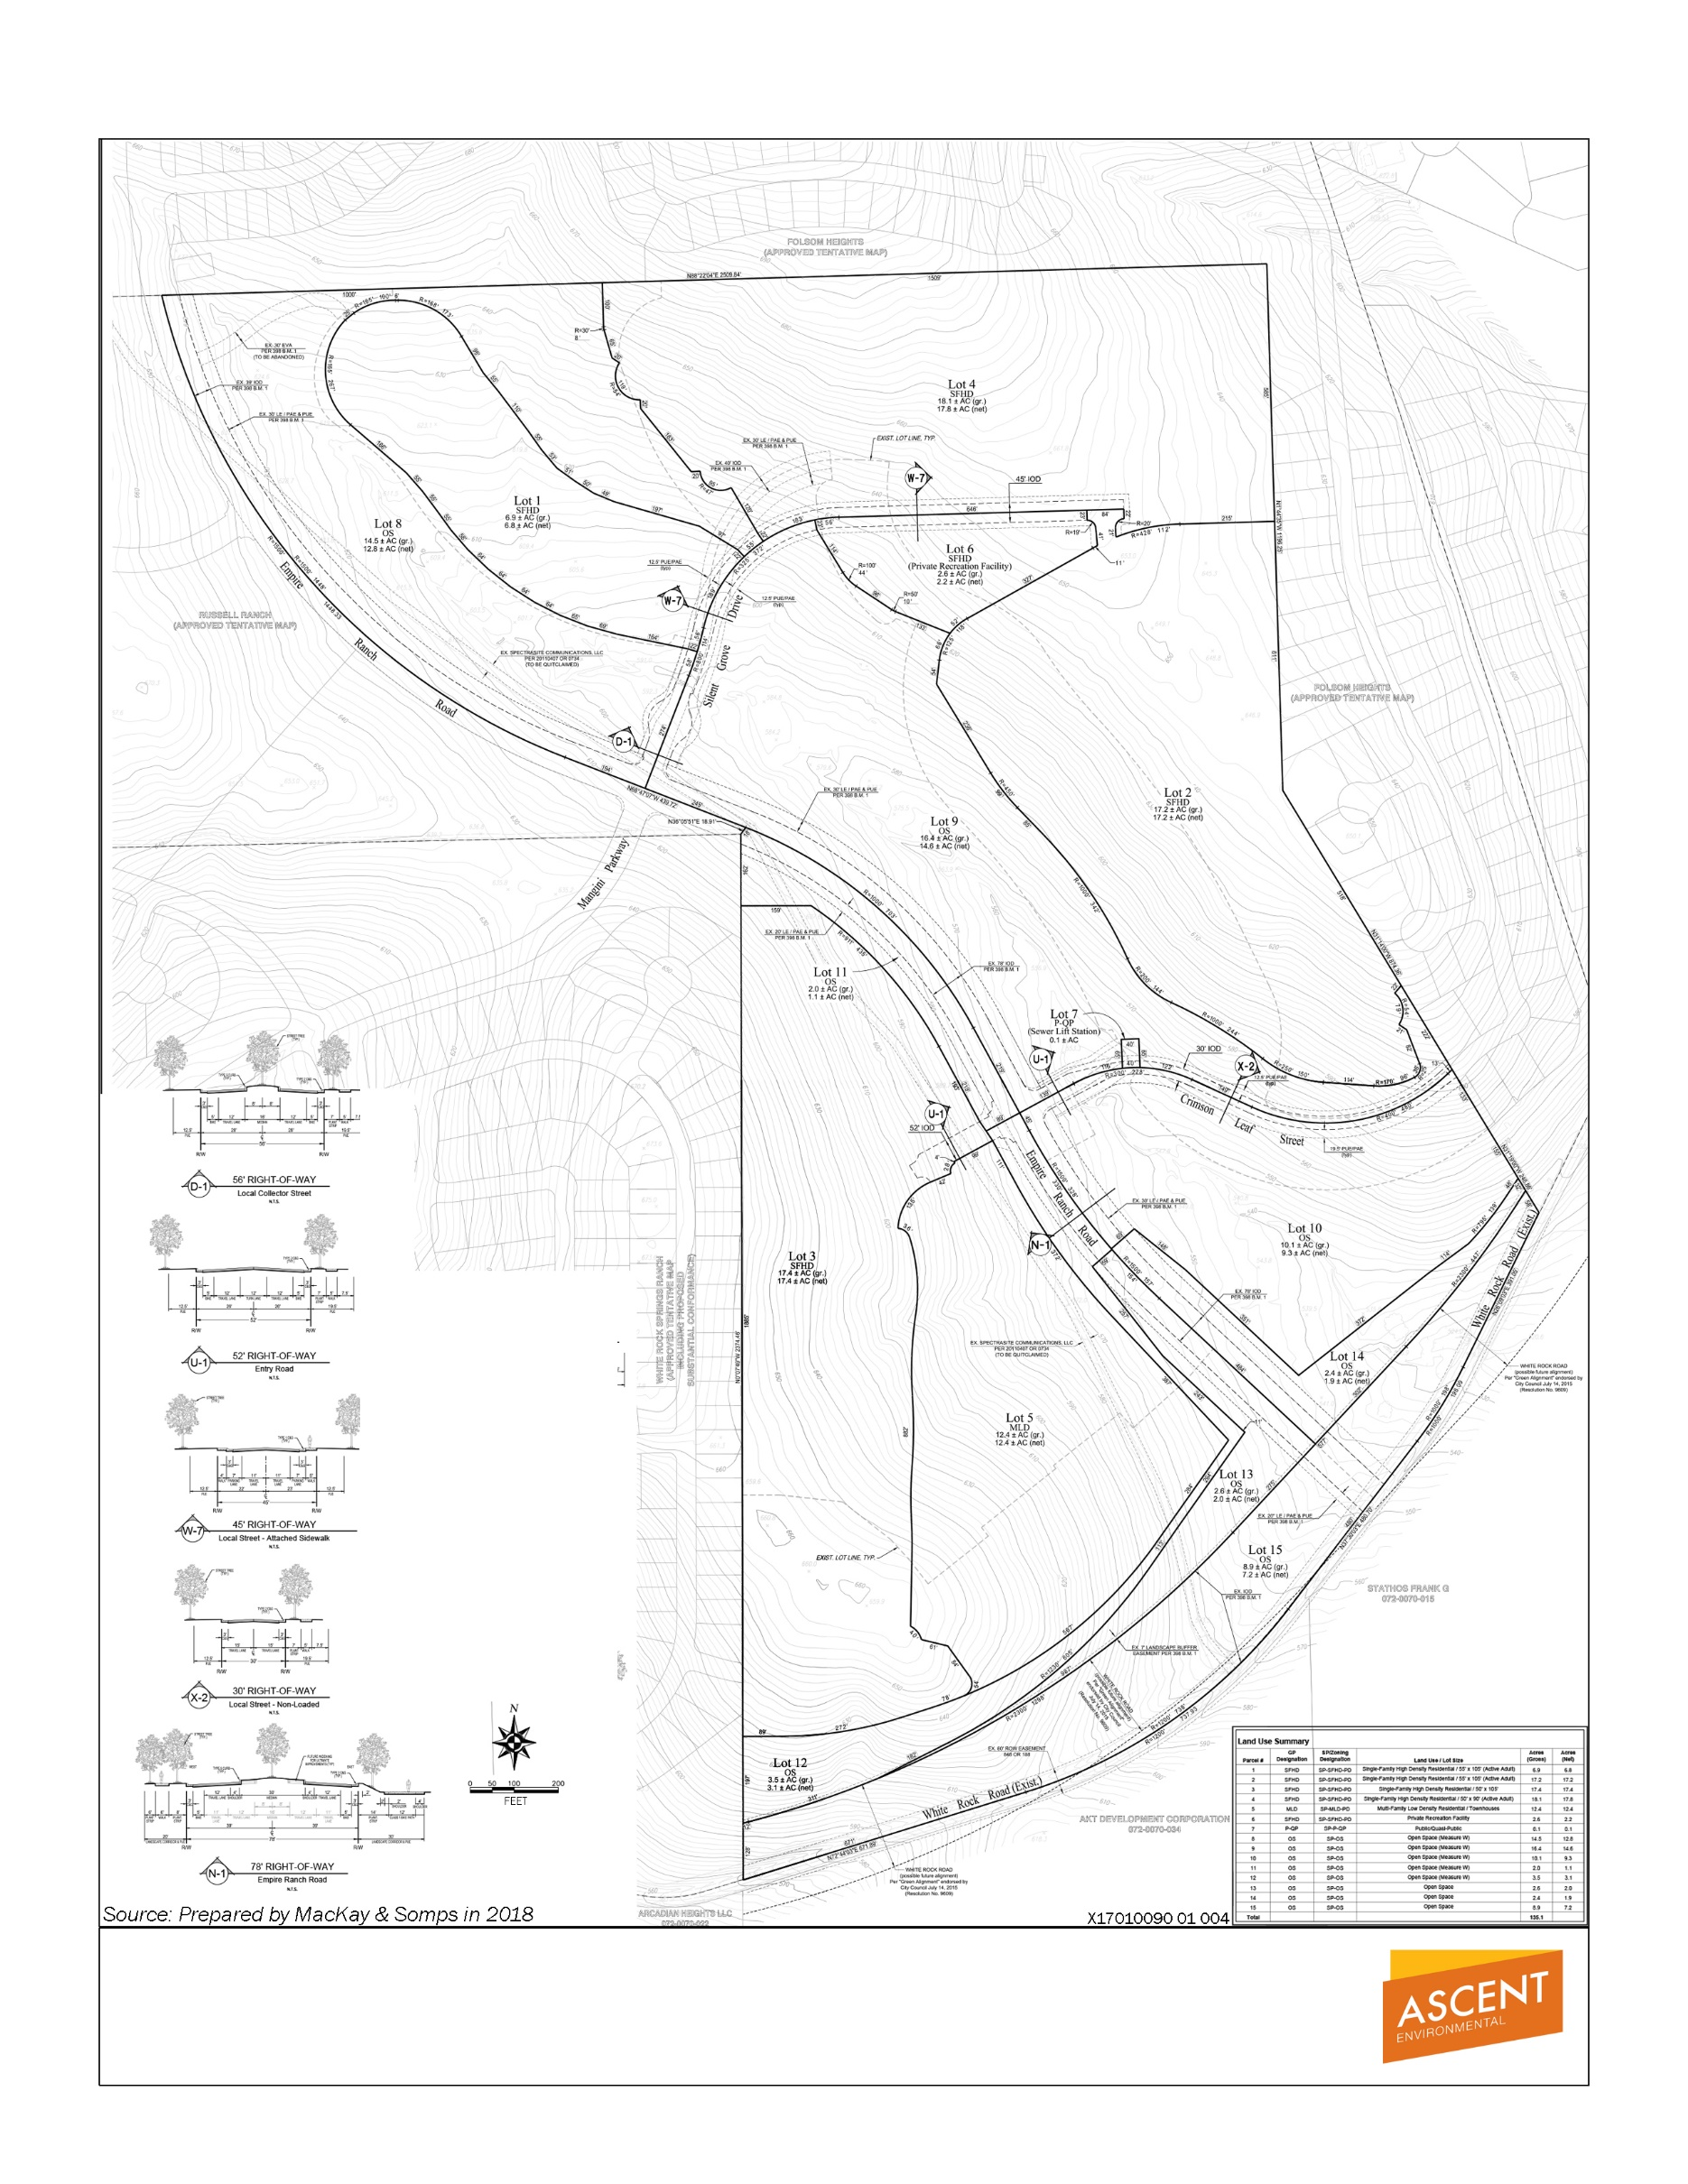

Exhibit 2-4 Large-Lot Vesting Tentative Subdivision Map

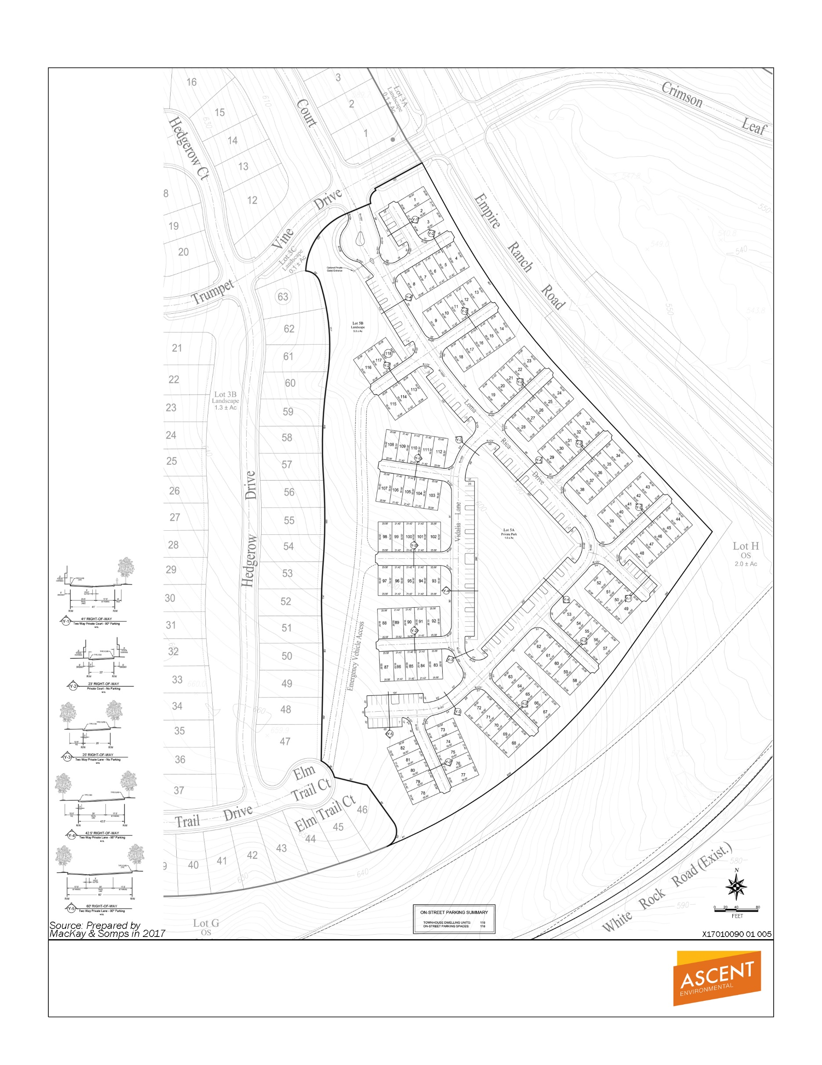

Exhibit 2-5 Village 5 Small-Lot Vesting Tentative Subdivision Map

Federal Actions/Permits
- U.S. Army Corps of Engineers: Department of the Army permit under Section 404 of the Clean Water Act (“CWA”) for discharges of dredge or fill material into waters of the U.S.
- Consultation for impacts on cultural resources pursuant to Section 106 of the National Historic Preservation Act.
- U.S. Environmental Protection Agency: concurrence with Section 404 CWA permit.
- U.S. Fish and Wildlife Service: Consultation and issuance of incidental-take authorization for the take of federally listed endangered and threatened species pursuant to Section 7 of the Endangered Species Act (“ESA”).

STATE ACTIONS/PERMITS
- California Department of Fish and Wildlife, Sacramento Valley—Central Sierra Region: California Endangered Species Act consultation and issuance of take authorization (if needed) (California Fish and Game Code Section 2081), streambed alteration agreement (California Fish and Game Code Section 1602), and protection of raptors (California Fish and Game Code Section 3503.5).
- California Department of Transportation: encroachment permits; approval of landscaping plans and specifications for landscape corridor adjacent to US 50.
- Central Valley Regional Water Quality Control Board (Region 5): National Pollutant Discharge Elimination System (NPDES) construction stormwater permit (Notice of Intent to proceed under General Construction Permit) for disturbance of more than 1 acre; discharge permit for stormwater; general order for dewatering; and Section 401 Clean Water Act (“CWA”) certification or waste discharge requirements; CWA, Section 401 Water Quality Certification; NPDES permit coverage for hydrostatic testing of pipeline (coverage expected under General Order for Low Threat Discharges to Surface Water).
- State Historic Preservation Officer (SHPO): approval of a Programmatic Agreement and/or MOU for Section 106 compliance with the National Historic Preservation Act.
- California Department of Public Health: approval of an amendment to the City’s Public Water System Permit.

REGIONAL AND LOCAL ACTIONS/PERMITS
- Sacramento Metropolitan Air Quality Management District: authority to construct (for devices that emit air pollutants), health risk assessment, and Air Quality Management Plan consistency determination.
- Sacramento County: approval of roadway encroachment permit for pipeline construction, rezoning, use permit, and approval of grading permit.
- City of Folsom: roadway encroachment permit for pipeline construction, tree removal permit (if needed), rezoning, and use permit.

This page intentionally left blank.

SUPPLEMENTAL ENVIRONMENTAL REVIEW
checklist instructions

Explanation of Checklist Evaluation Categories
The purpose of this checklist is to evaluate the categories in terms of any “changed condition” (i.e., changed circumstances, project changes, or new information of substantial importance) that may result in environmental impact significance conclusions different from those found in the Russell Ranch EIR. For the discussion that follows, the FPASP EIR/EIS and the Backbone MND is also referenced as the Russell Ranch EIR because the Russell Ranch EIR incorporated by reference applicable portions of the FPASP EIR/EIS and the Backbone MND. The row titles of the checklist include the full range of environmental topics, as presented in Appendix G of the State CEQA Guidelines. The column titles of the checklist have been modified from the Appendix G presentation to help answer the questions to be addressed pursuant to CEQA Section 21166 and State CEQA Guidelines Section 15162. A “no” answer does not necessarily mean that there are no potential impacts relative to the environmental category, but that there is no change in the condition or status of the impact because it was analyzed and addressed with mitigation measures in the Russell Ranch EIR. For instance, the environmental categories might be answered with a “no” in the checklist because the impacts associated with the project were adequately addressed in the Russell Ranch EIR, and the environmental impact significance conclusions of the Russell Ranch EIR remain applicable. The purpose of each column of the checklist is described below.

Where Topic was Analyzed
This column provides a cross-reference to the pages of the Russell Ranch EIR or FPASP EIR/EIS where information and analysis may be found relative to the environmental issue listed under each topic.

Do Proposed Changes Involve New Significant Impacts?
The significance of the changes proposed to the approved FPASP, as it is described and thereafter amended in the certified Russell Ranch EIR, is indicated in the columns to the right of the environmental issues.

Any new Circumstances Involving New or Substantially More Severe Significant Impacts?
Pursuant to Section 15162(a)(2) of the CEQA Guidelines, this column indicates whether there have been changes to the project site or the vicinity (circumstances under which the project is undertaken) that have occurred subsequent to the prior environmental documents, which would result in the current project having new significant environmental impacts that were not considered in the prior environmental documents or having substantial increases in the severity of previously identified significant impacts.

Any New Information Requiring New Analysis or Verification?
Pursuant to Section 15162(a)(3)(A-D) of the CEQA Guidelines, this column indicates whether new information of substantial importance which was not known and could not have been known with the exercise of reasonable diligence at the time the previous environmental documents were certified as complete is available, requiring an update to the analysis of the previous environmental documents to verify that the environmental conclusions and mitigation measures remain valid. If the new information shows that: (A) the project will have one or more significant effects not discussed in the prior environmental documents; or (B) that significant effects previously examined will be substantially more severe than shown in the prior environmental documents; or (C) that mitigation measures or alternatives previously found not to be feasible would in fact be feasible and would substantially reduce one or more significant effects or the project, but the project proponents decline to adopt the mitigation measure or alternative; or (D) that mitigation measures or alternatives which are considerably different from those analyzed in the prior environmental documents would substantially reduce one or more significant effects on the environment, but the project proponents decline to adopt the mitigation measure or alternative, the question would be answered “yes” requiring the preparation of a subsequent EIR or supplement to the EIR. However, if the additional analysis completed as part of this Environmental Checklist Review finds that the conclusions of the prior environmental documents remain the same and no new significant impacts are identified, or identified significant environmental impacts are not found to be substantially more severe, the question would be answered “no” and no additional EIR documentation (supplement to the EIR or subsequent EIR) would be required.
Notably, where the only basis for preparing a subsequent EIR or a supplement to an EIR is a new significant impact or a substantial increase in the severity of a previously identified impact, the need for the new EIR can be avoided if the project applicant agrees to one or more mitigation measures that can reduce the significant effect(s) at issue to less than significant levels. (See River Valley Preservation Project v. Metropolitan Transit Development Board (1995) 37 Cal.App.4th 154, 168.)

Do Prior Environmental Documents Mitigations Address/Resolve Impacts?
This column indicates whether the prior environmental documents and adopted CEQA Findings provide mitigation measures to address effects in the related impact category. In some cases, the mitigation measures have already been implemented. A “yes” response will be provided in either instance. If “NA” is indicated, this Environmental Checklist Review concludes that there was no impact, or the impact was less-than-significant and, therefore, no mitigation measures are needed.

Discussion and Mitigation Sections

Discussion
A discussion of the elements of the checklist is provided under each environmental category to clarify the answers. The discussion provides information about the particular environmental issue, how the project relates to the issue, and the status of any mitigation that may be required or that has already been implemented.

Mitigation Measures
Applicable mitigation measures from the prior environmental review that would apply to the proposed amendment are listed under each environmental category. New mitigation measures are included, if needed.

Conclusions
A discussion of the conclusion relating to the need for additional environmental documentation is contained in each section.

Acronyms Used in Checklist Tables
Acronyms used in the Environmental Checklist tables and discussions include:
EIR | Environmental Impact Report
EIR/EIS | Environmental Impact Report/Environmental Impact Statement
MM | Mitigation Measure
NA | not applicable
RR | Russell Ranch

This page intentionally left blank.

Environmental Checklist

Aesthetics
Environmental Issue Area | Where Topic Was Analyzed in the RR EIR or FPASP EIR/EIS | Do Any New Circumstances Involve New or Substantially More Severe Significant Impacts? | Any New Information Requiring New Analysis or Verification? | Do Prior Environmental Documents Mitigations Address/Resolve Impacts?
1. Aesthetics. Would the project:
- Have a substantial adverse effect on a scenic vista? | RR EIR Setting 4.1-3 to 4.1-12  Impact 4.1-1  FPASP EIR/EIS Setting pp. 3A.1-2 to 3A.1-22  Impact 3A.1-1 | No | No | Yes, but impact still remains significant and unavoidable
- Substantially damage scenic resources, including but not limited to, trees, rock outcroppings, and historic buildings within a state scenic highway? | RR EIR Setting p. 4.0-2  FPASP EIR/EIS Setting p. 3A.1-26  Impact 3A.1-2 | No | No | Yes
- Substantially degrade the existing visual character or quality of the site and its surroundings? | RR EIR Setting 4.1-1 to 4.1-12  Impact 4.1-1  FPASP EIR/EIS Setting pp. 3A.1-1 to 3A.1-20  Impacts 3A.1-3 and 3A.1-4 | No | No | Yes, but impact still remains significant and unavoidable
- Create a new source of substantial light or glare which would adversely affect day or nighttime views in the area? | RR EIR Setting 4.1-1 to 4.1-12  Impact 4.1-2  FPASP EIR/EIS Setting p. 3A.1-22  Impacts 3A.1-5, 3A.1-6 | No | No | Yes

Discussion
No substantial change in the environmental and regulatory settings as related to aesthetics, described in the Russell Ranch EIR, Chapter 4.1, Aesthetics, has occurred since certification of the Russell Ranch EIR in 2015. While the current application changes the density and types of housing, it does not constitute a change in circumstances regarding aesthetics because the land uses are still proposed within the range of single-family to medium-density housing types.
The project does not introduce any new or unique visual features that were not analyzed in the Russell Ranch EIR, as the project is still proposed for residential use and maximum building height of the homes would remain as previously proposed (i.e., 35-feet maximum building height). No new circumstances or project changes have occurred nor has any new information been found requiring new analysis or verification. The overall land use pattern would be consistent with the approved entitlements for Russell Ranch. The project would use the same development footprint and increase the density from what was analyzed in the Russell Ranch EIR.

Mitigation Measures
The following plan-level mitigation measures were referenced in the FPASP EIR/EIS analysis and incorporated by reference into the Russell Ranch EIR and would continue to remain applicable if the project were approved.
- Mitigation Measure 3A.1-4: Screen construction staging areas.
The following project-specific mitigation measures were included in the Russell Ranch EIR and would continue to remain applicable if the project were approved:
Mitigation Measure 4.1-1. Screening and locating staging and material storage to reduce visual impacts
- Mitigation Measure 4.1-2. Lighting Plan
On May 12, 2015, the City of Folsom, as lead agency, adopted Resolution No. 9564 to certify the Final EIR, adopt Findings of Fact, and adopt a Statement of Overriding Considerations. As stated in the Findings of Fact, the Russell Ranch EIR concluded that, Mitigation Measure 4.1-1 would alleviate the impacts to future residents during construction; however, other feasible mitigation measures are not available to reduce impacts associated with the alteration of a scenic vista or degradation of the existing visual character or quality of the project site from project development to a less-than-significant level. The City Council found that specific economic, legal, social, technological, or other considerations, including provision of employment opportunities for highly trained workers make infeasible additional mitigation measures or project alternatives identified in the Final EIR. Therefore, the impact to visual character would remain significant and unavoidable.
The Russell Ranch EIR concluded that, with Mitigation Measure 4.1-2, impacts to light and glare would be reduced to a less-than-significant level.

CONCLUSION
No new circumstances or project changes have occurred nor has any new information been found requiring new analysis or verification. This project would result in similar patterns of development as the previously approved Russell Ranch entitlements; therefore, the impacts would remain the same as what was analyzed in the Russell Ranch EIR. No additional mitigation measures are available to reduce the significant impacts to visual character and scenic vistas. As stated in the adopted Findings of Fact and Statement of Overriding Considerations (May 2015), the City made findings that no feasible mitigation measures are possible to mitigate impacts associated with the alteration of a scenic vista or degradation of the existing visual character or quality of the project site from project development to a less-than-significant level and found that the benefits of the project outweigh the significant and unavoidable impacts due to economic, social, technological, and environmental benefits—general plan consistency, FPASP consistency, inclusion of smart growth principles, and the creation of tax revenue-creating activities. The conclusions of the Russell Ranch EIR remain valid and approval of the project would not result in new or substantially more severe significant impacts to aesthetics.

Agriculture and Forest Resources
Environmental Issue Area | Where Topic Was Analyzed in the RR EIR or FPASP EIR/EIS | Any New Circumstances Involving New Significant Impacts or Substantially More Severe Impacts? | Any New Information Requiring New Analysis or Verification? | Do Prior Environmental Documents Mitigations Address/Resolve Impacts?
2. Agriculture and Forestry Resources. Would the project:
a. Convert Prime Farmland, Unique Farmland, or Farmland of Statewide Importance (Farmland), as shown on the maps prepared pursuant to the Farmland Mapping and Monitoring Program of the California Resources Agency, to non-agricultural use? | RR EIR Appendix C  No Impact  FPASP EIR/EIS Setting pp. 3A.10-2, 3A.10-5, 3A.10-6  No Impact | No | No | NA
b. Conflict with existing zoning for agricultural use, or a Williamson Act contract? | RR EIR Appendix C  No Impact  FPASP EIR/EIS Setting pp. 3A.10-2 to 3A.10-4, 3A.10-6, 3A.10-7  Impacts 3A.10-3 and 3A.10-4 | No | No | NA
c. Conflict with existing zoning for, or cause rezoning of, forest land (as defined in Public Resources Code section 12220(g)), timberland (as defined by Public Resources Code section 4526), or timberland zoned Timberland Production (as defined by Government Code section 51104(g))? | RR EIR Appendix C  No Impact | No | No | NA
d. Result in the loss of forest land or conversion of forest land to non-forest land? | RR EIR Appendix C  No Impact | No | No | NA
e. Involve other changes in the existing environment which, due to their location or nature, could result in conversion of Farmland, to non-agricultural use or conversion of forest land to non-forest use? | RR EIR Appendix C  No Impact | No | No | NA

Discussion
No substantial change in the environmental and regulatory settings related to Agriculture and Forest Resources, described in the Russell Ranch EIR Appendix C, Section II, Agriculture and Forest Resources, has occurred since certification of the Russell Ranch EIR in 2015. While the current application changes the density of residential land uses, it does not change the development footprint. These changes do not constitute a change in circumstances regarding agriculture and forest resources.
The project would not involve converting Prime Farmland, Unique Farmland, or Farmland of Statewide Importance to a non-agricultural use. The project site is not under a Williamson Act contract and is not designated or zoned for agricultural uses. The site does not contain forest land or timberland. The project would use the same development footprint and increase the density from what was analyzed in the Russell Ranch EIR. The project would not change what was previously analyzed regarding agricultural and forestry resources.

Mitigation Measures
None required.

CONCLUSION
No new circumstances have occurred nor has any new information been found requiring new analysis or verification. Therefore, the conclusions of the certified Russell Ranch EIR remain valid and implementation of the project would not result in any new significant impacts associated with agriculture and forest resources.

Air Quality
Environmental Issue Area | Where Topic Was Analyzed in the RR EIR or FPASP EIR/EIS | Any New Circumstances Involving New Significant Impacts or Substantially More Severe Impacts? | Any New Information Requiring New Analysis or Verification? | Do Prior Environmental Documents’ Mitigations Address/Resolve Impacts?
3. Air Quality. Would the project:
a. Conflict with or obstruct implementation of the applicable air quality plan? | RR EIR Setting pp 4.2-2 to 4.2-33  Impact 4.2-1 and 4.2-2  FPASP EIR/EIS Setting pp. 3A.2-10 to 3A.2-10; Impact 3A.2-1 and Impact 3A.2-2 | No | Yes | Yes, but impact remains significant and unavoidable
b. Violate any air quality standard or contribute substantially to an existing or projected air quality violation? | RR EIR Setting pp 4.2-2 to 4.2-33  Impact 4.2-1 and 4.2-2  FPASP EIR/EIS Setting p. 3A.2-2 to 3A.2-8; Impact 3A.2-1, Impact 3A.2-2, and Impact 3A.2-3 | No | Yes | Yes, but impact remains significant and unavoidable
c. Result in a cumulatively considerable net increase of any criteria pollutant for which the project region is non-attainment under an applicable federal or state ambient air quality standard (including releasing emissions which exceed quantitative thresholds for ozone precursors)? | RR EIR Setting pp 4.2-2 to 4.2-33  Impact 4.2-1 and 4.2-2  FPASP EIR/EIS Cumulative analysis on p. 4-22 to 4-23 | No | Yes | Yes, but impact remains significant and unavoidable
d. Expose sensitive receptors to substantial pollutant concentrations? | RR EIR Setting pp 4.2-2 to 4.2-33  Impact 4.2-3  FPASP EIR/EIS Setting p. 3A.2-7 to 3A.2-10 and 3A.2-20 to 3A.2-23; Impact 3A.2-4; and Cumulative analysis on p. 4-23 to 4-26 | No | Yes | Yes
e. Create objectionable odors affecting a substantial number of people? | RR EIR Setting pp 4.2-2 to 4.2-33  Impact 4.2-4  FPASP EIR/EIS Setting p. 3A.2-9;  Impact 3A.2-6 | No | Yes | Yes

Discussion
No substantial change in the environmental settings related to air quality, described in the Russell Ranch EIR, Chapter 4.2, Air Quality and Climate Change, has occurred since certification of the EIR in 2015. Sacramento County is in nonattainment with respect to the National Ambient Air Quality Standards (NAAQS) and California Ambient Air Quality Standard (CAAQS) for ozone. The County is in nonattainment for the NAAQS for particulate matter with an aerodynamic diameter of 2.5 micrometers or less (PM_{2.5}); and also, nonattainment of the CAAQS for particulate matter with an aerodynamic diameter of 10 micrometers or less (PM₁₀) (Sacramento Metropolitan Air Quality Management District [SMAQMD] 2016). In May 2015, SMAQMD adopted new thresholds of significance for PM_{2.5} and PM₁₀ of 82 pounds per day (lb./day) or 15 tons per year (tpy), and 80 lb./day or 14.6 tpy, respectively (SMAQMD 2015).
The project does not introduce any new air pollution sources or sensitive receptors. The refined land use map and lotting patterns reflect development that is substantially similar to the development assumptions analyzed in the Russell Ranch EIR and FPASP EIR/EIS. The Russell Ranch EIR concluded that air quality impacts would be similar in significance as those analyzed in the FPASP EIR/EIS. Furthermore, the Russell Ranch EIR included a project-specific mitigation measure regarding naturally occurring asbestos (NOA).
During construction of the project, various types of equipment and vehicles would be active on the project site. Construction exhaust emissions would be temporarily generated from use of construction equipment, vegetation clearing and earth movement activities, construction workers’ commutes, and construction hauling for the construction period. These activities would require the use of diesel- and gasoline-powered equipment that would generate emissions of criteria air pollutants and toxic air contaminants (primarily diesel PM).
Operational sources of criteria air pollutants would be generated from mobile and stationary sources. Mobile sources such as residential vehicle use would comprise the majority of mobile source emissions. Emissions would also occur from area sources such as natural gas combustion from heating mechanisms, landscape equipment exhaust, and consumer projects (e.g., refrigerants, cleaning products, architectural coatings).
Construction and operational emissions were modeled in both the Russell Ranch EIR and the FPASP EIR/EIS. As discussed in Appendix A and in Section 4.16, Transportation/Traffic of this document, the project would result in fewer daily trips (7,942) than the approved entitlements (8,269). While construction activities for this portion of the Russell Ranch property may be greater under the project than the approved entitlements because of the increase in housing units, overall development intensity would be similar to that approved in the 2011 FPASP. Additionally, the FPASP EIR/EIS accounted for greater construction emissions impacts than currently proposed. Construction activities would occur over a shorter duration and would generate less emissions as compared to the 2011 FPASP because of the reduced level of ground disturbance associated with fewer units.
Although the project would contribute construction- and operational-related emissions to Sacramento County which could result in the violation of an air quality plan or exceedance of an applicable air quality standard, the impacts associated with operational emissions have decreased with the proposed amendments and the project would continue to be subject to the mitigation measures identified and/or refined in the Russell Ranch EIR due to the overall nonattainment status in Sacramento County. No new or substantially more severe air quality impacts would occur. The mitigation measures and overall conclusions of the FPASP EIR/EIS and Russell Ranch EIR remain valid and no additional analysis is required.

Mitigation Measures
The following plan-level mitigation measures were referenced in the FPASP EIR/EIS analysis and incorporated by reference into the Russell Ranch EIR and would continue to remain applicable if the project were approved.
- Mitigation Measure 3A.2-1a: Implement Measures to Control Air Pollutant Emissions Generated by Construction of On-Site Elements.
- Mitigation Measure 3A.2-1b: Pay Off-site Mitigation Fee to SMAQMD to Off-Set NO_{X} Emissions Generated by Construction of On-Site Elements.
- Mitigation Measure 3A.2-1d: Implement SMAQMD’s Basic Construction Emission Control Practices during Construction of all Off- site Elements located in Sacramento County.
- Mitigation Measure 3A.2-1f: Implement SMAQMD’s Enhanced Exhaust Control Practices during Construction of all Off-site Elements.
- Mitigation Measure 3A.2-1g: Pay Off-site Mitigation Fee to SMAQMD to Off-Set NO_{X} Emissions Generated by Construction of Off-site Elements.
- Mitigation Measure 3A.2-1h: Analyze and Disclose Projected PM₁₀ Emission Concentrations at Nearby Sensitive Receptors Resulting from Construction of Off-site Elements.
- Mitigation Measure 3A.2-2: Implement All Measures Prescribed by the Air Quality Mitigation Plan to Reduce Operational Air Pollutant Emissions.
The following project-specific mitigation measures were referenced in the Russell Ranch EIR and would continue to remain applicable if the project were approved:
- Mitigation Measure 4.2-3: Conduct a field survey of the project site to demonstrate that NOA does not exist on the project site to the satisfaction of SMAQMD. In the case that NOA is found, all soil containing NOA, replace all contaminated areas with clean soils or materials.
The Russell Ranch EIR included a project-level mitigation measure to conduct a field survey for the presence of NOA on the project site that would reduce potential exposure of sensitive receptors to NOA to a less-than-significant level. As stated in the Findings of Fact (May 2015), Mitigation Measure 3A.2-2 would reduce operational emissions; however, significant and unavoidable impacts would remain. Additional feasible mitigation is not available to reduce the project’s emissions to below the applicable thresholds of significance. Therefore, the impact would remain significant and unavoidable. This conclusion would not change with implementation of the project.

CONCLUSION
As required by many of the air quality mitigation measures adopted as part of the FPASP, the Russell Ranch EIR provided additional project-level air quality analysis. Notably, the air quality impacts in the proposed project are less than anticipated with the approved entitlements. Even with this reduction in impacts, feasible mitigation measures in addition to what is required per the FPASP EIR/EIS/Russell Ranch EIR and the FPASP OAQMP do not exist sufficient to reduce the project’s emissions to below the applicable thresholds of significance such that a less-than-significant impact would occur. No new circumstances have occurred nor has any new information been found requiring new analysis or verification. As stated in the Statement of Overriding Considerations (May 2015), the City found that the benefits of the project outweigh the significant and unavoidable impacts due to economic, social, technological, and environmental benefits—general plan consistency, FPASP consistency, inclusion of smart growth principles, and the creation of tax revenue-creating activities. The conclusions of the Russell Ranch EIR remain valid and approval of the project would not result in new or substantially more severe significant impacts to aesthetics. The conclusions of the FPASP EIR/EIS and Russell Ranch EIR remain valid and no additional analysis is required.

Biological Resources
Environmental Issue Area | Where Topic Was Analyzed in the RR EIR or FPASP EIR/EIS | Any New Circumstances Involving New Significant Impacts or Substantially More Severe Impacts? | Any New Information Requiring New Analysis or Verification? | Do Prior Environmental Documents Mitigations Address/Resolve Impacts?
4. Biological Resources. Would the project:
a. Have a substantial adverse effect, either directly or through habitat modifications, on any species identified as a candidate, sensitive, or special status species in local or regional plans, policies, or regulations, or by the California Department of Fish and Wildlife or U.S. Fish and Wildlife Service? | RR EIR Setting 4.3-1 to 4.3-18  Impacts 4.3-1 to 4.3-10  FPASP EIR/EIS Setting pp. 3A.3-7 to 3A.3-21  Impacts 3A.3-2 and 3A.3-3 | No | No | Yes, and mitigation has been updated
b. Have a substantial adverse effect on any riparian habitat or other sensitive natural community identified in local or regional plans, policies, and regulations or by the California Department of Fish and Game or US Fish and Wildlife Service? | RR EIR Setting 4.3-1 to 4.3-18  Impact 4.3-11  FPASP EIR/EIS Setting pp. 3A.3-21 to 3A.3-26  Impact 3A.3-4 | No | No | Yes
c. Have a substantial adverse effect on federally protected wetlands as defined by Section 404 of the Clean Water Act (including, but not limited to, marsh, vernal pool, coastal, etc.) through direct removal, filling, hydrological interruption, or other means? | RR EIR Setting 4.3-1 to 4.3-18  Impact 4.3-11  FPASP EIR/EIS Setting pp. 3A.3-5 to 3A.3-7, 3A.3-18 to 3A.3-21  Impact 3A.3-1 | No | No | Yes
d. Interfere substantially with the movement of any native resident or migratory fish and wildlife species or with established native resident or migratory wildlife corridors, or impede the use of native wildlife nursery sites? | RR EIR Setting 4.3-1 to 4.3-18  Impact 4.3-12  FPASP EIR/EIS Setting p. 3A.3-7  Impact 3A.3-6 | No | No | Yes
e. Conflict with any local policies or ordinances protecting biological resources, such as a tree preservation policy or ordinance. | RR EIR Setting 4.0-2  Impact 4.3-13 and 4.3-14  FPASP EIR/EIS Setting pp. 3A.3-23 to 3A.3-26  Impact 3A.3-5 | No | No | Yes
f. Conflict with the provisions of an adopted Habitat Conservation Plan, Natural Community Conservation Plan, or other approved local, regional, or state habitat conservation plan? | RR EIR Setting 4.0-2  No Impact  FPASP Impact 3A.3-7 | No | No | NA
g. Have the potential to cause a commercial and/or recreational fishery to drop below self-sustaining levels? | FPASP EIR/EIS Setting p. 3A.3-17  No Impact | No | No | NA

Discussion
A November 2017 study by ECORP included a review of the project’s potential impacts on biological resources in comparison to the approved entitlements (ECORP 2017a [Appendix B]). This assessment was completed in accordance with the requirements in the First Amended Programmatic Agreement (FAPA), which includes guidance on how the project is to comply with all applicable state and federal requirements that were in place at the time of its execution. The FAPA provides the framework for compliance and requires that each individual project (including this project), must comply with specific terms that include, but are not limited to the following:
- Development of a project-specific Area of Potential Effect (“APE”),
- Good-faith identification efforts including wetland delineations, threatened and endangered species surveys, and rare plant surveys, and
- Mitigation for any impacts to such resources.
As an applicant for a permit within the FPASP, The New Home Company must meet the requirements outlined in the FPASP EIR/EIS specific to the project. The steps taken to identify biological resources are outlined in the FAPA. These steps include wetland delineations, threatened and endangered species surveys, and rare plant surveys. ECORP reviewed special-status species to ensure no additions have been made to the list of species located within the project site. Throughout development of the FPASP, including Russell Ranch, more specific plans and additional construction details have been developed and implemented, resulting in minor changes to project boundaries. ECORP cross-referenced the changed areas of impacts for Russell Ranch to the original permits authorizing work in those areas to ensure no additional impacts would occur, or that additional impacts would be properly approved and mitigated through USACE permit modification. Total impacts within Russell Ranch do not exceed the total impacts authorized by the Russell Ranch EIR (ECORP 2017a).
Permits have already been obtained from the USACE as part of the mitigation implementation of the Russell Ranch EIR. With the slight changes associated with this project, a permit compliance letter will be submitted to USACE for approval of these acreage changes to the CWA Section 404 individual permit and the Regional Water Quality Control Board 401 certification. A 1602 Sub-Notification Form (SNF) will be submitted under the existing Master Streambed Alteration Agreement with the CDFW for approval.
No new or substantially more severe biological impacts would occur. Similar to what was discussed in the Russell Ranch EIR, the project could have a significant impact on biological resources; however, the project would continue to be subject to the mitigation measures identified and/or refined in the Russell Ranch EIR and the ECORP analysis, which are presented below. As described in the Russell Ranch EIR, with implementation of these measures, biological impacts would be reduced to a less-than-significant level. Therefore, the conclusions of the Russell Ranch EIR remain valid and approval of the project would not result in new or substantially more severe significant impacts to biological resources.

Mitigation Measures
The following project-level mitigation measures were referenced in the Russell Ranch EIR analysis and would continue to remain applicable if the project were approved.
Mitigation Measure 4.3-1: Federally-listed vernal pool invertebrates.
Mitigation Measure 4.3-3(a) Conduct environmental awareness training for construction employees.
Mitigation Measure 4.3-3(b): Conduct Preconstruction Western Spadefoot Toad Survey.
Mitigation Measure 4.3-4 Northwestern Pond Turtle.
Mitigation Measure 4.3-5(a): Conduct preconstruction Swainson’s hawk and other raptor surveys.
Mitigation Measure 4.3-5(b): Prepare and implement Swainson’s hawk mitigation plan.
Mitigation Measure 4.3-6(a & b): Conduct preconstruction burrowing owl survey.
Mitigation Measure 4.3-7: Conduct a preconstruction tricolored blackbird survey.
Mitigation Measure 4.3-8(a & b): Preconstruction nesting bird survey.
Mitigation Measure 4.3-10: Conduct preconstruction American badger burrow survey.
Mitigation Measure 4.3-11(a) Clean Water Act Sections 401 and 404.
Mitigation Measure 4.3-11(b) Master Streambed Alteration Agreement.
- Mitigation Measure 4.3-11(c) Valley Needlegrass.
The following mitigation measure is updated for this project:
- Mitigation Measure 4.3-1: Special-status plant species. Prior to initiation of construction activities, a qualified biologist/botanist shall consult with the appropriate regulatory agencies (CDFW and USFWS) to determine if additional plant surveys are required. If additional surveys are required, protocol-level preconstruction special-status plant surveys will be conducted for all potentially occurring species in areas that have not previously been surveyed. If special-status plant populations are found, the Project Applicant shall consult with CDFW and USFWS, as appropriate, to determine appropriate mitigation measures. If impacts are likely, a mitigation and monitoring plan shall be developed before approval of grading plans or ground-breaking activity within 250 feet of special-status plant populations.
Upon approval of final proposed development plans by the USACE, a qualified biologist/botanist will consult with CDFW and USFWS to determine if additional surveys are required.
As described in the Russell Ranch EIR, with implementation of these measures, biological resources impacts would be reduced to a less-than-significant level.

CONCLUSION
Recent verification shows that there are no new or substantially more severe impacts to biological resources related to implementation of the project. Therefore, the findings of the Russell Ranch EIR remain valid and no further analysis is required.

Cultural Resources
Environmental Issue Area | Where Topic Was Analyzed in the RR EIR or FPASP EIR/EIS | Any New Circumstances Involving New Significant Impacts or Substantially More Severe Impacts? | Any New Information Requiring New Analysis or Verification? | Do Prior Environmental Documents Mitigations Address/Resolve Impacts?
5. Cultural Resources. Would the project:
a. Cause a substantial adverse change in the significance of a historical resource as defined in §15064.5? | RR EIR Setting 4.4-1 to4.4-5  Impact 4.4-1  FPASP EIR/EIS Setting pp. 3A.5-2 to 3B.5-5  Impact 3A.5-1 | No | No | Yes, and mitigation has been updated
b. Cause a substantial adverse change in the significance of an archaeological resource pursuant to §15064.5? | RR EIR Setting 4.4-1 to 4.4-5  Impact 4.4-2  FPASP EIR/EIS Setting pp. 3A.5-1 to 3B.5-3  Impacts 3A.5-1 and 3A.5-2 | No | No | Yes, and mitigation has been updated
c. Directly or indirectly destroy a unique paleontological resource or site or unique geologic feature? | RR EIR Setting 4.4-5  Impact 4.4-3  FPASP EIR/EIS Setting pp. 3A.7-13 to 3A.7-17  Impact 3A.7-10 | No | No | Yes
d. Disturb any human remains, including those interred outside the formal cemeteries? | FPASP EIR/EIS Setting p. 3A.5-13 to 3A.5-15  Impact 3A.5-3 | No | No | Yes, and mitigation has been updated
- Would the project cause a substantial adverse change in the significance of a tribal cultural resource, defined in Public Resources Code section 21074 as either a site, feature, place, cultural landscape that is geographically defined in terms of the size and scope of the landscape, sacred place, or object with cultural value to a California Native American tribe? | RR EIR Setting 4.4-2 to 4.4-5  No Impact  FPASP EIR/EIS Setting pp. 3A.5-1 to 3A.5-2; pp 3A.5-8 to 3A.5-16  Impacts 3A.5-1, 3A.5-2, and 3A.5-3 | No | No | Yes

Discussion
No substantial change in the environmental and regulatory settings related to cultural resources has occurred since the Russell Ranch EIR. Further, the cultural setting was reviewed and updated as part of the Russell Ranch EIR, including addressing impacts to Tribal Cultural Resources, and it has not changed since that time. On September 14, 2017, ECORP published a memo documenting the cultural and tribal cultural resources for the entire Russell Ranch project area, inclusive of Lots 24 through 32. There are no changes to the cultural or tribal cultural resources.
Because the applicant is seeking a specific plan amendment to the FPASP, the City is required to initiate consultation with California Native American tribes under Senate Bill (SB) 18 (Burton, Chapter 905, Statutes of 2004). On August 18, 2017, the City requested a SB 18 contact list from the California NAHC. The NAHC responded with a list on August 31, 2017, and letters to each contact were mailed by the City on September 7, 2017. Consultation was carried out in accordance with the Tribal Consultation Guidelines: Supplement to General Plan Guidelines (November 14, 2005) published by the Governor’s Office of Planning and Research. The consultation record for SB 18 tribal consultation will be provided under separate cover.
While the current application includes higher densities and additional housing units than what was evaluated in the Russell Ranch EIR, no additional land area would be developed as a result of the project. The Russell Ranch Project was previously found to have a significant impact on historical resources, as defined by CEQA. As described further below, however, all pre-construction mitigation measures, as required by the applicable Historic Property Treatment Plans (HPTPs), have been completed to the satisfaction of the USACE, in consultation with SHPO, the City, and the other parties to the FAPA. Compliance with the construction-related mitigation measures specified in the FPASP EIR/EIS and FAPA will further reduce that level to a less-than-significant level.
Nothing about the proposed changes would alter the cultural resources conclusions of the Russell Ranch EIR. No new or substantially more severe cultural resources impacts would occur. The project would continue to be subject to the mitigation measures identified and/or refined in the Russell Ranch EIR, which are presented below.

Mitigation Measures
The measures required to mitigate for significant impacts to historical resources are twofold. First, as part of the FPASP, the Russell Ranch development is subject to compliance with four mitigation measures in the FPASP EIR/EIS, from which the Russell Ranch EIR incorporates by reference. Second, the project is also subject to compliance with the treatment measures to resolve adverse effect to historic properties, as specified in the respective HPTPs that were prepared under the FAPA, which was required by the FPASP EIR/EIS and Russell Ranch EIR. A reconciliation of these requirements and a list of amended mitigation measures for the project are provided below.
- Mitigation Measure 4.4-1: Comply with the First Amended Programmatic Agreement and Carry Out mitigation.
The FAPA provides a management framework for identifying historic properties and Historical Resources through inventories and evaluations, determining adverse effects, and resolving those adverse effects with appropriate mitigation. Proof of compliance with the applicable procedures in the FAPA and implementation of applicable HPTP (Westwood and Knapp 2013b and 2013c) with regard to mitigation for the Keefe-McDerby Mine Ditch and Brooks Hotel Site is to be provided to the City’s Community Development Department prior to authorization of any ground-disturbing activities. Proof of compliance is defined as written approval from the USACE of all applicable mitigation documentation generated from implementation of an approved HPTP and includes the following mitigation actions:
- Historic American Engineering Record (HAER) Documentation of the Keefe-McDerby Mine Ditch (P-34-1475): in consultation with the National Park Service, the USACE shall require the completion of Historic American Engineering Record program documentation.
- Data Recovery Excavations of the Brooks Hotel Site (P-34-2166): Data recovery shall follow the standards and guidelines in the HPTP. The results of excavation, laboratory analysis, artifact analysis, and archival research, shall be documented in a confidential data recovery technical report, which shall be submitted to the City’s Community Development Department.
- Geoarchaeological Monitoring: Due to a potential for deeply buried archaeological resources down to a depth of 1.5m (approximately five feet) below soil formations known as the T-2 terrace, where colluvial deposits grade onto the T-2 terrace, and along the distal edge of tributary alluvial fans, all ground-disturbing activity in those areas shall be monitored by a qualified professional archaeologist with a specialization in geoarchaeology. Monitoring is no longer needed once subsurface disturbance extends beyond 1.5m below surface.
- Mitigation Measure 4.4-2(a): Conduct construction worker awareness training, on-site monitoring if required, stop work if cultural resources are discovered, asses the significance of the find, and perform treatment or avoidance as required.
To reduce potential impacts to previously undiscovered cultural resources, the Project applicant(s) shall retain a qualified archaeologist to conduct training for construction supervisors. Construction supervisors shall inform the workers about the possibility of encountering buried cultural resources and inform the workers of the proper procedures should cultural resources be encountered. Proof of the contractor awareness training shall be submitted to the City’s Community Development Department in the form of a copy of training materials and the completed training attendance roster.
Should any cultural resources, such as structural features, bone or shell, artifacts, or architectural remains be encountered during any construction activities, work shall be suspended within 200 feet of the find and the City of Folsom and USACE shall be notified immediately. The City shall retain a qualified archaeologist who shall conduct a field investigation of the specific site and shall evaluate the significance of the find by evaluating the resource for eligibility for listing on the CRHR and the NRHP. If the resource is eligible for listing on the CRHR or NRHP and would be subject to disturbance or destruction, the actions required by the FAPA and subsequent documentation shall be implemented. The City of Folsom Community Development Department and USACE shall be responsible for approval of recommended mitigation if it is determined to be feasible in light of the approved land uses, and shall implement the approved mitigation and seek written approval on mitigation documentation before resuming construction activities at the archaeological site.
- Mitigation Measure 4.4-2(b): Suspend ground-disturbing activities if human remains are encountered and comply with California Health and Safety Code procedures.
In the event that human remains are discovered, construction activities within 150 feet of the discovery shall be halted or diverted and the requirements for managing unanticipated discoveries in Mitigation Measure 3A.5-3 shall be implemented. In addition, the provisions of § 7050.5 of the California Health and Safety Code, § 5097.98 of the California PRC, and Assembly Bill (AB) 2641 shall be implemented. When human remains are discovered, state law requires that the discovery be reported to the County Coroner (§ 7050.5 of the Health and Safety Code) and that reasonable protection measures be taken during construction to protect the discovery from disturbance (AB 2641). If the Coroner determines the remains are Native American, the Coroner shall notify the NAHC, which then designates a Native American Most Likely Descendant (MLD) for the Project (§ 5097.98 of the PRC). The designated MLD then has 48 hours from the time access to the property is granted to make recommendations concerning treatment of the remains (AB 2641). If the landowner does not agree with the recommendations of the MLD, the NAHC can mediate (§ 5097.94 of the PRC). If no agreement is reached, the landowner must rebury the remains where they will not be further disturbed (§ 5097.98 of the PRC). This will also include either recording the site with the NAHC or the appropriate information center; using an open space or conservation zoning designation or easement; or recording a deed restriction with the county in which the property is located (AB 2641).
As described in the Russell Ranch EIR, with implementation of these measures, cultural resources impacts would be reduced to a less-than-significant level.

CONCLUSION
No new significant or substantially more severe cultural resources impacts would occur with the project. Therefore, the findings of the certified Russell Ranch EIR remain valid and no further analysis is required.

Geology and Soils
Environmental Issue Area | Where Topic Was Analyzed in the RR EIR or FPASP EIR/EIS | Any New Circumstances Involving New Significant Impacts or Substantially More Severe Impacts? | Any New Information Requiring New Analysis or Verification? | Do Prior Environmental Documents Mitigations Address/Resolve Impacts?
6. Geology and Soils. Would the project:
a. Expose people or structures to potential substantial adverse effects, including the risk of loss, injury, or death involving:  i. Rupture of a known earthquake fault, as delineated on the most recent Alquist-Priolo Earthquake Fault Zoning Map issued by the State Geologist for the area or based on other substantial evidence of a known fault? Refer to Division of Mines and Geology Special Publication 42.  ii. Strong seismic ground shaking?  iii. Seismic-related ground failure, including liquefaction?  iv. Landslides? | RR EIR Setting 4.0-2  No Impact  FPASP EIR/EIS Setting pp. 3A.7-3 to 3A.7-5, 3A.7-18, 3A.7-19  Impacts 3A.7-1, 3A.7-2 | No | No | Yes
b. Result in substantial soil erosion or the loss of topsoil? | RR EIR Setting 4.0-2  No Impact  FPASP EIR/EIS Setting pp. 3A.7-5 to 3A.7-6  Impact 3A.7-3 | No | No | Yes
c. Be located on a geologic unit or soil that is unstable, or that would become unstable as a result of the project, and potentially result in: on-or off-site landslide, lateral spreading, subsidence, liquefaction, or collapse? | RR EIR Setting 4.0-2  No Impact  FPASP EIR/EIS Setting p. 3A.7-6  Impacts 3A.7-4, 3A.7-5 | No | No | Yes
d. Be located on expansive soil, as defined in Table 18- 1-B of the Uniform Building Code (1994), creating substantial risks to life or property? | RR EIR Setting 4.0-2  No Impact  FPASP EIR/EIS Setting p. 3A.7-11  Impact 3A.7-6 | No | No | Yes
e. Have soils incapable of adequately supporting the use of septic tanks or alternative waste water disposal systems where sewers are not available for the disposal of waste water? | RR EIR Setting 4.0-2  No Impact  FPASP EIR/EIS Setting p. 3A.7-11  Impact 3A.7-7 | No | No | Yes

Discussion
No substantial change in environmental and regulatory settings related to geology and soils, as described in Appendix C, Section VI, Geology and Soils or in the EIR/EIS Section 3A.7 Geology, Soils, Mineral, and Paleontological Resources – Land has occurred since the certification of the Russell Ranch EIR in 2015 and the FPASP EIR/EIS in 2011. The same land area would be developed as examined in the Russell Ranch EIR and FPASP EIR/EIS. A project-specific geotechnical report was completed in December 2013 and included in the Russell Ranch EIR analysis, and this analysis does not require amendment or updating because there is no change in the land area to be developed. Nothing about the project changes would alter the conclusions of the Russell Ranch EIR and the mitigation measures discussed in the Russell Ranch EIR would mitigate potential impacts to a less-than-significant level.

Mitigation Measures
The following project-level mitigation measures were referenced in the FPASP EIR/EIS analysis and would continue to remain applicable if the project were approved.
Mitigation Measure VI-1: Incorporate project-specific geotechnical recommendations and seek approval of grading plan.
Mitigation Measure VI-2: Incorporate project-specific geotechnical recommendations and seek approval of foundation plans.
- Mitigation Measure VI-3: Geotechnical engineer monitoring of development.
As described in the Russell Ranch EIR, with implementation of these measures, geology and soil impacts would be reduced to a less-than-significant level.

CONCLUSION
No new circumstances or project changes have occurred nor has any new information been identified requiring new analysis or verification. Therefore, the conclusions of the Russell Ranch EIR remain valid and approval of the project would not result in new or substantially more severe significant impacts to geology and soils.

Greenhouse Gas Emissions
Environmental Issue Area | Where Topic Was Analyzed in the RR EIR or FPASP EIR/EIS | Any New Circumstances Involving New Significant Impacts or Substantially More Severe Impacts? | Any New Information Requiring New Analysis or Verification? | Do Prior Environmental Documents’ Mitigations Address/Resolve Impacts?
7. Greenhouse Gas Emissions. Would the project:
a. Generate greenhouse gas emissions, either directly or indirectly, that may have a significant impact on the environment? | RR EIR Setting 4.2.2 to 4.2.3  Impact 4.2-6.  FPASP EIR/EIS Environmental Setting p. 3A.4-1 to 3A.4-4 and updated below; Regulatory Setting p. 3A.4-4 to 3A.4-9 and updated below;  Impact 3A.4-1 and Impact 3A.4-2. | No | No | NA
b. Conflict with an applicable plan, policy or regulation adopted for the purpose of reducing the emissions of greenhouse gases? | Same as above. | No | No | Yes

Discussion
Since the FPASP EIR/EIS was certified in 2011 and the Russell Ranch EIR was certified in 2015, new policies, laws, and regulations have been passed regarding the treatment of greenhouse gas (GHG) emissions. For these reasons, an updated regulatory setting containing new policies, laws, and regulations not previously contained in the FPASP EIR/EIS or Russell Ranch EIR pertaining to GHGs are provided in this document.

Regulatory Setting
GHG emissions and responses to global climate change are regulated by a variety of federal, state, and local laws and policies. Key regulatory and conservation planning issues applicable to the project are discussed below.

Federal

National Program to Cut Greenhouse Gas Emissions and Improve Fuel Economy for Cars and Trucks
In October 2012, EPA and the National Highway Traffic Safety Administration (NHSTA), on behalf of the Department of Transportation, issued final rules to further reduce GHG emissions and improve corporate average fuel economy (CAFE) standards for light-duty vehicles for model years 2017 and beyond (77 FR 62624). NHTSA’s CAFE standards have been enacted under the Energy Policy and Conservation Act since 1978. This national program requires automobile manufacturers to build a single light-duty national fleet that meets all requirements under both federal programs and the standards of California and other states. This program would increase fuel economy to the equivalent of 54.5 miles per gallon (mpg) limiting vehicle emissions to 163 grams of CO2 per mile for the fleet of cars and light-duty trucks by model year 2025 (77 FR 62630).
In January 2017, EPA Administrator Gina McCarthy signed her determination to maintain the current GHG emissions standards for model year 2022-2025 vehicles. However, on March 15, 2017, the new EPA Administrator, Scott Pruitt, and Department of Transportation Secretary Elaine Chao announced that EPA intends to reconsider the final determination. EPA intends to make a new Final Determination regarding the appropriateness of the standards no later than April 1, 2018 (EPA 2017a).

State

Executive Order S-3-05
Executive Order (EO) S-3-05, which was signed by Governor Schwarzenegger in 2005, proclaims that California is vulnerable to the impacts of climate change. It declares that increased temperatures could reduce the Sierra Nevada snowpack, further exacerbate California’s air quality problems, and potentially cause a rise in sea level. To combat those concerns, the Executive Order established total GHG emission targets. Specifically, emissions are to be reduced to the 2000 level by 2010, the 1990 level by 2020, and to 80 percent below the 1990 level by 2050.
As described below, legislation was passed in 2006 (Assembly Bill [AB] 32) to limit GHG emissions to 1990 levels by 2020 with continued “reductions in emissions” beyond 2020, but no specific additional reductions were enumerated in the legislation. Further, Senate Bill (SB) 375 (sustainable community strategies/transportation) established goals for emissions from light duty truck and automobiles for 2020 and 2035.
This executive order was the subject of a California Appellate Court decision, Cleveland National Forest Foundation v. San Diego Association of Governments (SANDAG) (November 24, 2014) 231 Cal.App.4th 1056, which was reviewed by the California Supreme Court in January 2017. The Supreme Court decided a singular question in the case, which was released on July 13, 2017. The California Supreme Court ruled that SANDAG did not abuse its discretion by declining “to adopt the 2050 goal as a measure of significance in light of the fact that the Executive Order does not specify any plan or implementation measures to achieve its goal.”
In addition to concluding that an EIR need not use this executive order’s goal for determining significance, the Court described several principles relevant to CEQA review of GHG impacts, including: (1) EIRs should “reasonably evaluate” the “long-range GHG emission impacts for the year 2050;” (2) the 2050 target is “grounded in sound science” in that it is “based on the scientifically supported level of emissions reduction needed to avoid significant disruption of the climate;” (3) in the case of the SANDAG plan, the increase in long-range GHG emissions by 2050, which would be substantially greater than 2010 levels, was appropriately determined to be significant and unavoidable; (4) the reasoning that a project’s role in achieving a long-range emission reduction target is “likely small” is not valid for rejecting a target; and (5) “as more and better data become available,” analysis of proposed plan impacts will likely improve, such that “CEQA analysis stays in step with evolving scientific knowledge and state regulatory schemes.” The Court also ruled that “an EIR’s designation of a particular adverse environmental effect as ‘significant’ does not excuse the EIR’s failure to reasonably describe the nature and magnitude of the adverse effect.” The Court also recognized that the 40 percent reduction in 1990 GHG levels by 2030 is “widely acknowledged” as a “necessary interim target to ensure that California meets its longer-range goal of reducing greenhouse gas emission 80 percent below 1990 levels by the year 2050.” Senate Bill (SB) 32 has since defined the 2030 goal in statute (discussed below).

Executive Order B-30-15
On April 20, 2015 Governor Edmund G. Brown Jr. signed EO B-30-15 to establish a California GHG reduction target of 40 percent below 1990 levels by 2030. The Governor’s executive order aligns California’s GHG reduction targets with those of leading international governments such as the 28-nation European Union which adopted the same target in October 2014. California is on track to meet or exceed the current target of reducing GHG emissions to 1990 levels by 2020, as established by AB 32. California’s new emission reduction target of 40 percent below 1990 levels by 2030 will make it possible to reach the ultimate goal of reducing emissions 80 percent under 1990 levels by 2050. This is in line with the scientifically established levels needed in the U.S. to limit global warming below 2 degrees Celsius (°C)—the warming threshold at which there will likely be major climate disruptions such as super droughts and rising sea levels according to scientific consensus.

AB 32 Climate Change Scoping Plan and Update
In December 2008, the California Air Resources Board (CARB) adopted its Climate Change Scoping Plan, which contains the main strategies California will implement to achieve reduction of approximately 118 million metric tons (MMT) of CO₂e emissions, or approximately 21.7 percent from the State’s projected 2020 emission level of 545 MMT of CO₂e under a business-as-usual scenario (this is a reduction of 47 MMT CO₂e, or almost 10 percent, from 2008 emissions). CARB’s original 2020 projection was 596 MMT CO₂e, but the current 545 MMT CO₂e 2020 projection takes into account the economic downturn that occurred in 2008 and associated reductions in statewide GHG emissions (CARB 2011). The Scoping Plan reapproved by CARB in August 2011 includes the Final Supplement to the Scoping Plan Functional Equivalent Document, which further examined various alternatives to Scoping Plan measures. The Scoping Plan also includes ARB-recommended GHG reductions for each emissions sector of the State’s GHG inventory. CARB estimates the largest reductions in GHG emissions to be achieved by 2020 will be by implementing the following measures and standards (CARB 2011):
- improved emissions standards for light-duty vehicles (estimated reductions of 26.1 MMT CO₂e);
- the Low-Carbon Fuel Standard (15.0 MMT CO₂e);
- energy efficiency measures in buildings and appliances (11.9 MMT CO₂e); and
- a renewable portfolio and electricity standards for electricity production (23.4 MMT CO₂e), and the Cap-and-Trade Regulation for certain types of stationary emission sources (e.g., power plants).
In May 2014, CARB released, and has since adopted, the First Update to the Climate Change Scoping Plan to identify the next steps in reaching AB 32 goals and evaluate the progress that has been made between 2000 and 2012 (CARB 2014). According to the update, California is on track to meet the near-term 2020 GHG limit and is well positioned to maintain and continue reductions beyond 2020 (CARB 2014). The update also reports the trends in GHG emissions from various emission sectors.
The update summarizes sector-specific actions needed to stay on the path toward the Executive Order S-3-05 2050 target. While the update acknowledges certain reduction targets by others (such as in the Copenhagen Accord), it stops short of recommending a specific target for California, instead acknowledging that mid-term targets need to be set “consistent with the level of reduction needed [by 2050] in the developed world to stabilize warming at 2°C (3.6°F) [above pre-industrial levels].”
Actions are recommended for the energy sector, transportation (clean cars, expanded zero-emission vehicle program, fuels policies, etc.), land use (compliance with regional sustainability planning targets), agriculture, water use (more stringent efficiency and conservation standards, runoff capture, etc.), waste (elimination of organic material disposal, expanded recycling, use of Cap and Trade program, etc.), green building (strengthen Green Building Standards), and other sectors. Many of the actions that result in meeting targets will need to be driven by new or modified regulations.
On January 20, 2017, CARB released the Proposed 2030 Climate Change Scoping Plan which lays out the framework for achieving the 2030 reductions as established in EO B-30-15 and SB 32 and AB 197 (discussed below). The Proposed Scoping Plan Update identifies reductions to be made by each sector to achieve a 40 percent reduction of 1990 levels of GHGs by 2030. The Proposed Scoping Pan Update contains language recommending that land use development projects demonstrate a “zero net” increase in GHG emissions as compared to baseline conditions to ensure consistency with statewide GHG reduction goals. CARB also recognizes that this approach will not be feasible for all projects and therefore recommends that lead agencies develop bright-line numerical thresholds consistent with the state’s long-term GHG goals (40 percent of 1990 levels by 2030) or consistency with GHG reduction plans (e.g., Climate Actions Plans) be demonstrated if applicable. At the time of writing this environmental checklist, CARB has not yet approved the Proposed Scoping Plan Update (CARB 2017a).

SB 32 and AB 197, Statutes of 2016
In August 2016, Governor Brown signed SB 32 and AB 197, which serve to extend California’s GHG reduction programs beyond 2020. SB 32 amended the Health and Safety Code to include Section 38566, which contains language to authorize CARB to achieve a statewide GHG emission reduction of at least 40 percent below 1990 levels by no later than December 31, 2030. SB 32 codified the targets established by EO B-30-15 for 2030, which set the next interim step in the State’s continuing efforts to pursue the long-term target expressed in EOs S-3-05 and B-30-15 of 80 percent below 1990 emissions levels by 2050.
SB 32 is contingent upon AB 197, which grants the State Legislature stronger oversight over CARB’s implementation of its GHG reduction programs. AB 197 amended the existing Health and Safety Code sections and established new statutory directions, including the following provisions. Section 9147.10 establishes a six-member Joint Legislative Committee on Climate Change Policies to ascertain facts and make recommendations to the Legislature. CARB is required to appear before this committee annually to present information on GHG emissions, criteria pollutants, and toxic air contaminants from sectors covered by the Scoping Plan. Section 38562.5 requires that CARB consider social cost when adopting rules and regulations to achieve emissions reductions, and prioritize reductions at large stationary sources and from mobile sources. Section 38562.7 requires that each Scoping Plan update identify the range of projected GHG and air pollution reductions and the cost-effectiveness of each emissions reduction measure.

Senate Bill 375
SB 375, signed by the Governor in September 2008, aligns regional transportation planning efforts, regional GHG emission reduction targets for cars and light duty trucks, and land use and housing allocation. SB 375 requires Metropolitan Planning Organizations (MPOs) to adopt a Sustainable Communities Strategy (SCS) or Alternative Planning Strategy, showing prescribed land use allocation in each MPO’s Regional Transportation Plan. CARB, in consultation with the MPOs, is to provide each affected region with reduction targets for GHGs emitted by passenger cars and light trucks in their respective regions for 2020 and 2035.
The applicable MPO in Sacramento County is the Sacramento Area Council of Governments (SACOG. SACOG adopted its Metropolitan Transportation Plan (MTP)/SCS in 2012 and updated the plan in February 2016. SACOG was initially tasked by CARB to achieve a 7 percent per capita reduction by 2020 and a 16 percent per capita reduction by 2035, which CARB confirmed the region would achieve by implementing its MTP/SCS (CARB 2016). In June 2017, CARB released the proposed Target Update for the SB 375 targets tasking SACOG to achieve a 7 percent and a 19 percent per capita reduction by 2020 and 2035, respectively (CARB 2017b). At the time of writing this environmental checklist, the Target Update has not been approved by CARB.

Impact Analysis
Although there have been updates to statewide and local regulations as identified above, no substantial change in the environmental impacts related to GHGs, described in the Russell Ranch EIR, Chapter 4.2, Air Quality and Climate Change, has occurred since certification of the EIR in 2015.
Regulations of emissions of GHGs as they relate to the contribution of global climate change are inherently dynamic and frequently changing as developing science manifests to more accurately predict the future impacts associated with climate change. Further, in line with guidance from the Executive Orders listed above, California continues to pass legislation (i.e., AB 32 and SB 32) to serve as legally binding targets for the state to achieve its goals of reducing GHGs to 80 percent below 1990 levels by 2050. Although legislation does not currently exist that solidifies this target, interim targets such as achieving 1990 levels of GHG emissions by 2020 (i.e., AB 32) and a 40 percent reduction in GHG emissions by 2030 (i.e., SB 32) can be interpreted as benchmark goals on the pathway to achieving the 2050 target.
The project does not introduce any new GHG sources. The refined land use map and lotting patterns reflect development that is substantially similar to the development assumptions analyzed in the FPASP EIR/EIS and Russell Ranch EIR. The Russell Ranch EIR concluded that because of the reduction in overall development, GHG impacts would be similar in significance as those analyzed in the FPASP EIR/EIS. In relation to the previous iteration of the Russel Ranch development, the project would result in an addition of eight persons to the project site while reducing VMT.
During construction of the project, various types of equipment and vehicles would be active on the project site. Direct emissions of GHGs would be temporarily emitted from use of construction equipment, construction workers’ commutes, and construction hauling for the construction period. Direct and indirect operational sources of GHGs would be generated from mobile and area sources, energy consumption, waste disposal, and water and wastewater treatment. Mobile sources such as residential vehicle use would comprise the majority of mobile source emissions.
Construction and operational emissions were modeled in both the Russell Ranch EIR and the FPASP EIR/EIS. As discussed in Appendix A and in Section 4.16, Transportation/Traffic, the project would result in fewer daily trips (7,942) than the approved entitlements (8,269). While construction activities may be greater under the project than the approved entitlements because of the increase in housing units within this portion of the site, the 2011 FPASP analyzed in the EIR/EIS accounted for greater construction emissions impacts because a greater number of overall units would be constructed. Construction activities would occur over a shorter duration and would generate less emissions as compared to the 2011 FPASP because of the reduced level of ground disturbance associated with fewer units.
The State CEQA Guidelines Section 15164 regarding addenda to previously certified EIRs states that the “lead agency or responsible agency shall prepare an addendum to a previously certified EIR if some changes or additions are necessary” but does not meet “the conditions described in Section 15162 [which calls] for preparation of a subsequent EIR.” Conditions that may trigger the preparation of a subsequent EIR include (1) substantial changes to the project which would require major revisions to the EIR, (2) substantial changes occur with respect to the circumstances under which the project is undertaken, or (3) new information of substantial importance, which was not known or could not have been known at the time the previous EIR was certified becomes known.
As stated previously, the project would not include substantial changes to the project description as compared to that of the Russell Ranch EIR nor has new information of substantial importance become available as it pertains to the project. The analyses performed in Chapter 4.2, Air Quality and Greenhouse Gas Emissions, of the Russell Ranch EIR includes estimation of construction and operational emissions based upon the best available modeling tools (i.e., CalEEMod Version 2013.2.2) and project parameters (e.g., construction phasing, acres disturbed, projected VMT, energy and water usage) at the time of writing the EIR. The analysis concluded that amortized construction and operational emissions of GHGs would not be substantial to result in a significant contribution to global climate change.
Given that proposed changes under the project would result in lower overall VMT, and that mobile-source emissions of GHGs typically contribute the greatest level of GHG emissions as compared to other GHG-generating sectors (i.e., energy, area, waste, and water and wastewater), emissions of GHGs would be similar or less as that estimated in the Russell Ranch EIR.
The Russell Ranch EIR concluded a less-than-significant impact with respect to GHG emissions, and therefore did not recommend the application of mitigation measures identified in the FPASP EIR/EIS. Although no new or substantially more severe climate change impacts would occur, the following mitigation measures contained in the FPASP EIR/EIS should be applied to project to reduce GHGs to be consistent with statewide reduction targets. The conclusions of the FPASP EIR/EIS and Russell Ranch EIR remain valid and no additional analysis is required.

Mitigation Measures
The following plan-level mitigation measures were referenced in the FPASP EIR/EIS analysis and would continue to remain applicable if the project were approved.
- Mitigation Measure 3A.4-1: Implement Additional Measures to Control Construction-Generated GHG Emissions.
- Mitigation Measure 3A.4-2a: Implement Additional Measures to Reduce Operational GHG Emissions.
- Mitigation Measure 3A.4-2b: Participate in and Implement an Urban and Community Forestry Program and/or Off-Site Tree Program to Off-Set Loss of On-Site Trees.
The FPASP EIR/EIS concluded that the mitigation measures help reduce GHG emissions; however, it concluded significant and unavoidable impacts based on the program-level analysis and lack of project-level details. The Russell Ranch EIR concluded that even without plan-level mitigation (for a total of 903 units), buildout of the project would not result in a cumulatively considerable contribution to climate change. While the number of units is higher under this project than the approved entitlements, this change would not cause a new or more substantially significant impact than was analyzed under the FPASP EIR/EIS (for a total of 1,143 units).

CONCLUSION
No new circumstances or project changes have occurred nor has any new information been identified requiring new analysis or verification. Therefore, the conclusions of the FPASP EIR/EIS and Russell Ranch EIR remain valid and approval of the project would not result in new or substantially more severe significant impacts to GHGs. No additional analysis is required.

Hazards and Hazardous Materials
Environmental Issue Area | Where Topic Was Analyzed in the RR EIR or FPASP EIR/EIS | Any New Circumstances Involving New Significant Impacts or Substantially More Severe Impacts? | Any New Information Requiring New Analysis or Verification? | Do Prior Environmental Documents Mitigations Address/Resolve Impacts?
8. Hazards and Hazardous Materials. Would the project:
a. Create a significant hazard to the public or the environment through the routine transport, use, or disposal of hazardous materials? | RR EIR Setting 4.0-3  No Impact  FPASP EIR/EIS Setting pp. 3A.8-11, 3A.8-12  Impact 3A.8-1 | No | No | NA
b. Create a significant hazard to the public or the environment through reasonably foreseeable upset and accident conditions involving the release of hazardous materials into the environment? | RR EIR Setting 4.0-3  No Impact  FPASP EIR/EIS Setting p. 3A.8-13  Impact 3A.8-2 | No | No | NA
c. Emit hazardous emissions or handle hazardous or acutely hazardous materials, substances, or waste within one-quarter mile of an existing or proposed school? | RR EIR Setting 4.0-3  No Impact  FPASP EIR/EIS Setting p. 3A.8-13  Impact 3A.8-2 | No | No | NA
d. Be located on a site which is included on a list of hazardous materials sites compiled pursuant to Government Code Section 65962.5 and, as a result, would it create a significant hazard to the public or the environment? | RR EIR Setting 4.0-3  No Impact  FPASP EIR/EIS Setting p. 3A.8-2 to 3A.8-9  Impact 3A.8-3 | No | No | NA
e. For a project located within an airport land use plan or, where such a plan has not been adopted, within two miles of a public airport or public use airport, would the project result in a safety hazard for people residing or working in the project area? | RR EIR Setting 4.0-3  No Impact  FPASP EIR/EIS Setting p. 3A.8-18  No Impact | No | No | NA
f. For a project within the vicinity of a private airstrip, would the project result in a safety hazard for people residing or working on the project area? | RR EIR Setting 4.0-3  No Impact  FPASP EIR/EIS Setting pp. 3A.8-18, 3A.8-19  No Impact | No | No | NA
g. Impair implementation of or physically interfere with an adopted emergency response plan or emergency evacuation plan? | RR EIR Setting 4.0-3  No Impact  FPASP EIR/EIS Setting p. 3A.8-14  Impact 3A.8-4 | No | No | NA
h. Expose people or structures to a significant risk of loss, injury or death involving wildland fires, including where wildlands are adjacent to urbanized areas or where residences are intermixed with wildlands? | RR EIR Setting 4.0-3  No Impact  FPASP EIR/EIS Setting pp. 3A.8-18, 3A.8-19  No Impact | No | No | NA
i. Create a significant hazard to the public through use of explosive materials in grading or earth-moving activities? | FPASP Setting pp.3A.8-13, 3A.8-14  Impact 3A.8-5 | No | No | Yes
j. Expose project residents to excessive electrical or magnetic fields? | FPASP Setting pp. 3A.8-7, 3A.8-11, 3A.8-12, 3A.8-13, 3A.8-15  Impact 3A.8-6 | No | No | NA
k. Create public health hazards from increased exposure to mosquitoes by providing substantial new habitat for mosquitoes or other vectors? | FPASP Setting pp. 3A.8-10, 3A.8-15  Impact 3A.8-7 | No | No | Yes

Discussion
There have been no substantial changes in the environmental and regulatory settings related to hazards and hazardous materials as described in the Russell Ranch EIR Appendix C, Section VIII, Hazards and Hazardous Materials. A project-specific Phase 1 Environmental Site Assessment was prepared in 2013 and used in the Russell Ranch EIR analysis. The types of activities occurring at the site would be the same as those analyzed in the Russell Ranch EIR. The same land area would be developed. The Russell Ranch EIR explains how the project would be required by law to implement and comply with existing hazardous material regulations. This project would not change that requirement. Nothing about the project changes would alter the analysis of hazards and hazardous materials in the Russell Ranch EIR. No new or substantially more severe hazardous materials impacts would occur. In addition, the project-specific analysis found that no mitigation measures were required.

Mitigation Measures
The following plan-level mitigation measures were referenced in the FPASP EIR/EIS analysis and incorporated by reference into the Russell Ranch EIR and would continue to remain applicable if the project were approved.
- Mitigation Measure 3A.7-4: Prepare a Seismic Refraction Survey and Obtain Appropriate Permits for all On-Site and Off-site Elements East of Old Placerville Road.
- Mitigation Measure 3A.8-7: Prepare and Implement a Vector Control Plan in Consultation with the Sacramento-Yolo Mosquito and Vector Control District.

CONCLUSION
No new circumstances or project changes related to hazards and hazardous materials have occurred nor has any new information been identified requiring new analysis or verification. Therefore, the conclusions of the Russell Ranch EIR remain valid and approval of the project would not result in new or substantially more severe significant impacts. No additional analysis is required.

Hydrology and Water Quality
Environmental Issue Area | Where Topic Was Analyzed in the RR EIR or FPASP EIR/EIS | Any New Circumstances Involving New Significant Impacts or Substantially More Severe Impacts? | Any New Information Requiring New Analysis or Verification? | Do Prior Environmental Documents Mitigations Address/Resolve Impacts?
9. Hydrology and Water Quality. Would the project:
a. Violate any water quality standards or waste discharge requirements? | RR EIR Setting4.7-1 to 4.7-6  Impact 4.7-2  FPASP Setting pp. A.9-10 to 3A.9-23  Impacts 3A.9-1 and 3A.9-3 | No | No | Yes
b. Substantially deplete groundwater supplies or interfere substantially with groundwater recharge such that there would be a net deficit in aquifer volume or a lowering of the local groundwater table level (e.g., the production rate of pre-existing nearby wells would drop to a level which would not support existing land uses or planned uses for which permits have been granted? | RR EIR Setting 4.7-11 to 4.7-15  Impact 4.7-12  FPASP EIR/EIS Setting pp. 3A.9-5 to 3A.9-6  Impact 3A.9-6 | No | No | Yes
c. Substantially alter the existing drainage pattern of the site or area, including through the alteration of the course of a stream or river, in a manner which would result in substantial erosion or siltation on- or off-site? | RR EIR Setting 4.7-11 to 4.7-15  Impact 4.7-10  FPASP EIR/EIS Setting pp. 3A.9-1 to 3A.9-5  Impacts 3A.9-1 and 3A.9-3 | No | No | Yes
d. Substantially alter the existing drainage pattern of the site or area, including through the alteration of the course of a stream or river, or substantially increase the rate or amount of surface runoff in a manner which would result in flooding on- or off-site? | RR EIR Setting 4.7-11 to 4.7-15  Impact 4.7-10  FPASP EIR/EIS Setting pp. 3A.9-1 to 3A.9-5  Impacts 3A.9-2 | No | No | Yes
e. Create or contribute runoff water which would exceed the capacity of existing or planned storm water drainage systems or provide substantial additional sources of polluted runoff? | RR EIR Setting 4.7-1 to 4.7-5 and 4.7-11 to 4.7-15  Impact 4.7-11  FPASP EIR/EIS Setting pp. 3A.9-1 to 3A.9-5  Impacts 3A.9-1 and 3A.9-3 | No | No | Yes
f. Otherwise substantially degrade water quality? | RR EIR Setting 4.7-1 to 4.7-5 and 4.7-11 to 4.7-15  Impact 4.7-1  FPASP EIR/EIS Setting pp. 3A.9-6 to 3A.9-9  Impacts 3A.9-1 and 3A.9-3 | No | No | Yes
g. Place housing within a 100-year flood hazard area as mapped on a federal Flood Hazard Boundary or Flood Insurance Rate Map or other flood hazard delineation map? | RR EIR Setting 4.0-3  No Impact  FPASP EIR/EIS Setting pp. 3A.9-5 to 3A.9.1-7  Impact 3A.9-5 | No | No | Yes
h. Place within a 100-year flood hazard area structures which would impede or redirect flood flows? | RR EIR Setting4.0-3  No Impact  FPASP EIR/EIS Setting pp. 3A.9-5 to 3A.9.1-7  Impact 3A.9-5 | No | No | Yes
i. Expose people or structures to a significant risk of loss, injury or death involving flooding, including flooding as a result of the failure of a levee or dam? | RR EIR Setting 4.0-3  No Impact  FPASP EIR/EIS Setting p. 3A.9-20  Impact 3A.9-4 | No | No | Yes
j. Inundation by seiche, tsunami, or mudflow? | RR EIR Setting 4.0-3  No Impact  FPASP EIR/EIS Setting pp. 3A.7-5  No Impact | No | No | NA

Discussion
No substantial change in the environmental and regulatory settings related to hydrology and water quality as described in the Russell Ranch EIR Chapter 4.7, Public Services, Utilities, and Hydrology, has occurred since certification of the Russell Ranch EIR in 2015. The project would add additional units above what was analyzed in Russell Ranch EIR; however, the number of units in the project would be fewer than what was analyzed in the FPASP EIR/EIS (by 116 units). The same land area would be developed, resulting in the same types of impacts as previously analyzed. The project would continue to be subject to the mitigation measures identified and/or refined in the Russell Ranch EIR. MacKay & Somps evaluated the storm drainage system and concluded that the project design would maintain impacts equal to or below the existing predeveloped condition (Appendix G). The proposed changes would not change the use of groundwater and would not result in any new or substantially more significant flood hazards. No new or substantially more severe hydrology or water quality impacts would occur.

Mitigation Measures
The following plan-level mitigation measures were referenced in the FPASP EIR/EIS analysis and incorporated by reference into the Russell Ranch EIR and would continue to remain applicable if the project were approved.
- Mitigation Measure 3A.9-1: Acquire appropriate regulatory permits and prepare and implement SWPPP and BMPs.
- Mitigation Measure 3A.9-2: Prepare and submit final drainage plans and implement requirements contained in those plans.
- Mitigation Measure 3A.9-3: Develop and implement a BMP and water quality maintenance plan.
- Mitigation Measure 3A.9-4: Inspect and evaluate existing dams within and upstream of the project site and make improvements if necessary.
As described in the Russell Ranch EIR, with implementation of these measures, hydrology and water quality impacts would be reduced to a less-than-significant level.

CONCLUSION
No new circumstances or project changes have occurred nor has any new information been found requiring new analysis or verification. Therefore, the conclusions of the Russell Ranch EIR remain valid and approval of the proposed amendment to the FPASP would not result in new or substantially more severe significant impacts to hydrology and water quality.

Land Use and Planning
Environmental Issue Area | Where Topic Was Analyzed in the RR EIR or FPASP EIR/EIS | Any New Circumstances Involving New Significant Impacts or Substantially More Severe Impacts? | Any New Information Requiring New Analysis or Verification? | Do Prior Environmental Documents Mitigations Address/Resolve Impacts?
10. Land Use and Planning. Would the project:
a. Physically divide an established community? | RR EIR Setting 4.5-1 to 4.5-12  No Impact  FPASP EIR/EIS Setting p. 3A.10-1  No Impact | No | No | NA
b. Conflict with any applicable land use plan, policy, or regulation of an agency with jurisdiction over the project (including, but not limited to the general plan, specific plan, local coastal program, or zoning ordinance) adopted for the purpose of avoiding or mitigating an environmental effect? | RR EIR Setting 4.5-1 to 4.5-17  Impacts 4.5-1 to 4.5-3  FPASP EIR/EIS Setting pp. 3A.10-4 to 3A.10-28  Impacts 3A.10-1 and 3A.10-2 | No | No | NA
c. Conflict with any applicable habitat conservation plan or natural community conservation plan? | RR EIR Setting 4.5-1 to 4.5-10  No Impact  FPASP Impact 3A.3-7 | No | No | NA

Discussion
No substantial change in the environmental and regulatory settings related to land use and planning, as described in the Russell Ranch EIR Chapter 4.5, Land Use and Planning, has occurred since certification of the Russell Ranch EIR in 2015.
There is no existing community that would be divided by this development and no approved habitat conservation plan, natural community conservation plan, or local, regional, or state habitat conservation plan has yet been adopted and the draft South Sacramento HCP does not include the City of Folsom. The Russell Ranch EIR found that no mitigation was needed as the project would not have a significant effect related to land use or planning. The project would not create new or substantially more significant impacts.

Mitigation Measures
None required.

CONCLUSION
No new circumstances or project changes have occurred nor has any new information been identified requiring new analysis or verification. Therefore, the conclusions of the Russell Ranch EIR remain valid and approval of the project would not result in new or substantially more severe significant impacts to land use and planning.

Mineral Resources
Environmental Issue Area | Where Topic Was Analyzed in the RR EIR or FPASP EIR/EIS | Any New Circumstances Involving New Significant Impacts or Substantially More Severe Impacts? | Any New Information Requiring New Analysis or Verification? | Do Prior Environmental Documents Mitigations Address/Resolve Impacts?
11. Mineral Resources. Would the Project:
a. Result in the loss of availability of a known mineral resource that would be of value to the region and the residents of the state? | RR EIR Setting 4.0-3  No Impact  FPASP EIR/EIS Setting pp. 3A.7-12 and 3A.7-13  Impacts 3A.7-8, 3A.7-9 | No | No | NA
b. Result in the loss of availability of a locally-important mineral resource recovery site delineated on a local general plan, specific plan or other land use plan? | RR EIR Setting 4.0-3  No Impact  FPASP EIR/EIS Setting pp. 3A.7-12 and 3A.7-13  Impacts 3A.7-8, 3A.7-9 | No | No | NA

Discussion
There have been no substantial changes in the environmental and regulatory settings related to mineral resources since that described in the Russell Ranch EIR and FPASP EIR/EIS. The Russell Ranch EIR details how the project area is not identified as containing locally important mineral resources that would be considered to have local, regional, or statewide importance by either the City of Folsom or Sacramento County General Plans. The only source of minerals on the project site is around the Alder Creek drainage area which would not be developed as part of this project. The project would be located on the same area of land as that examined in the Russell Ranch EIR and would not impact the mineral resources. No new or substantially more severe mineral resources impacts would occur.

Mitigation Measures
None required.

CONCLUSION
No new circumstances or project changes have occurred nor has any new information been found requiring new analysis or verification. Therefore, the conclusions of the Russell Ranch EIR remain valid and approval of the project would not result in new or substantially more severe significant impacts to mineral resources.

Noise
Environmental Issue Area | Where Topic Was Analyzed in the RR EIR or FPASP EIR/EIS | Any New Circumstances Involving New or Substantially More Severe Significant Impacts? | Any Substantially Important New Information Requiring New Analysis or Verification? | Do Prior Environmental Documents’ Mitigations Address/Resolve Impacts?
12. Noise. Would the project result in:
a. Exposure of persons to or generation of noise levels in excess of standards established in the local general plan or noise ordinance, or applicable standards of other agencies? | RR EIR Setting 4.6.2 to 4.6.3  Impact 4.6-1, 4.6-2, and 4.6-3.  FPASP EIR/EIS Setting p. 3A.11-12 to 3A.11-17  Impacts 3A.11-4, 3A.11-5, and 3A.11-7 | No | No | Yes
b. Exposure of persons to or generation of excessive groundborne vibration or groundborne noise levels? | RR EIR Setting 4.6.2 to 4.6.3  Impact 4.6-1 and 4.6-3.  FPASP EIR/EIS Setting p. 3A.11-4  Impact 3A.11-3 | No | No | NA
c. A substantial permanent increase in ambient noise levels in the project vicinity above levels existing without the project? | RR EIR Setting 4.6.2 to 4.6.3  Impact 4.6-2 and 4.6-4.  FPASP EIR/EIS Setting pp. 3A.11-5 to 3A.11-11  Impacts 3A.11-4, 3A.11-5, and 3A.11-7 | No | No | Yes
d. A substantial temporary or periodic increase in ambient noise levels in the project vicinity above levels existing without the project? | RR EIR Setting 4.6.2 to 4.6.3  Impact 4.6-1.  FPASP EIR/EIS Setting pp. 3A.11-5 to 3A.11-11  Impact | No | No | NA
e. For a project located within an airport land use plan or where such a plan has not been adopted, within two miles of a public airport or public use airport, would the project expose people residing or working in the project area to excessive noise levels? | RR EIR Setting 4.6.2 to 4.6.3  No Impact  FPASP EIR/EIS Setting pp. 3A.11-5, 3A.11-10, 3A.11-11  Impact 3A.11-6 overflight | No | No | NA
f. For a project within the vicinity of a private airstrip, would the project expose people residing or working in the project area to excessive noise levels? | RR EIR Setting 4.6.2 to 4.6.3  No Impact  FPASP EIR/EIS Setting pp. 3A.11-5, 3A.11-10, 3A.11-11  No Impact | No | No | NA

Discussion
No substantial change in the environmental and regulatory settings related to noise and vibration, described in the Russell Ranch EIR, Chapter 4.6, Noise, has occurred since certification of the EIR in 2015. No new noise sources or new sensitive receptors have been introduced near the planning area. The current application includes construction of additional units compared to that evaluated in the Russell Ranch EIR, but, as described in Section 4.16, Transportation/Traffic, the adult housing units would result in a lower trip generation rate and fewer trips overall. This reduction would lead to a minimal reduction in traffic-related noise. There are no other noise impact changes related to this project. In September 2017 (Appendix D), j.c. brennan & associates, Inc. reviewed the project and the mitigation measures to determine if any changes would need to be made to respond to the changes in the project. “Barrier heights, Barrier heights as described in Mitigation Measure 4.6-3(a) and in Table 4.6-12, and Figure 4.6-2 of the Russell Ranch EIR are appropriate based upon the grading plans” (j.c brennan & associates 2017). Similar to what was discussed in the Russell Ranch EIR, they found that the mitigation measures, with a few changes (reflected below) would be sufficient to reduce the potential impact related to noise to less than significant. Nothing about the project changes would alter the conclusions of the Russell Ranch EIR or would be different from the issues identified and analyzed in the FPASP EIR/EIS.

Mitigation Measures
The following plan-level mitigation measures were referenced in the FPASP EIR/EIS analysis and incorporated by reference into the Russell Ranch EIR and would continue to remain applicable if the project were approved. Where clarifying text was provided during the review by j.c. brennan & associates, Inc., the full mitigation measure is included below.
- Mitigation Measure 3A.11-1: Implement Noise-Reducing Construction Practices, Prepare and Implement a Noise Control Plan, and Monitor and Record Construction Noise near Sensitive Receptors.
- Mitigation Measure 3A.11-3: Implement Measures to Prevent Exposure of Sensitive Receptors to Groundborne Noise or Vibration from Project Generated Construction Activities.
To the extent feasible, blasting activities shall not be conducted within 275 feet of existing or future sensitive receptors.
To the extent feasible, bulldozing activities shall not be conducted within 50 feet of existing or future sensitive receptors.
All blasting shall be performed by a blast contractor and blasting personnel licensed to operate in the State of California.
A blasting plan, including estimates of vibration levels at the residence closest to the blast, shall be submitted to the enforcement agency for review and approval prior to the commencement of the first blast.
Each blast shall be monitored and documented for groundbourne noise and vibration levels at the nearest sensitive land use and associated recorded submitted to the enforcement agency.
To reduce the potential for annoyance because of blasting and blast-induced air overpressures, the peak value overpressures should not exceed 0.01 psi (equivalent to 110 dB Linear) at the nearest property line, which prevents damage or undue annoyance at neighboring properties. To the extent possible, blasting contractors will design blasts so that a worst-case blast would not exceed 0.01 psi. This generally is done through blast charge and interval delays.
- Mitigation Measure 3A.11-5: Implement Measures to Reduce Noise from Project-Generated Stationary Sources.
The following project-specific mitigation measures were referenced in the Russell Ranch EIR and would continue to remain applicable if the project were approved. In addition, the map related to Mitigation Measure 4.6-3(a) was updated to show where noise barriers are required for this project (see Exhibit 4.12-1):
- Mitigation Measure 4.6-3(a): Construct noise barriers along U.S. 50, White Rock Road, and Empire Ranch Road, and conduct site-specific acoustical analysis to confirm that the development would meet the adopted City noise standard.
- Mitigation Measure 4.6-3(c): Implement mechanical ventilation in all residential land uses to promote acoustical isolation.
The Russell Ranch EIR concluded that with plan- and project-level mitigation, buildout of the project would result in less-than-significant impacts related to noise.

CONCLUSION
No new circumstances or project changes have occurred nor has any new information been found requiring new analysis or verification. Therefore, the conclusions of the Russell Ranch EIR remain valid and approval project would not result in new or substantially more severe significant noise impacts. No additional analysis is required.

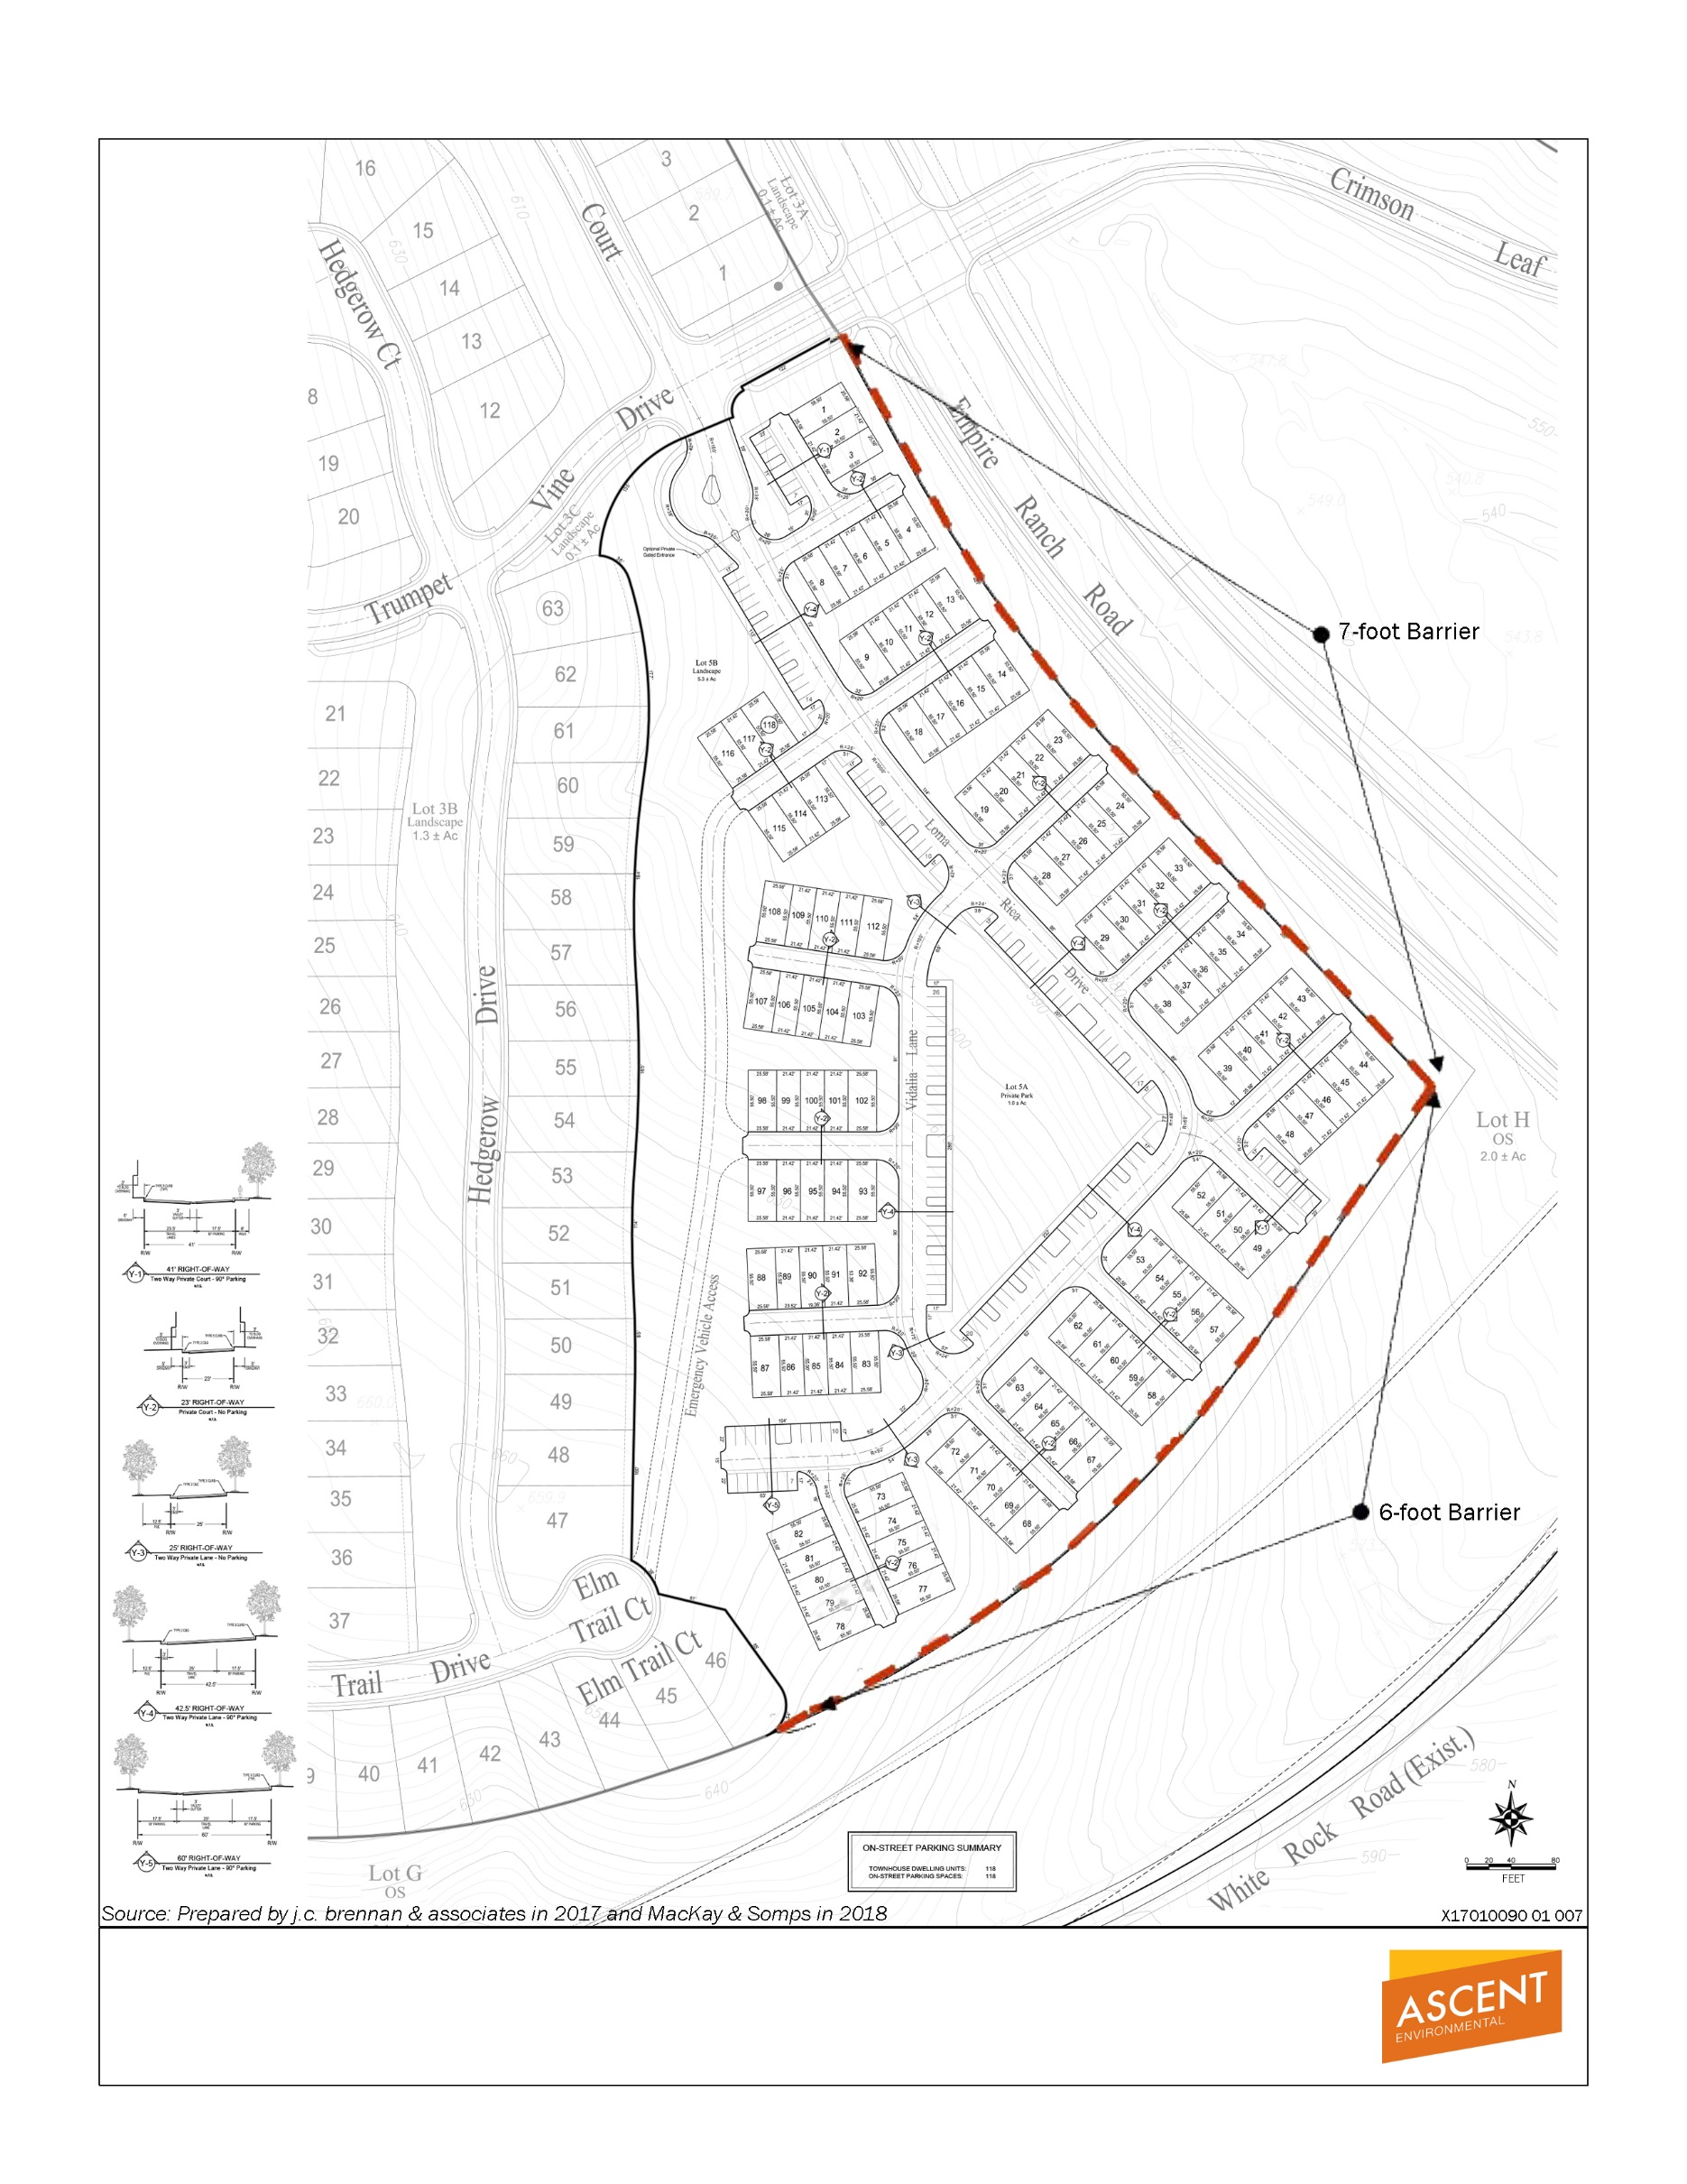

Exhibit 4.12-1 Noise Barrier Locations

Population and Housing
Environmental Issue Area | Where Topic Was Analyzed in the RR EIR or FPASP EIR/EIS | Any New Circumstances Involving New Significant Impacts or Substantially More Severe Impacts? | Any New Information Requiring New Analysis or Verification? | Do Prior Environmental Documents Mitigations Address/Resolve Impacts?
13. Population and Housing. Would the project:
a. Induce substantial population growth in an area, either directly (for example, by proposing new homes and businesses) or indirectly (for example, through extension of roads or other infrastructure)? | RR EIR Appendix C  FPASP EIR/EIS Setting pp. 3A.13-1 to 3A.13-6  Impacts 3A.13-1, 3A.13-2 | No | No | NA
b. Displace substantial numbers of existing housing, necessitating the construction of replacement housing elsewhere? | RR EIR Appendix C  FPASP EIR/EIS Impact 3A.13-3 | No | No | NA
c. Displace substantial numbers of people, necessitating the construction of replacement housing elsewhere? | RR EIR Appendix C  FPASP EIR/EIS Impact 3A.13-3 | No | No | NA

Discussion
No substantial change in the regulatory settings related to population and housing has occurred, as described in the Russell Ranch EIR, Appendix C, Section XIII, Population and Housing since the EIR was certified in 2015. The project site is currently vacant and does not have any on-site housing so there would be no displacement of existing housing or people. This project would create some additional residents but nothing greater than was analyzed in the FPASP EIR/EIS.
Population is estimated based on an average number of persons per dwelling unit and differs between multi-family and single-family units. In addition, age-restricted housing has a separate average number of persons per dwelling unit. Using standard persons per household, there is a slight increase in estimated population (+55 persons) as shown in Tables 2-1 through 2-3 of this document However, even with this increase of 55 persons, the overall population would be lower than the population estimated in the FPASP EIR/EIS which allocated a total of 1,143 units as compared to the proposed total of 1,027 units. This does not constitute a substantial change in growth compared to that evaluated in the Russell Ranch EIR. No new significant population and housing impacts would occur.

Mitigation Measures
None required.

CONCLUSION
No new circumstances or project changes have occurred nor has any new information been found requiring new analysis or verification. Therefore, the conclusions of the Russell Ranch EIR remain valid and approval of the project would not result in new or substantially more severe significant impacts to population and housing.

Public Services
Environmental Issue Area | Where Impact Was Analyzed in the RR EIR and FPASP EIR/EIS | Any New Circumstances Involving New Significant Impacts or Substantially More Severe Impacts? | Any New Information Requiring New Analysis or Verification? | Do Prior Environmental Documents Mitigations Address/Resolve Impacts?
14. Public Services.
a. Would the project result in substantial adverse physical impacts associated with the provision of new or physically altered governmental facilities, need for new or physically altered governmental facilities, the construction of which could cause significant environmental impacts, to maintain acceptable service ratios, response times or other performance objectives for any public services:
i. Fire protection? | RR EIR Setting 4.7-6 to4.7-7 and 4.7-21 to 4.7-22  Impact 4.7-5  FPASP EIR/EIS Setting pp. 3A.14-1 to 3A.14-2  Impacts 3A.14-1, 3A.14-2, 3A.14-3 | No | No | Yes
ii. Police protection? | RR EIR Setting 4.7-5 to 4.7-6  Impact 4.7-4  FPASP EIR/EIS Setting pp. 3A.14-2 to 3A.14-3  Impact 3A.14-4 | No | No | NA
iii. Schools? | RR EIR Setting 4.7-7 to 4.7-8  Impact 4.7-6  FPASP EIR/EIS Setting pp. 3A.14-3 to 3A.14-5  Impacts 3A.14-5, 3A.14-6 | No | No | Yes
iv. Parks? | See below in Section 4.15, Recreation

Discussion
No substantial change in the environmental and regulatory settings related to public services, described in the Russell Ranch EIR, Chapter 4.7, Public Services, has occurred since the certification of EIR in 2015. The project would not lead to any changes to the public service needs presented in the Russell Ranch EIR. As stated in Section 4.13, above, no substantial increase in population is anticipated to occur. In addition, the FPASP EIR/EIS accounted for a larger population in this area and the associated public facilities and services. The project would continue to be required to pay its fair share for facilities and services. Similar to what was discussed in the Russell Ranch EIR, the project has potential for some impacts to fire protection services; however, the project would continue to be subject to mitigation measures which would reduce the impacts to less than significant. No new or substantially more severe public service impacts would occur.

Mitigation Measures
The following mitigation measures were referenced in the FPASP EIR/EIS analysis and would continue to remain applicable if the project were approved.
- Mitigation Measure 3A.14-2: Incorporate California Fire Code; City of Folsom Fire Code Requirements; and EDHFD Requirements, if necessary, into project design and submit project design to the City of Folsom Fire Department for review and approval.
- Mitigation Measure 3A.14-3: Incorporate fire flow requirements into project designs.
As described in the Russell Ranch EIR, with implementation of these measures, public services impacts would be reduced to a less-than-significant level.

CONCLUSION
No new circumstances or project changes have occurred nor has any new information been found requiring new analysis or verification. Therefore, the conclusions of the Russell Ranch EIR remain valid and approval of the project would not result in new or substantially more severe significant impacts to public services.

Recreation
Environmental Issue Area | Where Topic Was Analyzed in the RR EIR or FPASP EIR/EIS | Any New Circumstances Involving New Significant Impacts or Substantially More Severe Impacts? | Any New Information Requiring New Analysis or Verification? | Do Prior Environmental Documents Mitigations Address/Resolve Impacts?
15. Recreation.
a. Would the project increase the use of existing neighborhood and regional parks or other recreational facilities such that substantial physical deterioration of the facility would occur or be accelerated? | RR EIR Setting 4.7-8 to 4.7-11  Impact 4.7-8  FPASP EIR/EIS Setting pp. 3A.12-1 to 3A.12-11  Impacts 3A.12-1, 3A.12-2 | No | No | NA
b. Does the project include recreational facilities or require the construction or expansion of recreational facilities which might have an adverse physical effect on the environment? | RR EIR Setting 4.7-8 to 4.7-11  Impact 4.7-8  FPASP EIR/EIS Setting pp. 3A.12-1 to 3A.12-11  Impact 3A.12-1 | No | No | NA

Discussion
No substantial change in regulatory settings related to recreation, described in the Russell Ranch EIR Chapter 4.7, Public Services, Utilities, and Hydrology, has occurred since the certification of the Russell Ranch EIR in 2015. Currently, the project site is empty without existing neighborhood and regional parks so there would not be a significant impact upon parks in the area. The plan would also not have a significant impact upon the environment with regards to constructing a park. The plan includes open spaces that could be used as recreation. These open spaces were included in previous analyses in the Russell Ranch EIR and FPASP EIR/EIS. As discussed in the project description, Quimby park dedication requirements are satisfied by parks located throughout the entire FPASP area, with the project contributing its fair share through dedication of 5.3 acres of neighborhood parkland within the project and payment of an in-lieu fee pursuant to the Public Facilities Financing Plan (PFFP) for the FPASP area. Nothing about the project changes, including the estimated population increase by 8 persons, would alter the conclusions of the Russell Ranch EIR.

Mitigation Measures
None required.

CONCLUSION
No new circumstances or project changes have occurred nor has any new information been identified requiring new analysis or verification. Therefore, the conclusions of the Russell Ranch EIR remain valid and approval of project would not result in new or substantially more severe significant impacts to recreation.

Transportation/Traffic
Environmental Issue Area | Where Topic Was Analyzed in the RR EIR or FPASP EIR/EIS | Any New Circumstances Involving New Significant Impacts or Substantially More Severe Impacts? | Any New Information Requiring New Analysis or Verification? | Do Prior Environmental Documents Mitigations Address/Resolve Impacts?
16. Transportation/Traffic. Would the project:
a. Conflict with an applicable plan, ordinance or policy establishing measures of effectiveness for the performance of the circulation system, taking into account all modes of transportation including mass transit and non-motorized travel and relevant components of the circulation system, including but not limited to intersections, streets, highways and freeways, pedestrian and bicycle paths, and mass transit? | RR EIR Setting pp. 4.8-1 to 4.8-23  Impacts 4.8-1, 4.8-2, 4.8-3  FPASP Setting pp. 3A.15-2 to 3A.15-24  Impacts 3A.15-1, 3A.15-2, 3A.15-4 | No | No | Yes
b. Conflict with an applicable congestion management program, including, but not limited to level of service standards and travel demand measures, or other standards established by the county congestion management agency for designated roads or highways? | RR EIR Setting pp. 4.8-1 to 4.8-23  Impacts 4.8-1, 4.8-2, 4.8-3  FPASP Setting pp. 3A.15-2 to 3A.15-24  Impacts 3A.15-1, 3A.15-2, 3A.15-4 | No | No | Yes
c. Result in a change in air traffic patterns, including either an increase in traffic levels or a change in location that results in substantial safety risks? | Not addressed, no impact | No | No | NA
d. Substantially increase hazards due to a design feature (e.g., sharp curves or dangerous intersections) or incompatible uses (e.g., farm equipment)? | Not addressed, no impact | No | No | NA
e. Result in inadequate emergency access? | Discussed under 4.14, Public Services | No | No | Yes
f. Conflict with adopted policies, plans, or programs regarding public transit, bicycle, or pedestrian facilities, or otherwise decrease the performance or safety of such facilities? | RR EIR Setting pp. 4.8-1 to 4.8-23  Impacts 4.8-1, 4.8-4, 4.8-5  FPASP Setting pp. 3A.15-2 to 3A.15-24 | No | No | NA

Discussion
No substantial change in the environmental and regulatory settings related to transportation/traffic, as described in Chapter 4.8, Transportation, Traffic, and Circulation, has occurred since certification of the Russell Ranch EIR. Fehr & Peers conducted an analysis of the project change’s potential impact on the transportation system in a January 2018 memo (Appendix A).
The project would result in a change to residential land uses and total number of residential units from that approved in the Russell Ranch EIR. The Russell Ranch EIR evaluated traffic impacts from 903 residential dwelling units, of which 789 were detached single-family units and 114 were multi-family units. The project would result in an increase of the total number of dwelling units to 1,027, of which 587 would be detached single-family units (no age restrictions), 208 would be age-restricted detached single-family units, and 232 would be multi-family units.
The change in trip generation was computed using trip rates contained in Trip Generation Manual, 9th Edition, published by the Institute of Transportation Engineers. Table 4.16-1 presents the resulting trip generation of the plan approved in the Russell Ranch EIR and the project.
As shown, the project would result in a decrease in trip generation by 231 daily trips, 27 AM peak hour trips, and 52 PM peak hour trips, as compared to the plan analyzed within the Russell Ranch EIR. Thus, in all three key time periods (i.e., daily, AM peak hour, and PM peak hour), the project would generate less traffic than the approved Russell Ranch land use plan. Even though the number of proposed units is higher than currently approved, the shift of unit type from single family to multi family and to age restricted results in a decrease in total trips.
Table 4.16-1 Trip Generation Comparison
 | Approved Entitlements (for Lots 24-32) |  |  |  | Proposed Project (Lots 24-32)
 | Units | Daily | AM Peak Hour | PM Peak Hour | Units | Daily | AM Peak Hour | PM Peak Hour
Single Family Residential | 789 | 7,511 | 592 | 789 | 587 | 5,588 | 440 | 587
Age-Restricted Residential | 0 | 0 | 0 | 0 | 208 | 907 | 64 | 77
Multi-Family Residential | 114 | 758 | 58 | 71 | 232 | 1,543 | 118 | 144
Total | 903 | 8,269 | 650 | 860 | 1,027 | 8,038 | 622 | 808
Source: Fehr & Peers 2018 (Appendix A)
Note: As shown in Appendix A, age-restricted residential land uses have much lower trip generation rates than residential units with no age restrictions and do not contribute significantly to peak hour traffic.

Cumulative Impacts Discussion
The Russell Ranch EIR was completed in 2015. The transportation/circulation chapter of that EIR included an evaluation of cumulative traffic impacts under Year 2035 traffic conditions. Cumulative impacts refer to the combined effect of project impacts with the impacts of other past, present, and reasonably foreseeable future projects. This cumulative impact analysis does not rely on a list of specific pending, reasonably foreseeable development proposals in the vicinity of the project; rather, it relies on existing and future development accommodated under the City of Folsom General Plan, which is included in regional travel demand modeling.
The SACOG regional traffic model was used to forecast cumulative year 2035 traffic volumes both within and outside of the FPASP area. The resulting cumulative scenario included buildout of the Russell Ranch development as well as the surrounding FPASP. The model also included land use growth in other portions of Folsom as well as the surrounding six-county region.
The year 2035 traffic model assumed a substantial increase in land use development north of US 50 as anticipated by the Folsom General Plan. As the Russell Ranch EIR had assumed a substantial amount of development north of US 50 under Year 2035, the proposed land use change would not result in any new significant traffic impacts under cumulative conditions.
Therefore, the project would not introduce new or substantially more significant impacts than was analyzed in prior environmental documents and no additional environmental review is required.

Mitigation Measures
The following mitigation measures were referenced in the Russell Ranch EIR analysis and would continue to remain applicable if the project were approved.
- Mitigation Measure 4.8-1 Construction traffic and parking management plan.
- Mitigation Measure 4.8-2(a) Fair share costs towards the modification to the westbound approach to the East Bidwell Street/Iron Point Road intersection.
- Mitigation Measure 4.8-2(b) Fair share through the PFFP fee towards a westbound right-turn lane to the White Rock Road/Placerville Road intersection.
- Mitigation Measure 4.8-3 Pay CIP fee, towards the construction of auxiliary lanes on US 50 from Sunrise Boulevard to East Bidwell Street/Scott Road.
- Mitigation Measure 4.8-6 Fair share fee towards the addition of right of way and add a channelized westbound right-turn lane to the Scott Road/Easton Valley Parkway intersection.
The FPASP EIR/EIS, and subsequently the Russell Ranch EIR, concluded that impacts to level of service of some facilities (intersection and freeway access ramps) would remain significant and unavoidable even with implementation of recommended mitigation. No additional mitigation measures are available to reduce or eliminate the impacts.

CONCLUSION
The January 2018 trip generation analysis determined that, although the number of proposed units for the project is higher than the number of units approved under the Russell Ranch EIR, the new mix of housing results in a decrease in total daily, AM peak hour, and PM peak hour trips. Further, the projected cumulative traffic operating conditions have not changed substantially since the Russell Ranch EIR was certified.
Thus, no new circumstances or project changes have occurred, nor has any new information been identified, requiring new analysis or verification. Therefore, the conclusions of the Russell Ranch EIR and FPASP EIR/EIS remain valid and approval of the project would not result in new or substantially more severe significant impacts to transportation.

Utilities and Service Systems
Environmental Issue Area | Where Impact Was Analyzed in the RR EIR and FPASP EIR/EIS | Any New Circumstances Involving New Significant Impacts or Substantially More Severe Impacts? | Any New Information Requiring New Analysis or Verification? | Do Prior Environmental Documents Mitigations Address/Resolve Impacts?
17. Utilities and Service Systems. Would the project:
a. Exceed wastewater treatment requirements of the applicable Regional Water Quality Control Board? | RR EIR Setting 4.7-4 and 4.7-18  Impacts 4.7-1 and 4.7-2  FPASP EIR/EIS Setting pp. 3A.16-1 to 3A.16-3 and 3A.18-1 to 3A.18-6  Impacts 3A.16-1, 3A.16-2, 3A.18-2, 3A.16-3, 3A.16-4, 3A.16-5 | No | No | Yes
b. Require or result in the construction of new water or wastewater treatment facilities or expansion of existing facilities, the construction of which could cause significant environmental effects? | RR EIR Setting 4.7-4 and 4.7-18  Impact 4.7-2  FPASP EIR/EIS Setting pp. 3A.16-1 to 3A.16-3 and 3A.18-1 to 3A.18-6  Impacts 3A.16-1, 3A.16-2, 3A.18-2, 3A.16-3, 3A.16-4, 3A.16-5 | No | No | Yes
c. Require or result in the construction of new storm water drainage facilities or expansion of existing facilities, the construction of which could cause significant environmental effects? | RR EIR Setting 4.7-11 to 4.7-14  Impact 4.7-10  FPASP EIR/EIS Setting p. 4-68 | No | No | Yes
d. Have sufficient water supplies available to serve the project from existing entitlements and resources, or are new or expanded entitlements needed? | RR EIR Setting 4.7-11 to 4.7-14  Impact 4.7-10  FPASP EIR/EIS Setting pp. 3A.18-1 to 3A.18-6  Impact 3A.18-1 | No | No | Yes
e. Result in a determination by the wastewater treatment provider which serves or may serve the project that it has adequate capacity to serve the project’s projected demand in addition to the provider’s existing commitments? | RR EIR Setting 4.7-11 to 4.7-14  Impact 4.7-10  FPASP EIR/EIS Setting pp. 3A.16-1 to 3A.16-3  Impacts 3A.16-2, 3A.16-3, 3A.16-4, 3A.16-5 | No | No | Yes
f. Be served by a landfill with sufficient permitted capacity to accommodate the project’s solid waste disposal needs? | RR EIR Setting  Impact 4.7-3  FPASP EIR/EIS Setting pp. 3A.16-3 to 3A.16-4  Impacts 3A.16-6, 3A.16-7 | No | No | NA
g. Comply with federal, state, and local statutes and regulations related to solid waste? | RR EIR Setting 4.7-5  Impact 4.7-3  FPASP EIR/EIS Setting p. 3A.16-4  Impacts 3A.16-6, 3A.16-7 | No | No | NA
h. Create demand for natural gas, electricity, telephone, and other utility services that cannot be met. | RR EIR Setting 4.7-11  Impact 4.7-9  FPASP EIR/EIS Setting pp. 3A.16-5 to 3A.16-7  Impacts 3A.16-8, 3A.16-9, 3A.16-10, 3A.16-11 | No | No | NA
i. Result in inefficient, wasteful, and unnecessary consumption of energy. | RR EIR Setting 4.7-11  Impact 4.7-9  FPASP EIR/EIS Setting pp. 3A.16-5to 3A.16-6, 3A.16-8  Impact 3A.16-12 | No | No | NA

Discussion
No substantial change in environmental and regulatory settings related to utilities and service systems as described in Russell Ranch EIR Chapter 4.7, Public Services, Utilities, and Hydrology, has occurred since certification of the Russell Ranch EIR in 2015. The analysis was done in the middle of a drought which lasted from 2012 to 2017 (DWR 2017) and considered conservation efforts as part of the analysis. In addition, the current approved entitlements for FPASP include the addition of recycled water infrastructure to allow for water reuse in the future (RR EIR, Appendix C). The project would not substantially increase water demand or change the type of structures analyzed in the utilities section of the Russell Ranch EIR. Both the FPASP and Russell Ranch EIR examined the potable water needs for plan area. MacKay & Somps reviewed the project in January 2018 to determine whether the water supply would be sufficient (MacKay & Somps 2018a and MacKay & Somps 2018b). The water supply agreement for the FPASP area provides an overall cap of 5,600 acre-feet per year (Appendix E). With the changes to the project, Russell Ranch would maintain the same level of water use as the approved entitlements; the project area would continue to require 191 acre-feet of water per year (Appendix F).
MacKay & Somps also reviewed the wastewater and sewer transmission infrastructure requirements and compared the wastewater generation and sewer flow estimates for both the existing approved entitlements and the proposed land use changes in Appendix H. Per the memo in Appendix H, the analysis concludes the project would generate 0.1165 million gallons a day (mgd) Average Dry Weather Flow (ADWF) of effluent compared to the existing entitlements of 0.1060 mgd. The difference of 0.0105 mgd is considered insignificant (MacKay & Somps 2018c). A sewer master plan was prepared for the entire FPASP area which assumed 1,119 units would be developed in the Russell Ranch area (as shown in Table 1-1). The analysis conducted as part of the sewer master plan showed that the total flow of sewer and wastewater into the Sacramento Regional County Sanitation District (Regional San) system would be 6.23 mgd ADWF and 11.1 mgd in Peak Wet Weather Flow (PWWF) conditions. The Regional San Interceptor Master Plan prepared in 2000 provided for a flow excess of this demand. All the pipelines conveying the flow from the site to the regional Folsom South Lift Station have been planned and constructed to date at a capacity (maximum depth of flow to diameter of pipe) of not to exceed 0.7 full. The Regional San Interceptor Master Plan analyzed all the pipelines within the FPASP area and determined that flow in all pipelines would be substantially less than 0.7 full. Thus, the minor increase can be accommodated from the project site to the connection with Regional San. The increase in sewer flow caused by this project, if approved, would be accommodated without need to change the wastewater and sewer transmission facilities. Per Mitigation Measure 3A.16-1, before receiving final map approval, the applicant must show proof that an adequate wastewater conveyance system either has been constructed or is ensured through payment of the City’s facilities augmentation fee. With the inclusion of this mitigation measure, the Russell Ranch EIR found that impacts to wastewater transmission and treatment facilities would be less than significant. As described in Appendix H, this project would not substantially change the conclusions of the Russell Ranch EIR.
The FPASP EIR/EIS analyzed the potential impacts to solid waste capacity for a higher unit count and determined that the landfill has adequate capacity and no mitigation measures were required to ensure that the impact would less than significant (RR EIR pp. 4.7 - 51). The appropriate landfills have enough capacity to serve both during construction and after build out.
MacKay & Somps evaluated the storm drainage system and concluded that the project design would maintain impacts equal to or below the existing predeveloped condition, as described in Appendix G (MacKay & Somps 2017.
No other changes related to storm drainage facilities, solid waste services, or electricity or natural gas services are proposed. No new significant or substantially more severe environmental impacts would occur.

Mitigation Measures
The following plan-level mitigation measures were referenced in the FPASP EIR/EIS analysis and incorporated by reference into the Russell Ranch EIR and would continue to remain applicable if the project were approved.
- Mitigation Measure 3A.16-1: Submit proof of adequate on- and off-site wastewater conveyance facilities and implement on- and off-site infrastructure service systems or ensure that adequate financing is secured.
- Mitigation Measure 3A.16-3: Demonstrate adequate SRWTP wastewater treatment capacity.
- Mitigation Measure 3A.18-1: Submit proof of surface water supply availability.
- Mitigation Measure 3A.18-2a: Submit proof of adequate off-site water conveyance facilities and implement off-site infrastructure service system or ensure that adequate financing is secured.
- Mitigation Measure 3A.3-1a: Design stormwater drainage plans and erosion and sediment control plans to avoid and minimize erosion and runoff to all wetlands and other waters that are to remain on the SPA and use low impact development features.
With implementation of the above measures, impacts related to utilities and service systems would be reduced to a less-than-significant level.

CONCLUSION
No changes in circumstances would result in new or substantially more severe significant environmental impacts related to utilities and service systems. Therefore, the conclusions of the certified Russell Ranch EIR remain valid and no additional analysis is required.

List of Preparers and Persons Consulted

List of Preparers

Ascent Environmental
Amanda Olekszulin Principal-in-Charge
Elizabeth Boyd Project Manager
Megan Diliberti Environmental Planner
Zachary Miller Transportation Planner
Julia Wilson AQ/GHG/Noise Analyst
Lisa Merry GIS Analyst/Graphics
Michele Mattei Document Production

This page intentionally left blank.

References
Abbas Metzker, AICP, Sherri. 2018 (January 16). Consultant Planner. E-mail correspondence with Bonnie Chiu of The New Home Company regarding persons per age-restricted household.
DWR. 2017. Drought Information. Available: http://www.water.ca.gov/waterconditions/index.cfm. Accessed: December 6, 2017.
City of Folsom. 2010 (June). Public Draft EIR/EIS for the Folsom South of U.S. Highway 50 Specific Plan Project. SCH #2008092051. Available: http://folsom-web.civica.granicuslabs.com/city_hall/depts/community/annexation/current_documents.asp. Accessed February 8, 2017.
______. 2011 (May). Mitigation Monitoring and Reporting Program for the Folsom South of U.S. Highway 50 Specific Plan Project. SCH #2008092051. Available: http://folsom-web.civica.granicuslabs.com/city_hall/depts/community/annexation/current_documents.asp. Accessed February 8, 2017.
ECORP. 2017a (November 20). Biological Resources Assessment to Support an Amendment to the Folsom Plan Area Specific Plan for the Russell Ranch Phase 2 Project. Prepared for the City of Folsom. Rocklin, CA.
______. 2017b (September 27). Cultural Resources Assessment to Support an Amendment to the Folsom Plan Area Specific Plan for the Russell Ranch Project. Prepared for the City of Folsom. Rocklin, CA.
Fehr & Peers. 2018 (January 8). Russell Ranch – Change in Trip Generation & Cumulative Impacts Discussion. Sacramento, CA. Letter memorandum to Bonnie Chiu of The New Home Company.
j.c. brennan & associates. 2017 (September 29). Review of Noise Mitigation for the Russell Ranch Project Entitlements. Letter memorandum to Elizabeth Boyd of Ascent Environmental.
MacKay & Somps. 2018a (January 17). Potable Water Demand Chart. Prepared for Bonnie Chiu of The New Home Company.
______. 2018b (January 17). Potable Water Demand Comparison. Prepared for Bonnie Chiu of The New Home Company.
______. 2018c (January 17). Waste Water and Sewer Transmission Analysis. Prepared for Bonnie Chiu of The New Home Company.
______. 2017 (August 11). Preliminary Storm Drainage Evaluation for the Russell Ranch Phase 2 Development. Letter Memorandum Prepared for Bonnie Chiu of The New Home Company.
U.S. Environmental Protection Agency. 2017a. Midterm Evaluation of Light-Duty Vehicle Greenhouse Gas Emissions Standards for Model Years 2022-2025. Available: https://www.epa.gov/regulations-emissions-vehicles-and-engines/midterm-evaluation-light-duty-vehicle-greenhouse-gas. Last updated August 10, 2017. Accessed: August 31, 2017.

This page intentionally left blank.

The City Council originally approved the FPASP on June 28, 2011 for development of up to 10,210 residential homes with a range of housing types, styles, and densities along with commercial, industrial/office park, and mixed-use land uses, open space, public schools, parks, and supporting infrastructure. The development would be located on approximately 3,514 acres (Resolution No. 8863). The FPASP has been amended as separate owners of portions of the FPASP have brought forward large and small lot maps for consideration, with each proposed amendment subject to its own environmental analysis based upon the scope of amendments presented by an individual project. The environmental analysis for the FPASP is summarized in Section 1.2.
The City Council made a finding in Resolution No. 9783 that no additional environmental analysis was required for the approval of these amendments because none of the requirements for subsequent environmental analysis (as described in the text, above) existed under CEQA Guideline 15162. The lot count identified above also included the transfer of lots from an adjacent property (known as Carr Trust) pursuant to a lot line adjustment. These lots were included in the original FPASP EIR/EIS and did not require further environmental review.
In 2004, the City of Folsom’s residents voted in favor of Measure W, an amendment to the City Charter regarding local control of the FPASP area. Among others, Measure W required 30 percent of the FPASP area to be maintained as natural open space to preserve oak woodlands and sensitive habitat areas.
Traditionally, this is stated as “Where Impact was Analyzed”, however, this could be confusing to some readers. The use of the word “impact” doesn’t indicate that the topic had a significant impact on the environment. In this context, the word “impact” indicates an environmental topic for which CEQA provides a question on whether a significant impact may occur (Appendix G of the CEQA Guidelines). Therefore, “topic” is used in the checklist.

