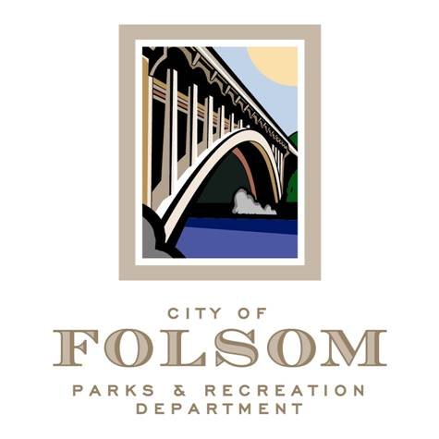
Parks and Recreation Commission
Budget and Finance Subcommittee

Date: Friday, February 2, 2024
Time: 1:00 – 2:00 pm
Location: Parks & Recreation Dept. Conference Room
50 Natoma St.
Folsom, CA 95630

Agenda:
- FY2024-25 Budget Development Update

Future Meeting Topics

Attendees:
- Brian Wallace, Commissioner
- Matt Hedges, Commissioner
- Bill Davis, Commissioner
- Kelly Gonzalez, Parks & Recreation Director
- Elizabeth Vaage, Senior Management Analyst
- Tom Hellman, Recreation and Cultural Services Manager

