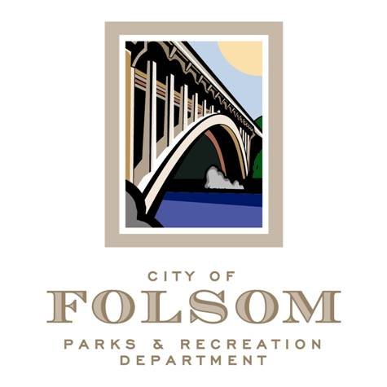
Parks and Recreation Commission
Planning & Development Subcommittee

Date: June 21, 2024
Time: 1:00p – 2:00p
Location: Parks & Recreation Dept. Conference Room
50 Natoma St.
Folsom, CA 95630

Agenda:
1. Discussion Item: Benevento Family Park Planning History and Project Budget for Phase I.

Attendees:
- Samantha Davidson, Commissioner
- Alayna Wagner, Commissioner
- Marina Leight, Commissioner
- Kelly Gonzalez, Parks & Recreation Director
- Brad Nelson, Park Planning Manager
- Chris O’Keefe, Parks & Facilities Maintenance Manager
- Elizabeth Vaage, Senior Management Analyst
- Tom Hellman, Recreation and Cultural Services Manager

