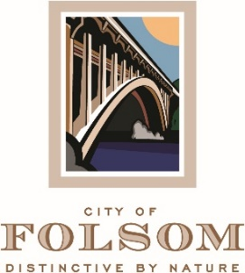

MEETING CANCELLATION NOTICE

THE REGULAR MEETING OF JULY 02, 2024 OF THE FOLSOM PARKS and RECREATION COMMISSION HAS BEEN CANCELED.

THE NEXT REGULAR MEETING IS SCHEDULED TO BE HELD ON TUESDAY, AUGUST 06, 2024 AT 6:30 P.M.

