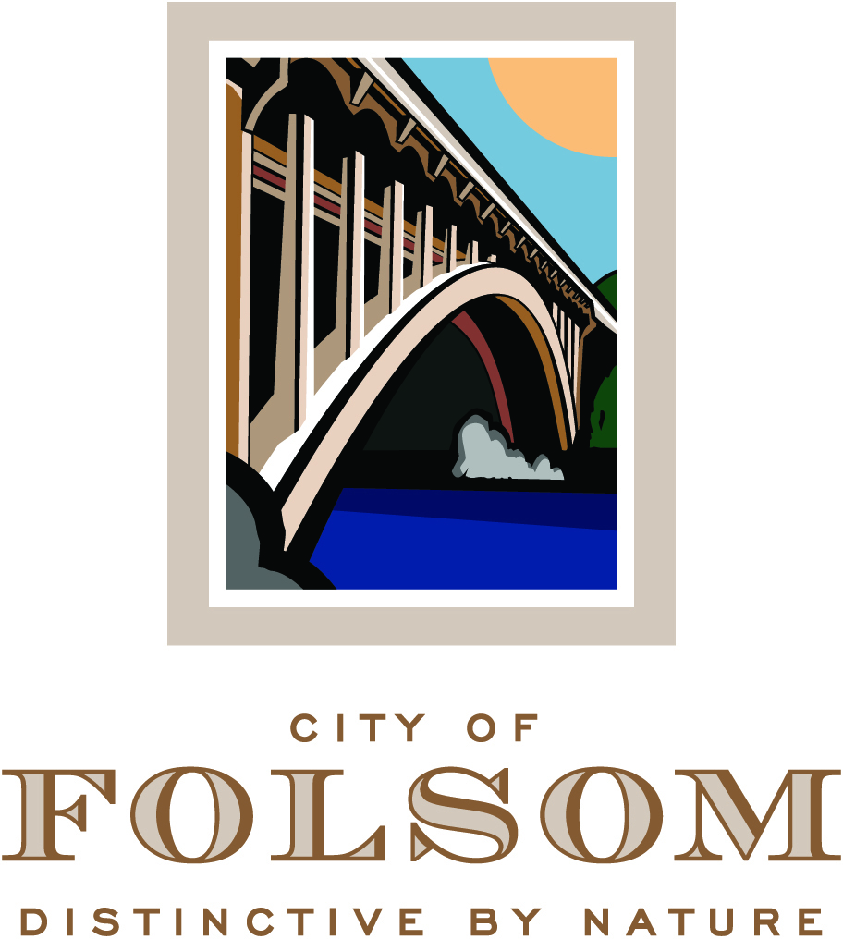

NOTICE OF ADJOURNMENT

The regularly scheduled meeting of July 6, 2016 of the
Folsom Planning Commission
has been adjourned to
July 20, 2016 at 6:30 p.m., to be held at the City Council Chambers.

Business to be discussed:

PN 15-162, Cresleigh Ravine and Campus - General Plan Amendment, Rezone, Tentative Subdivision Map, Planned Development Permit, and Consideration of Adoption of a Mitigated Negative Declaration (Continued from the June 15, 2016 Planning Commission Meeting)

A Public Hearing to consider a request from Folsom Urban Homes, LLC and Folsom Residences, LLC for approval of a General Plan Amendment, Rezone, Tentative Subdivision Map, and Planned Development Permit for development of a 276-unit mixed residential development near the intersection of Iron Point Road and Willard Drive. The zoning classification for the site is C-3 PD and the General Plan land-use designation is CC. An Initial Study and Mitigated Negative Declaration have been prepared in accordance with the requirements of the California Environmental Quality Act. (Project Planner: Principal Planner, Steve Banks / Applicant: Folsom Urban Homes, LLC & Folsom Residences, LLC)

