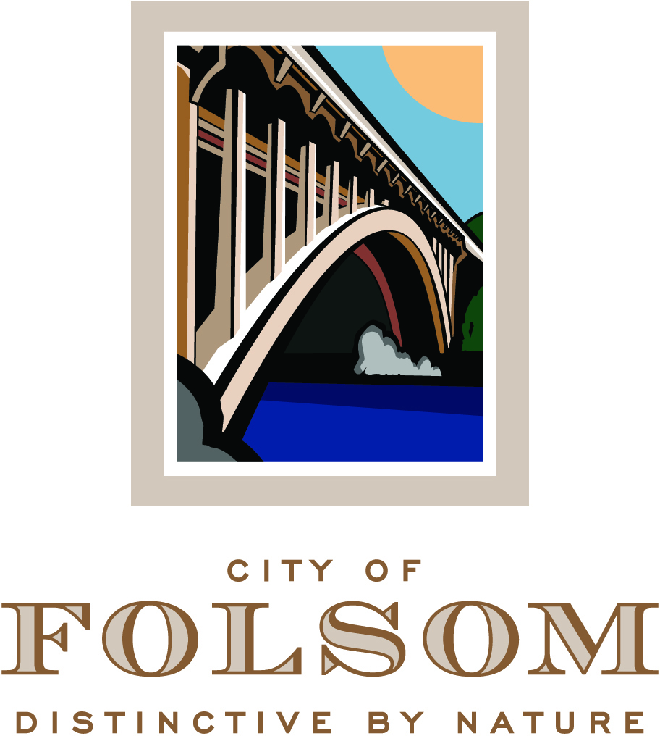

NOTICE OF ADJOURNMENT

The regularly scheduled meeting of September 7, 2016 of the
Folsom Planning Commission
has been adjourned to
September 21, 2016 at 6:30 p.m., to be held at the City Council Chambers.

Business to be discussed:

PN 16-025, Enclave at Folsom Ranch, Easton Valley Parkway – Tentative Parcel Map, Vesting Tentative Subdivision Map, Planned Development Permit, and Determination that the Project is Exempt from CEQA

A Public Hearing to consider a request from Enclave at Folsom, LLC for approval of a Tentative Parcel Map, Vesting Tentative Subdivision Map, and Planned Development Permit for development of a 111-unit single-family residential subdivision on a 14.7-acre site located on Easton Valley Parkway (APN 072-3190-036). The Specific Plan designation is SP-GC and SP MLD and the General Plan is GC-MLD. An Exemption has been prepared for the project pursuant to California Environmental Quality Act Guidelines Sections 15063 and 15084. (Project Planner: Principal Planner, Steve Banks / Applicant: Enclave at Folsom, LLC)

